FFGDM to FF New Mexico Journal
Journey #26164 – May 2026

Monday, May 11--Day 1
Alice
Ten members from our club were invited to visit the Albuquerque, New Mexico Friendship Force club. Gary and Nan Stubbs drove and 8 members (Ronda and Mike Davis, Claudia Holcomb, Shelley Bain, Anita Linfield, Pat Headley, Karen Kilpatrick and Alice Rasmussen) flew into Denver, then onto Albuquerque. We saw a lot of pictures and information in the airport about Route 66. We were met by our hosts and spent the evening getting acquainted.
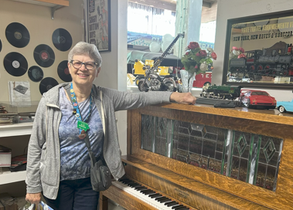
Tuesday, May 12 – Day 2
Claudia
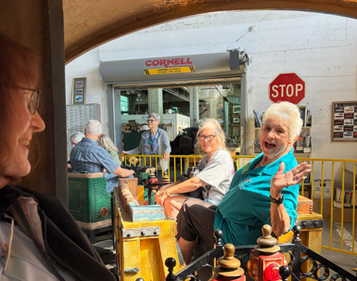
We visited the “Wheels Museum” on Tuesday morning, May 12. “Wheels” is an acronym for “We Have Everything Everyone Loves Spinning.” The museum is a volunteer run, non-profit organization dedicated to collecting, preserving, and creating historic exhibits relating to transportation. It is on the historic site of the Santa Fe Railroad Shops. Originally this area was a repair shop for steam engines. The introduction of the diesel engine spelled its demise. Now 8,000 square feet is designated for events, small groups and presentations. Among the exhibits in the museum, we saw model trains, antique vehicles, a bubble train that some of us rode, unusual bikes, an airplane, a player piano, and a pump organ. We spent an enjoyable time visiting the museum and learning about Albuquerque history.

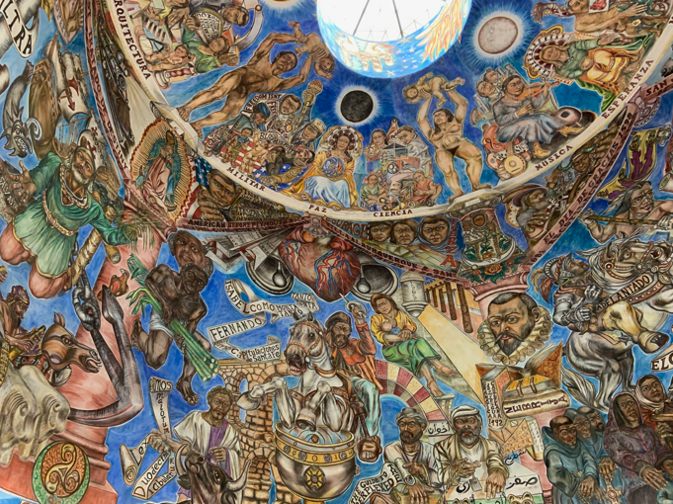
Mike
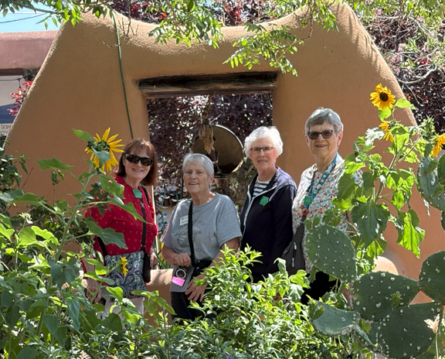
After lunch at La Fonda, we went to the Hispanic cultural center, beginning at the Mundos de Mestizaje dome. Painting of this magnificent fresco began in 2003 and was completed in 2010. It references the mix of people and cultures in the history of New Mexico. Ken and Chris Fenner of the New Mexico club, described the references in the fresco and how they related to the history of the area. The fresco included Europeans, pre-Colombian meso America, Mexico, Blancos from Santa Fe, and Indians from the area.

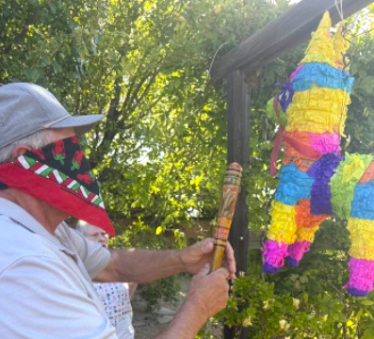
Then we went to the art museum at the cultural center. We viewed the Aqui Estamos (We Are Here) permanent exhibits, along with the Downwinders exhibit of art and photography, documenting the effects of being downwind from the atomic bomb tests from the 60s and 70s. We also viewed an exhibit of art by the staff of the art museum.

Our next stop was at a piñata party at Ginger’s home. We had beautiful views of the mountains behind home and enjoyed guacamole and margaritas. Then we took our whacks at a piñata. Gary Stubbs gave the final blow and we collected the candy that spilled out.

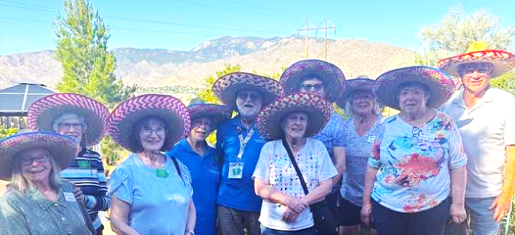

More FFNM members joined us at a barbecue dinner at the home of our host, Carolyn. We enjoyed the food, participated in some singing with Ken and Chris, and all had a good time. The New Mexico members expressed a great deal of pride in their state.

Wednesday, May 13 – Day 3
Anita
Wednesday had a very, very early start. We were taking the train, the railrunner to Santa Fe for the day. My host Lenore had me at the downtown depot to catch the 7:15 first stop. Others piled on at other stops. We rode up top and the view was spectacular. We traveled through many pueblos so picture taking was limited. At the depot in Santa Fe was a small replica of Zozobra. A 15-foot statue is made annually and represents a powerful modern expression of the ancient spiritual practice of burning paper. By participating in this event, individuals tap into ago-old traditions of release, purification, and transformation. The communal nature of Zozobra amplifies these effects, creating a shared experience of renewal and hope. People write their glooms and things they want to rid themselves of to be added to the statue.

In Santa Fe after visiting Loretto Chapel with a miracle circular staircase to the balcony we split into two groups, one took museum hill for tours and the other stayed in the plaza area visiting the oldest church and art in the state capital.

Shelley
We did a short bus tour around downtown Santa Fe and then traveled up to Museum Hill to tour the Museum of International Folk Art and Museum of Indian Arts & Culture. I loved both museums and took many photos of the modern art exhibit at the Museum of Indian Arts & Culture. There was art everywhere from outdoor sculptures to interior exhibitions and wall art. Also, a great gift shop.

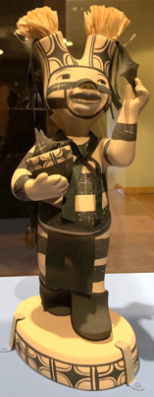
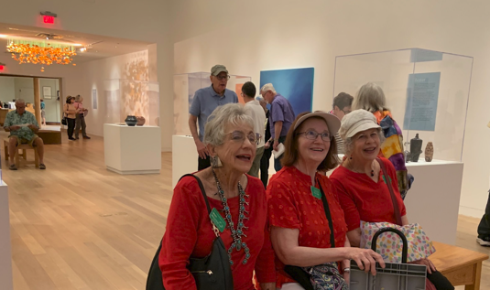
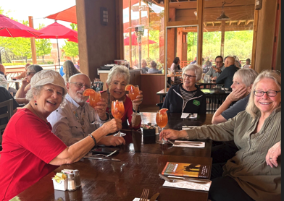
We had lunch at a lovely open-air restaurant with excellent Sangria. Spice-challenged Claudia thought she ordered a low-heat dish of shrimp stuffed poblano but she was wrong.

The Museum of International Folk Art was free as two or three major exhibits were closed going through transition. The political exhibition “Truths Be Told: Artists Activate Traditions” was especially good. I especially liked pottery artist Elyse Pignolet’s display “Yes Means Yes” with messages from survivors of sexual assault. It was reminiscent of Judy Chicago’s dinner party exhibition. Judy Chicago is still alive for those who have lost track of her.

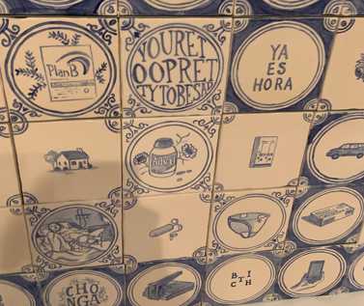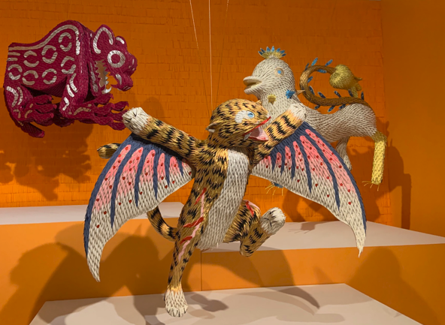

Not having time to visit the Santa Fe Botanical Garden, we took a bus back to downtown where we had ice cream at La Lecheria. I splurged and had two scoops one coffee and one sea salt chocolate. Delicious.

After the train ride back to Albuquerque, several ambassadors took their hosts to dinner at El Pino, a sprawling, mostly outdoor among the trees, restaurant. The food was good but the company was excellent.

Thursday, May 14 – Day 4
Ronda
After a relaxing morning we left for the meet up at Target to drive to Jemez Pueblo. We were hosted by Emma Yeta from a family of potters. We were very fortunate to have her explain her technique and to actually see her work. She had pieces to purchase and many of us did! Then we were treated to a delicious lunch at her home.
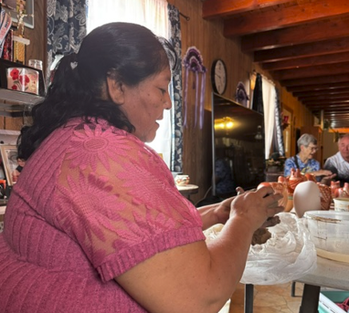
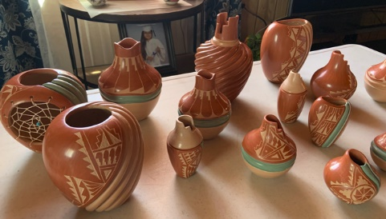
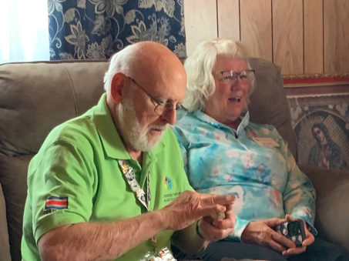

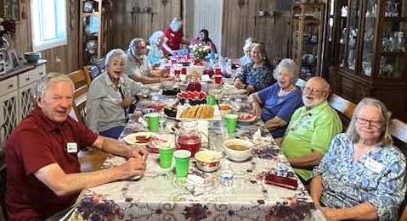
Nan
Following our delicious lunch with traditional Indian bread baked in a horno, red chili stew, cheese enchiladas (they stack the tortillas verse roll them),potato salad, pinto beans, orange jello with mandarin oranges, and birthday cake, we parted from Emma Yepez home and traveled to Walatowa Visitor Center and Hummingbird Cafe where we learned of the powers of burning sage and local Jemez Pueblo.

Then off to the National Historic ruins of the first Jemez settlement. A self guided tour of the grounds seeing their home, church, and cemetery.

On the way back into town we stopped at the Ponderosa Winery. We talked with the owner about the lack of water for the grapes and the three frosts after the leaves started to bud. Miraculously there are pin sized grapes starting to form. They may still get a crop. We did taste some wines and contributed to the New Mexico economy.

We then had our small group dinner with Pastor Dave and Fran Ring of green chile chicken enchiladas, pisole, green chile stew, chips and queso followed by Biscochios (anise and cinnamon shortbread type cookies). Our evening was filled with many jokes, groans, laughter and delicious food.

Friday, May 15 – Day 5
Gary
While waiting for our “Breakfast by Jim” egg casserole to cook we listened to the spirted Irish singer/Johnny Tarr from Alexa. Due to an easy morning late start, we got to walk around the oldest Catholic Church in the city - San Felipe de Neri Church. We also saw classic cars carrying 8th grade graduates in a classic car parade. The arts and culture museum was next on our list of interesting activities. Lunch for me, “Frito Pie”, was great at the Albuquerque Museum Cafe.

Pat
At the Albuquerque Museum we saw the Fred Harvey Route 66 exhibit, bringing back memories of yesteryear, something none of us saw originally. This is the year of the Route 66 centennial and there were maps, postcards, brochures, and other memorabilia of a time gone by including images that were used during the 1930s to promote tourism. They all seem outdated to us, but were quite popular at the time, and did indeed bring tourism. Also, in the museum were striking works by Georgia O’Keeffe, and an exhibit of beautiful Native American pottery and jewelry.
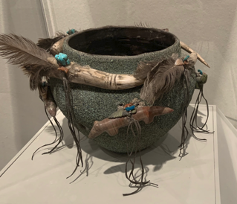
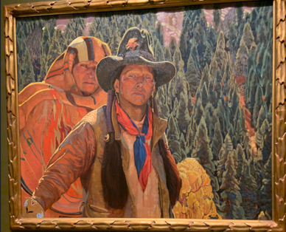

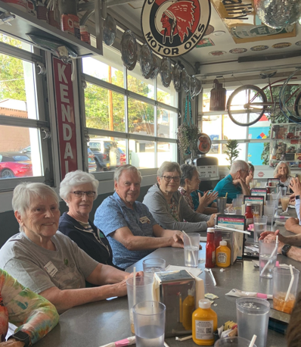
Shelley
Our hosts organized the “Farewell Dinner” at the 66 Diner, a fun traditional diner on Route 66. A good time was had by all.

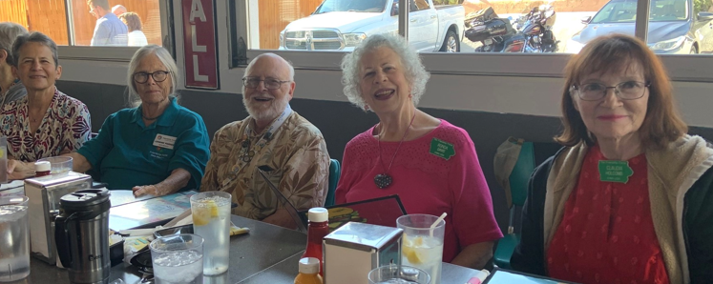

Saturday, May 16 – Day 6
Karen
Up bright and early and bushy tailed as we get on the road to our destination of Chimayo! Along the way we notice the lovely Sandia and Santa Fe mountains, mesas, various Pueblos, hornos (Pueblo outdoor ovens), sculpture galleries, Camel Rock, coyote fences, and changing topography and vegetation. Arriving at our destination, we tour the Santuario de Chimayo, the Santo Nino chapel and other structures in the complex. The shell symbol reminds us this is the largest Catholic renowned pilgrimage site in the US, built in the early 1800’s, and known for its reputed healing “holy dirt”.

Alice
After a good lunch at Rancho de Chimayo, Gary and Nan Stubbs, Jim Twohig and I took a different route back to his home. Gary's phone said we got to 8040 feet elevation. The beautiful scenery changed 3 times during our drive--which lasted until 8:45PM!! We stopped in Las Trampas to take pictures of the Church of San Jose built around 1770. In Las Vegas we bought cherries from a roadside stand and then viewed the United World College noted for the Montezuma Castle, an architectural landmark built in 1886, that was originally a resort and railway hotel but now on the college campus. After arriving at our host's home, we ate leftovers and did more visiting! Another good day.

Sunday, May 17 – Day 7
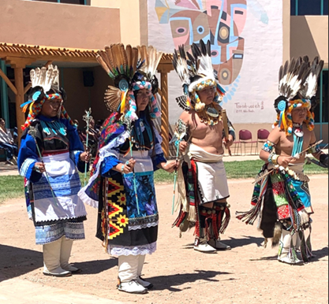
Pat
We all met at the Pueblo Cultural Center to see a traveling installation of contemporary works, focusing on the voices, history, and legacy of New Mexico giving us a better understanding of their culture. We enjoyed seeing the “Grounded in Clay: The spirit of Pueblo Pottery” dating back more than 1,000 years. We finally understood what a Pueblo is, basically a village, and saw a map of all nineteen of them giving us a greater perspective of where these people lived. The most interesting part of the morning was watching the Zuni children doing the “Rainbow,” “Corn,” and “Arrow,” dances. The kids, who had been practicing for only a month, did a great job, their feet keeping time with the drumming. The were in full regalia, from their headgear to their knee-high boots, and that was a treat to see.

Claudia
On the afternoon of Sunday, May 17, I spent my time packing for the trip home and helping my host, Carolyn prepare for a small group dinner. We were supposed to ride the Sandia Peak Tramway later that evening but the winds were too strong. I know I would have liked the view at the top of the ride, roughly 11,000 square miles of the New Mexico countryside. I did get to take a picture of the tramway and the Sandia “car”.

We visited Tom M’s home, Shelley’s host, to view his beautiful garden and home filled with clocks, family memorabilia, and family photos. Shelley said she slept with the ancestors because the wall behind her headboard held over 40 family photos.

Monday, May 18 – Day 8
Shelley
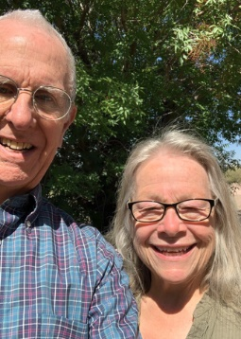
I got my garden fix when my host, Tom, and I toured the ABQ BioPark-Botanic Garden in the morning. It was the perfect time to visit – a cool morning and no weekend crowds.

The garden showcases plants of local New Mexico habitats and xeric plants from North America.

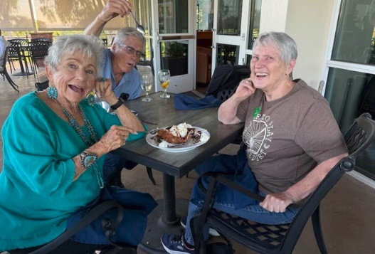
Tom has a fantastic home and property with over 70 roses (they came with the house), tall bearded iris, asiatic lilies, and lavender; many plants are in large cobalt blue pots. He has an underground watering system that extends into the pots in order to water efficiently. He also has an New Mexico garden outside the short wall where native plants thrive on their own. I enjoyed sitting outside, watching the hummingbirds and geckos.

On the other hand, Pat had crepes at one of several French restaurants in the city.

In the afternoon, six ambassadors flew to Denver to connect to a flight to Des Moines. Our plane was struck by lightning as it approached Des Moines and we were diverted to Omaha to land. When we boarded the next day - new plane, same pilots and flight crew - the pilot explained how planes are built to withstand lightning strikes and not fall out of the sky. After an uneventful 30-minute flight to Des Moines, we arrived home Tuesday afternoon with great memories of our new friends in New Mexico and a story to tell.

