Friendship Force of Greater Des Moines
Friendship force of Minnesota-Twin Cities
Journey to Saitama and Koriyama, Japan
March 25 to April 23, 2026

Ambassadors: Cindy Cauble (coordinator FFMN-TC), Mike Davis (coordinator FFGMD) Ronda Davis, Christine Allen, Ann Besser, Gelina Boyer and Tom Thies, Roberta (Robin) and Peter Knaeble, Terese Libby, Gene Lucht and Gail Sheridan-Lucht, Mary Montagne, Marcia Novak, and Carol Nasby

March 25. Most ambassadors from both clubs were on the same flight to Japan. The Minnesota-Twin Cities group and some of us from the Des Moines group met at the Minneapolis-St. Paul airport. We were scheduled to arrive the next day, Japan time (14 hours ahead of Central time).

March 26. We landed at Haneda airport and took an airport shuttle to another terminal to meet the hotel shuttle. The day was overcast, damp, and windy. We found that the hotel was really two separate sister hotels, and some of us were staying in each of them. We met for dinner at Sakiyu, a tiny and very busy counter-service restaurant serving Japanese food, located across from the hotel on a street that had convenience stores, dental clinics, and apartments. After dinner, some of us explored the street and some stores. Then back to the hotel for an early bedtime after our very long day of flying.

March 27. After breakfast at the hotel, we took the shuttle to the airport. It was an interesting drive through the city on a nice day. We had enough time at the airport to wander and shop. After we gathered again, a few Saitama club members met at the airport and guided us to the airport bus to Omiya train station, where our hosts met us and took us to our home stays. But first many of us went to a food hall—so bright, so much color, it was beautiful!
Ronda Davis

March 28. We were staying with our hosts in Saitama and traveled by train to the Kitaurawa Cultural Club for our Welcome Party. After casual conversations with our new Japanese friends, the Saitama FF president gave a warm introduction to his club and what we could expect for the coming week. He then introduced the next wonderful activities of flower arranging, calligraphy, and kimono modeling. Robin Knaeble
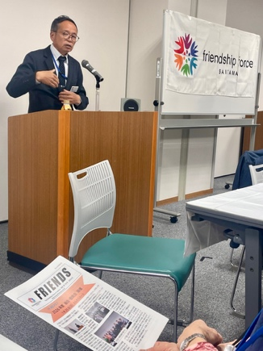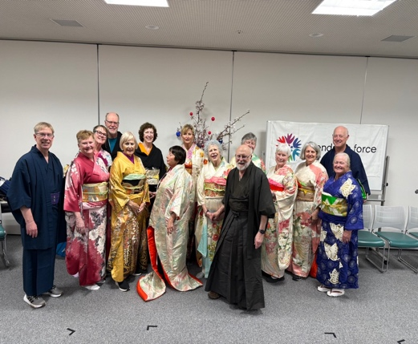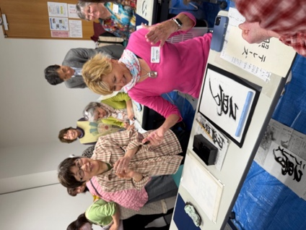

Carol Nasby’s spirit, soul, heart (left) and friend (right).

After the welcome, we participated in three cultural activities with local experts: Ikebana flower arranging with cherry tree blossoms and a group arrangement above. Shodo: Japanese calligraphy. We each chose a symbol from a sample list and practiced painting with guidance. Terese Libby is happy with hers: dream. It was a fun, interactive day of learning and sharing. Mary Montagne

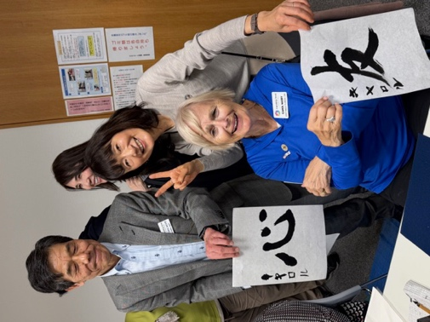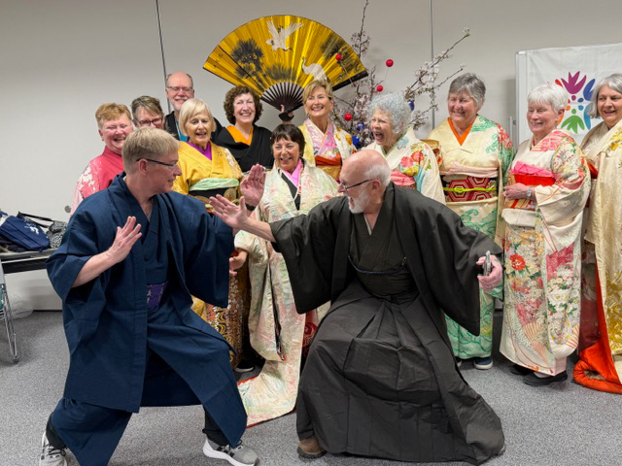
Kimono: Japanese traditional clothing. Gene Lucht (left) and Mike Davis (right) as warriors.

March 29. We took four trains to meet the group at Omiya Bonsai Art Museum. Tokyo travel by train really is a different life than hopping in your car. Tom struck up a conversation with a lady on the train and by the time we got off, she knew about Friendship Force and had our host Aya's contact information to get involved! Bonsai museum was lovely. We learned to appreciate the art by looking at the front, back, by looking up and by observing the table on which the tree is presented. One tree is estimated to be 1000 years old! Both living and dead branches are important in bonsai, as both life and death, God and Buddha, exist in bonsai art. Next we took a beautiful stroll through streets lined with cherry blossoms to the Saitama Prefectural Museum of History and Folklore. On the way, we observed young ladies participating in a traditional archery competition. Fascinating! After lunch, we toured the museum, walked along the river where families were enjoying picnics amidst the cherry blossoms. Then it was off to the bullet train for an overnight at onsen Hotel Laforet Nasu. Wow! Gelina Boyer

March 30. Free day. Tom Thies, Gelina Boyer, Ann Besser, Marcia Novak, Terese Libby and our hosts took the Shinkansen (bullet train) north 168 km to Laforet Nasa Hotel. Enjoyed the indoor onsen and wonderful 8 course dinner at the hotel. We grilled fish at our table for breakfast. The variety of food was incredible. We visited the Minamigaoka Ranch. Horses, pigs, rabbits and guinea pigs. The cows must have been out to pasture. Had cream cheese and Matcha ice cream cones. We rented bows and discovered our archery skills. Took a cab back to the train station and made the train by only a few minutes. Fun memories. Tom Thies

March 30 was a free day with hosts so everyone truly has their own story. For us, the free day really started the previous afternoon when 7 of us (three Iowans and four hosts) took a train ride to the mountain city of Nikko to enjoy the Japanese hot baths, or onsen, at a hotel. We enjoyed the onsen, a new experience for the Americans in the group. We also had two formal meals served by workers in Kimonos. The, on the 30th, we visited a large complex containing two Shinto shrines and a Buddhist temple before hopping back on the train for a ride home and an evening with our hosts. The shrine was also burial place of the Shogun Tokugawa, whose entrance is watched over by a small but famous sleeping cat sculpture. Gene Lucht

March 31. For me, one of the many highlights of this jam-packed day came before our official program even started. At 6:30am I joined my Saitama host, her neighbor and dozens of other neighborhood seniors at the nearby park for half an hour of early morning stretching, exercise and community spirit. A wonderful start to any day! Such a joyful group of folks. A practice worth replicating in any community.
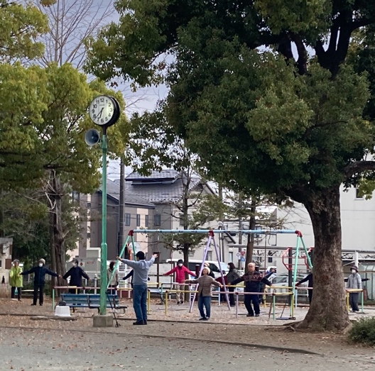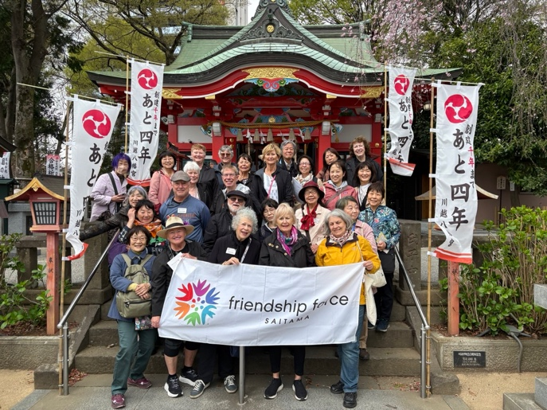

By 9:00 our FF group was walking through the residential streets and neighborhoods of the Kawagoe district to visit three very different shrines and temples: Hachimangu Shrine, Nakain Temple (small, serene gardens, quiet earth tones—no reds or gold here), Kitain Temple (large temple with ornate historic interiors and landscaping, cherry blossom lined grounds with vendors, and “Buddha Garden”).

And then we stopped for lunch. Shoes off and chopsticks out for a traditional Japanese lunch featuring some local sweet potato specialties at a lovely traditional restaurant.

After lunch we toured a small soy sauce factory and then spent the rest of our afternoon exploring Kawagoe’s Kurazukuri Zone (“Little Edo” area) with its bell tower, local festival museum, and charming shops along streets which preserve the style and feel of small town Edo period Japan. On display at the Kawagoe Festival Museum we saw massive 8-meter tall “floats” that are part of their annual October celebration which goes back 370 years and now has UNESCO Cultural Heritage designation. I thought about how the US is about to celebrate its 250th birthday! We’re such kids compared to Japan!

I think we all easily made 10,000 steps without even having to really try today!
Ann Besser

April 1. Outside the evening was cool and rainy. That didn’t dampen our spirits. Inside we stepped into a room with a stunning vista of the city at night, where the air was alive with laughter and the warmth of friendship – a celebration of our time together.
Upon arrival, each US ambassador was presented with a memento from our Calligraphy lesson-a keepsake scroll adorned with the unique Japanese symbol each of us had learned to draw. Although our gracious hosts praised our calligraphy skills, we suspected, with a smile, that Toyoko, the Saitama Club Master Calligrapher, had made some much-needed touch ups.
When dinner was announced, we made our way to a buffet table laden with traditional Japanese delicacies enticingly displayed. There was Soup, salads, rice, sandwiches, raw fish, assorted sushi, and Japanese sweets for dessert. In true Japanese style, the colorful raw fish and sushi platter was a work of art. At our tables, wine and beer flowed freely. We toasted to memories, laughter and friendship.
Throughout the evening there were heartfelt speeches, thank you’s and hugs. Each ambassador was introduced by their host(s), invited to say a few words about their experiences in Saitama, and given photos of themselves dressed in Kimono or Samurai attire posing with their hosts.
When it was time for entertainment, our group sang “Let There Be Peace”. What we lacked in vocal ability, we made up for with a sincere wish for a peaceful world. Our Saitama hosts entertained us with the lively song and dance, the Saitama Samba. We all joined in the fun.
As the party wound down, a spontaneous chorus of “Old MacDonald” filled the room. The playful and varied animal sounds brought more laughter. This lighthearted finale was a fun way to conclude our time together.
April 2. It was time to start our tour with UME. Here is a summary of the itinerary.
Day & Date | City | Activity
D1  Thu, April 2,2026 | Saitama-Hakone | 10:30 Pick up at Omiya Station Rotary.  Drive to Hakone, visit West Lake Village, Yamanashi Prefectural Fuji Mountain World Heritage Center, Yamanakako Hana no Miyako Park.
D2  Fri, April 3,2026 | Hakone-Kyoto | Hakone Full Day Tour  Visit Owaku-dani Valley, Lake Ashi, Hakone Sightseeing cruise, Hakone Shrine.  After tour, transfer to Odawara Train Station, take Shinkansen from Odawara(18:07) to Kyoto(20:12).
D3  Sat, April 4,2026 | Kyoto | Arashiyama Full Day Tour (Visit Kinkaku-ji Temple, Togetsukyo Bridge, Sagano Bamboo Forest, Tenryu-ji, Arashiyama Park.
D4  Sun ,April 5,2026 | Kyoto | Kyoto Full Day Tour Visit Japanese Calligraphy Experience, Nishiki Market Food Experience, Hanamikoji Dori, Japanese traditional culture performance.
D5  Mon, April 6,2026 | Kyoto-Osaka | Nara and Fushimi Full Day Tour Visit Sanjusangendo, Fushimi Inari Taisha/Red Torii Gates, Nara Park.
D6  Tue, April 7,2026 | Osaka | Hiroshima Full Day Tour  Osaka Train Station, take Shinkansen from Osaka to Hiroshima.  Visit Itsukushima Shinto Shrine, Hiroshima Peace Memorial Park, Hiroshima Peace Memorial Museum, Atomic Bomb Dome.  After tour, back to Hiroshima Train Station, take Shinkansen from Hiroshima to Osaka,
D7  Wed, April 8,2026 | Osaka | Osaka Full Day Tour  Visit Kema Sakuranomiya Park, Osaka Castle, Osaka Museum of History, Namba Yasaka Shrine, Dotonbori.
D8  Thu, April 9,2026 | Osaka(ITM)Fukushima  NH3179/FW079  11:00-12:05 | Transfer to Osaka International Airport for flight to Koriyama.

April 9. We left Osaka and said farewell to our guide, Gary. We then flew to Fukushima, where our hosts picked us up and took us to a cafe for lunch. We enjoyed a great meal of soup and sandwiches at the cafe, which was connected to a park. After lunch, we walked through the park to see the cherry blossoms before returning home with our hosts for a rest. Carol Nasby

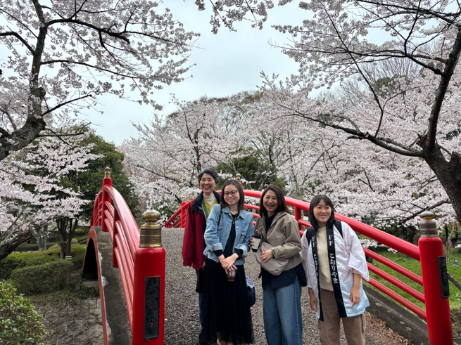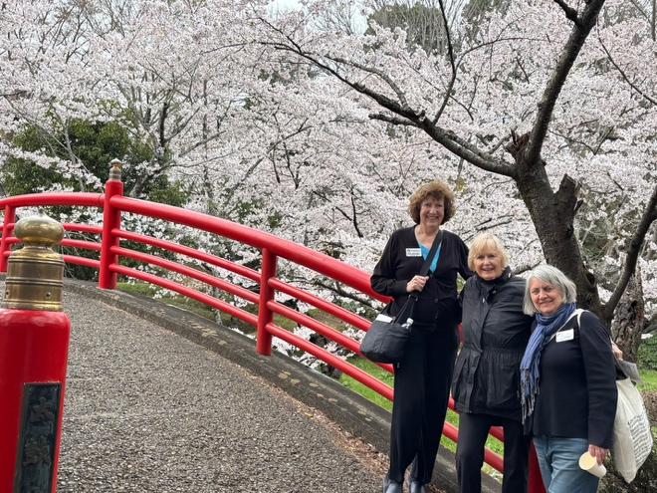

April 10. Nothing was scheduled until 11 letting the host and ambassador decide how to spend their time. Terese and I are staying with a host that has many talents, pianist, potter, and ballroom dancer are just a few. We spent the morning taking a neighborhood walk discovering rice paddies amidst the condos and houses. Then being shown the studio across the street where Masumi teaches piano, the pottery she has made as well as the awards and pictures from ballroom dancing. We ended with a visit to her husband and son’s car inspection and repair shop, Hashimoto Diesel, which is next to their house.

Others reported:
- Stayed home and relaxed
- Went to supermarket
- Looked at cherry blossom trees and shrines
- Visited Miharu dam
Hosts and ambassadors gathered together for lunch at Sarara in Miharu town where we enjoyed a Japanese natural food buffet focusing on fresh vegetables. Christine Allen

April 11. We gathered at a community center to learn how to make Japanese sweets, experience a tea ceremony, and have a bento box lunch. Sensei Kamiyama, a certified master in the art of making Wagashi (a Japanese sweet) taught us in this Japanese Cultural Experience. Some of us had our picture in a local newspaper!

We were all the “main guests” of the Tea Master for a Tea Ceremony Experience of the Edo style.

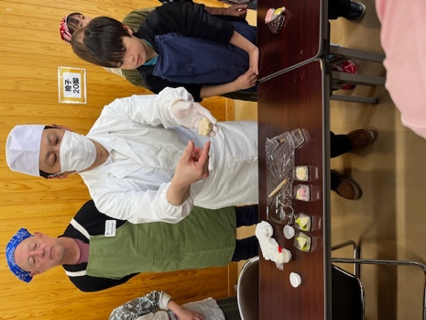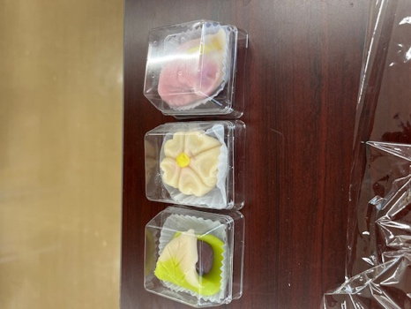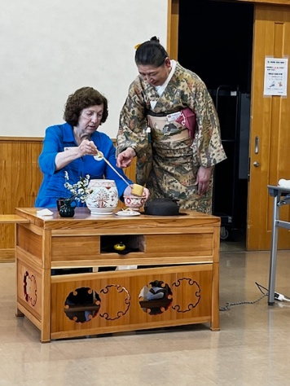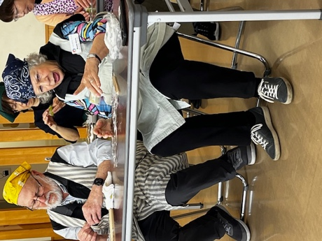

April 12. Today we drove by bus for 1.5 hours north to Aizu to see Tsurugajo Castle. The historic castle is in the samurai town of Aizu (Aizuwakamatsu), Fukushima Prefecture, Japan. This castle is famous for its distinctive red roof tiles and its role in the Boshin War in 1868. It was originally built in the 14th century (1384) and the current 5 story structure was reconstructed in 1965 and houses a museum with artifacts and exhibits. The top floor offers panoramic views of the city and Mt. Bandai. We ate lunch at a restaurant on the castle grounds and got to shop in the large souvenir store on the premises. There were many beautiful cherry blossom trees (sakura) on the castle grounds.
After lunch we traveled by bus for another hour to Ouchijuku Village, also in Fukushima Prefecture. This quaint, thatched roof village flourished during the Edo period as an important post town on the road connecting Aizu and Nikko Japan. People still live and work here in small shops in their homes. There was a shrine and a nice overlook of the town at the end of the street. Specialty of the town was soba noodles eaten with a leek/green onion instead of chopsticks.

We headed back to Koriyama afterwards to get ready for the farewell dinner at the Koriyama View Hotel. There was a program and multicourse dinner. Many toasts and thank yous were made to our wonderful hosts. Guests told of things they had learned about Japan and Koriyama. The Koriyama FF Club did a dance and we took a group photo. We also had a slide show of photos taken while here. It was a wonderful way to end our trip to Japan. Gail Lucht

April 13. Our hosts drove us to the Koriyama station for our Shinkansen trip to Haneda airport. We all got on the same car (except Ann, who remained in Koriyama to continue her journey) for the fast train to Omiya station, where a couple of Saitama hosts met us to guide us to the train to Hamamasutcho station and then to the monorail to our terminal at the airport. Time to fly home!

