GREATER DES MOINES JOURNEY TO BIG CANOE/NORTH GEORGIA
OCTOBER 28 TO NOVEMBER 2, 2021

Twelve members of Friendship Force Club of Greater Des Moines and one member of the Cedar Rapids/Iowa City Club Journeyed to Big Canoe /North Georgia on October 28, 2021. Not all members of the North Georgia club lived in Big Canoe. Some members lived in communities within a 30-mile radius of Big Canoe. Our members stayed in homes in Big Canoe as well as the cities of Jasper, Cummings, Waleska, and Canton, Georgia.

We were in this region for 5 fun and exciting days. This visit was filled with a number of interesting activities each day. Members of the Friendship Force Big Canoe/North Georgia Club were very friendly, kind and enjoyable. Our time there provided us with knowledge of the history, culture, and geography of the area. It was truly a learning experience, but one mixed with memories of a warm and inviting people. Ginny Renda

Day 1: We finally get to travel. Nine members of Friendship Force of Greater Des Moines and one member of the Cedar Rapids club left the Des Moines airport at noon for Big Canoe, Georgia. This is the first time in over two years we have travelled anywhere. We are staying with members of the Gorgia club. They are all vaccinated, and we are all vaccinated, which made this journey possible.
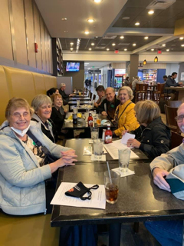 | 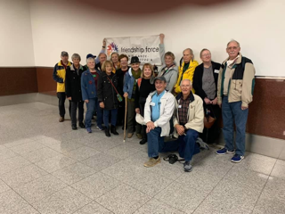 | 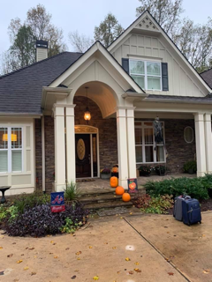 | 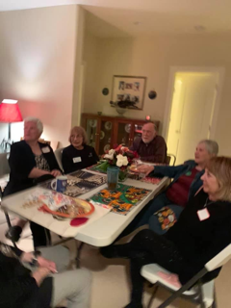

Des Moines Airport Atlanta Airport Welcome Dinner at home of Sherry Wileman and
Dan Hunsberger

Big Canoe is about an hour north of the Atlanta airport, so several Georgia members came and picked us up and shuttled us back to Big Canoe. We had a Welcome Party at the home of Sherry Wileman and Dan Hunsberger. It was a potluck with lots of wonderful southern cooking. Members enjoyed themselves. We had cheese grits with shrimp on it, shredded roast beef sliders, greens, squash casserole, pimento cheese dip/spread, cheese straws, Mac and cheese, salads, fruit and pecan pie. The Welcome Party was wonderful, and we are looking forward to a very fun-filled and interesting week. Marla Carr

Day 1: Nearly all the ambassadors flew to Atlanta. We made the journey a road trip, stopping on the way in Metropolis, Illinois, to see the big statue of Superman, spending a day touring Chattanooga, and visiting family and friends in the Atlanta area.

The welcome party was held at Sherry Wileman and Dan Hunsberger’s home in Canton. We learned that the members of the Big Canoe-North Georgia club live across a wide area. Canton was somewhat central, which made it easy for the hosts and ambassadors to get to the host homes after the party.

Sherry introduced herself. She had expected people to arrive at 6, but the people who flew in arrived at 5 (not knowing that, we were the last people there when we arrived shortly after 6. She talked about the southern food that club members had made for the buffet supper to follow soon. And there was a lot of it. Then she introduced Bob Anderson, the club journey director and co-coordinator of the journey, who was our host along with his wife Peggy.

Bob introduced the other co-coordinator, Tim Anderson (they made sure to let us know they are not related), Bob introduced Ginny and thanked her for her work as Ambassador Coordinator. Then he went over a change in itinerary due to the cool, wet weather expected the next day. We are all hoping predictions for warmer, dryer weather on the weekend really pans out.

Then it was time for the buffet dinner. Pimento cheese spread, cornbread, cheese grits, shrimp (cooked plain or with bacon), shredded beef sandwiches, several salads, pecan pie and more. Nobody went away hungry. People sat at several small tables, each with some hosts and some ambassadors. We got to learn a bit about each other.

Before we went to the host homes, pictures were taken of ambassadors with their hosts. Then we went out into the dark, damp night to take the drive along winding roads to Bob and Peggy’s (and Tate the dog’s) home in Big Canoe. Ronda and I stayed up late talking to Bob and Peggy. We learned about their family, how they got to Big Canoe, and the club. We knew immediately that we would enjoy our time as their guests. It was a good start to the week. Mike Davis

DAY 2: The morning began with breakfast at 8:00; eggs, bacon, fruit, and bagel, with our hosts, Peggy and Bob Anderson. Bob and Mike left to get Gibbs Garden tickets while Peggy and I prepared for the day. Then it was time to go to Chateau Meichtry to set up for lunch. But first we made some stops. We stopped at Burt’s Pumpkin Farm to see what was left of the pumpkin patch. We visited Hillcrest Orchards, where we bought apples and fritters. Then we were off to the Chateau.
We had a private screened and heated patio for our group. Lunch was giant turkey or chicken salad sandwiches, chips, mint Oreos, and delicious peanut butter cookies made by Peggy. Most of us then participated in a tasting of the Chateau’s wines. Some of us shopped inside at the winery. Everyone seemed to enjoy the event.
On the way back to the Anderson’s, we stopped at the Wright Agri-Tourism Farm Store. They sold meats, cheeses, jams, and candies and more, all locally produced. We had time for a bit of a rest after arriving home before going to a dinner hosted by Lance and Sharon McCoy at their home in Big Canoe. We were with Ginny and Carmie and their hosts. We were offered caramel apple mules to go with a beautiful appetizer spread of meats, cheeses, and accompaniments, followed by a delicious chicken and wild rice soup and a salad with apples, cranberries, pepitas, and walnuts. The Fall themed dinner carried through with a dessert of caramel tres leches cake. We bid our fabulous hosts goodnight and returned home to chat a while with Peggy and Bob before turning in. Ronda Davis

Day 2: Brunch with our hosts Tim and Lenna Anderson and Huw and Marie Williams. Good food and fellowship, what a good way to start our day. Following brunch, we wound our way through beautiful scenery to reach Chateau Meichtry for lunch and wine tasting. The rain did not deter us from having a wonderful time. We ate chicken salad and turkey sandwiches, chips, apples cookies, and, oh yes, Moon Pies in the enclosed, heated gazebo. We tasted wines made of local and imported grapes and learned the history of Chateau Meichtry and the art of wine making from one of our hosts, Wes. Many of us could not resist taking a bottle of wine home.
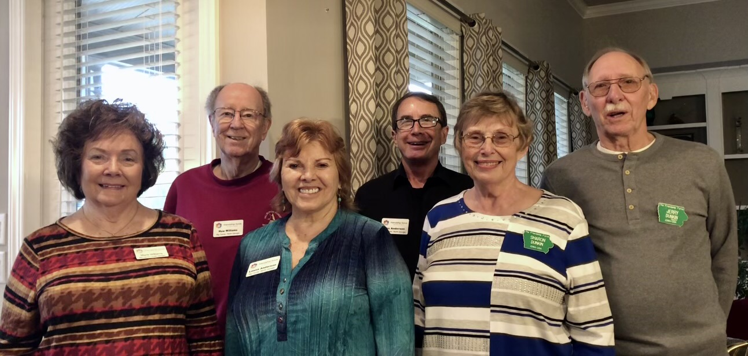 | 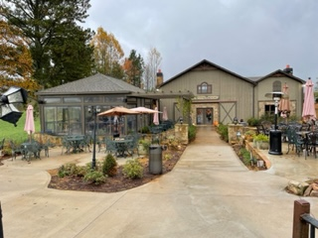 | 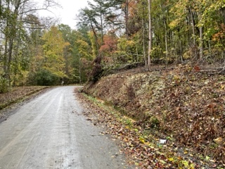
Hosts Tim and Lenna Anderson and Chateau Meichtry Beautiful Countryside
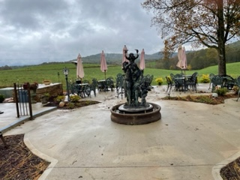  Rain, rain, go away | 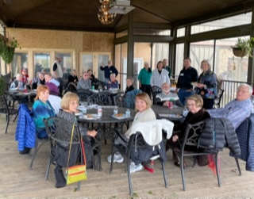  Good food | 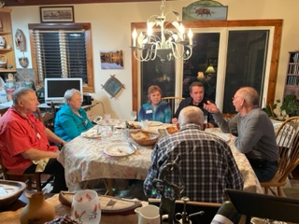  Good fellowship
In the evening Tim, Lenna, Tom Ficht, Jerry and I ventured to Big Canoe for dinner with Barry and Linda Kudechuk. Their home is right on the lake so we braved the rain to get a picture of the beautiful view. We ended the day as it began with good food and new friends. Sharon Dunkin
Day 3: Today will be an education day spent at two entirely different museums; starting at Reinhart University, a small private collage in Waleska, GA, with an art driven curriculum. Here you find the Funk Heritage Center and the story of the “Trail of Tears”. After an impressive video of the history of the indigenous natives of the southeast, we were off to explore in more detail how these Indians managed during the destruction of their tribes and lifestyle.
As history tells the story, Army General and American President Andrew Jackson reversed an agreement with the Native American Indians of the Cherokee, Chickasaw, Choctaw, Creek and Seminole, all of the “Cherokee” Nation, to keep their land and their own government, forcing all into a lifestyle of complete confinement. The “Trail of Tears” started in Georgia and ends in Oklahoma either by waterway or a northern land track over many years of travel. Nothing like this has happened in American to this extent. A little-known fact. . .if you had 1/8th Cherokee blood on your mother’s side. . .you were considered to be “Cherokee”. One of those persons, Will Rogers!
Within this center is the largest tool museum assembled. The Smithsonian could not find adequate space for it so decided the collage and museum would be its caretaker. One man’s collection over a lifetime. Our afternoon exploration led us to Cartersville, GA, and a guided tour of the Booth Western Art Museum. An impressive modern building on immaculate grounds with large western bronze art outside. As one enters the museum for the tour by well experienced docents the two murals at either end of the main building were massive. Titled “Stamped” and “Burial on the Range”, they were completed by Henry Jackson, a student of Jackson Pollock?
We continued through two floors of western art to include bronze sculptures, paintings in oil, watercolor, charcoal and acrylic. Named the #1 art museum of Western Art, it is affiliated with the Smithsonian. From named artists and sculptures to “new age,” the collection is diverse and many times “ah-inspiring” with beauty, techniques and enormity as the mural “Red Butte with Mountain Men”, by L.M. Dixon. Whether it be the smallest or largest bronze statue of Native American Indians, or cowboys on the range, they are all beautifully expressed by the talent of the many artists worth viewing may times over.
A surprise gallery was the Presidential Gallery where each President has donated a signed letter for display at the Booth Western Museum. One would expect a museum like this to be in a more “western state”, but luckily Georgia has this jewel! Our evening was completed by a “take-out-dinner” shared by our hosts in the comfort of their home sharing our experience of the day and watching the “World Series”, with the Atlanta Braves! Nancy Lundstrom
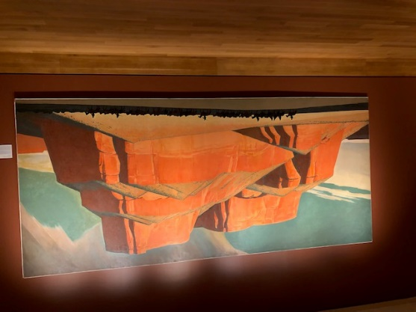 | 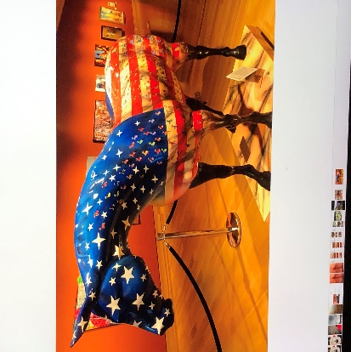
Booth Western Art Museum
Day 3: Nancy, Steve, and I shared the same Host Home and the rest of our group were hosted there for the Welcome Dinner. So, everyone enjoyed the same hospitality that the 3 of us had for our stay. It was great fun getting acquainted and sharing stories of ourselves and our families.

Nancy has already given a full day's review of what we did and where we went. The Funk Center with its "Trail of Tears" was a repeat for me of my Oklahoma City Friendship Force Adventure. Our trip to OK City Indian Museum shared the same story and a video of the Cherokee Nation as well as all the other similar Indian Tribal Stories of being driven from their homes.
The afternoon trip to the Booth Western Art was very interesting with its wide range of modern art and its association with the Smithsonian Museums of D.C. It was amazing and surprising to see all the famous well known artists' work on display. I could have gone back for another afternoon stay since our time seemed to be cut short. "All's Well that ends Well". Our day ended with a relaxed fun Gourmet take out dinner at home, then having a nightcap while cheering the Braves to Victory. Beverly Lytle

Day 3: Happy Halloween! Sunshine, blue skies, some clouds and crisp temperatures found our group touring Gibbs Gardens located in Ball Ground, GA. Advertised as “Seasons of Color”, we are visiting in November, at the height of the fall color of Japanese maples, tall yellow maples, green willows and the last of the annual colors for bedded plantings. Also, so many tree specimens we cannot grow well in Iowa! There was “Monet’s Waterlily Garden”, lilies blooming in pink, white and purple, terraces of wildflowers, ferns lining the walkways, all in a 300+ acre public garden. It was a joy to capture all the extreme colors of mountain fall.
Our afternoon was spent whiling time away on Lake Sconti in Big Canoe in pontoon boats watching for eagles, hawks and other flighted birds to take roost on the island in the middle of the lake. While three boats (powered by electricity) leisurely cruised the lake with their attendees sipping wine and more wine. . .we enjoyed the peaceful setting nestled in the high mountains of northern Georgia. With the hustle and bustle of four days of exploring this area, taking time to enjoy nature and the beauty around was worth the wait like… “cruising down the river on a Sunday afternoon”. (Somewhere there is a song in that)!
Our late afternoon into evening celebration was shared by all with a pizza party at the Big Canoe Lodge! Sitting next to the lake with views mile high, we enjoyed pizza, salads, desserts and costumes by some celebrating the “Halloween Day” and continuing to build friendships with the Big-Canoe-North Georgia clubs. Steve Lundstrom

Day 4: Our afternoon was spent on Lake Petit in the communtiy of Big Canoe. Three pontoons, wine, snacks, beautiful scenery, and great friends – what more could we ask for! We ended out day with a pizza party at the Big Ccanoe Lodge. We then spent 2-3 hours at Gibbs Gardens - 336 acres of landscaped gardens. Beautiful, but impossible to describe, so I'll just include a few photos. Marty Novak

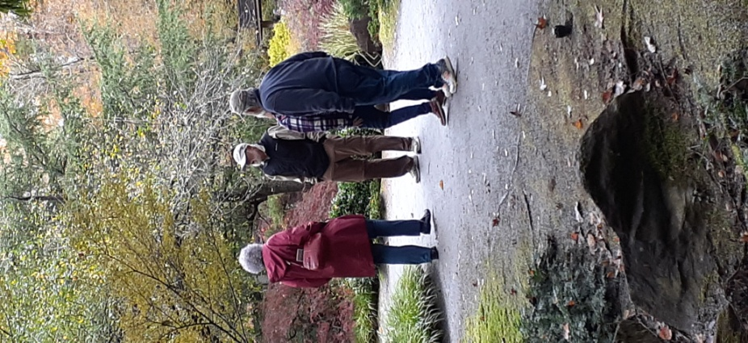 | 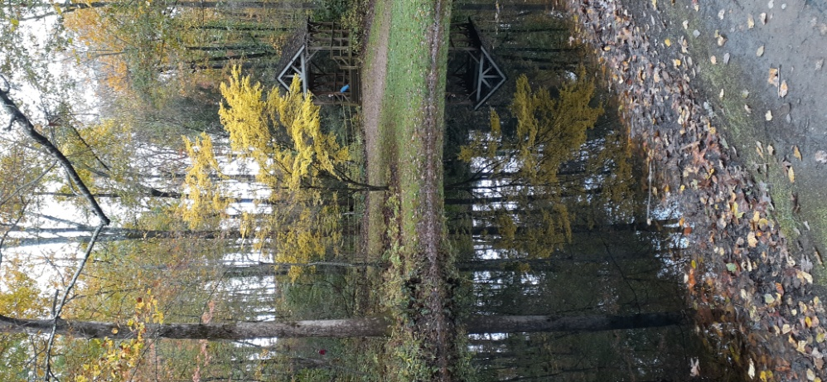 | 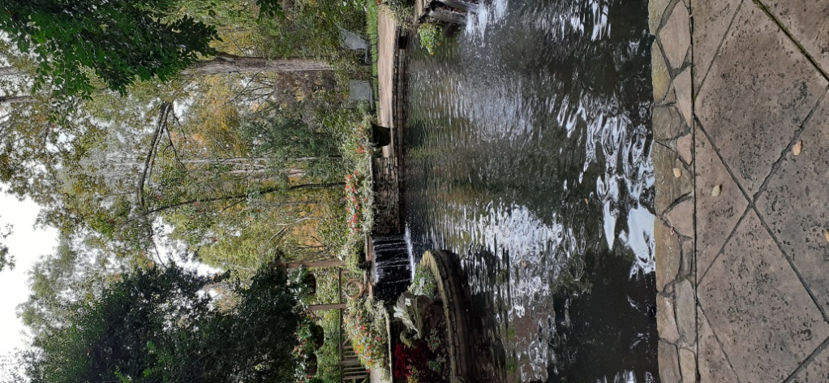 |  | 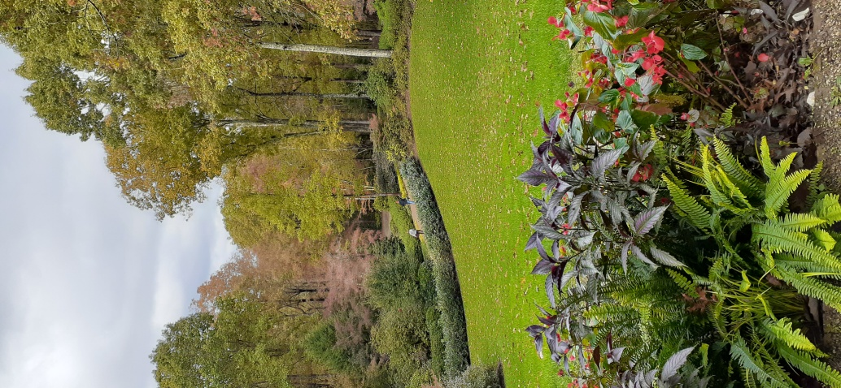
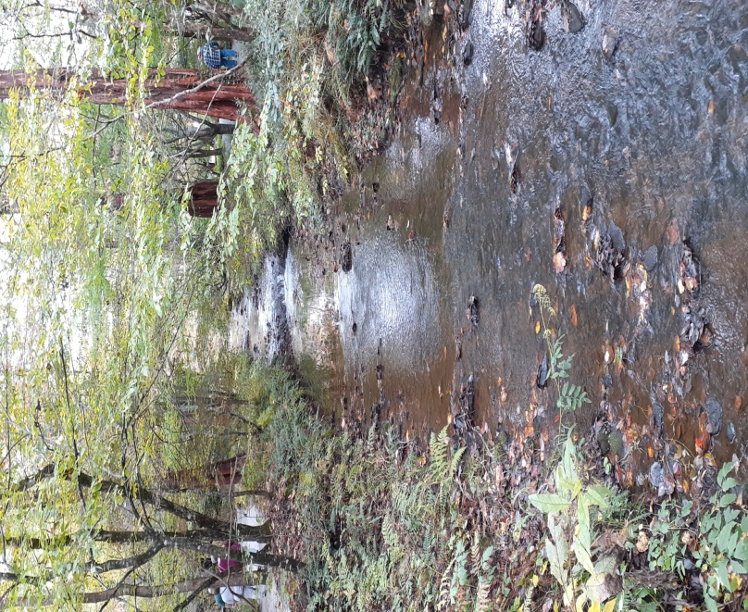 | 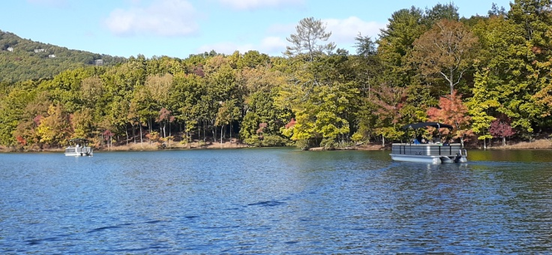 | 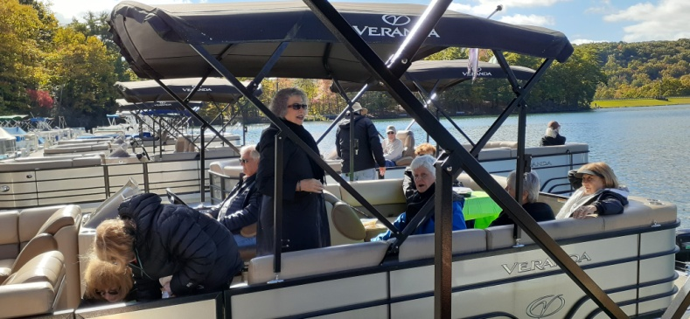 |  | 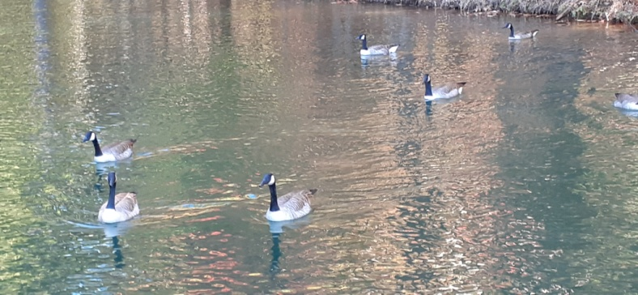
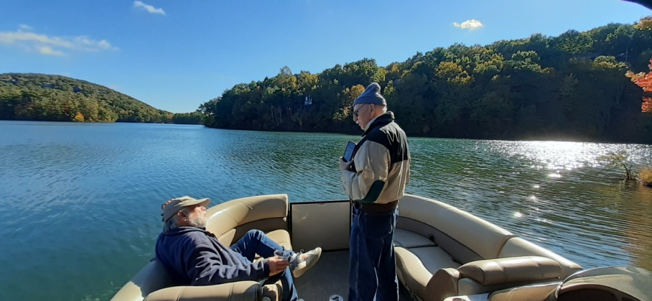 |  |  | 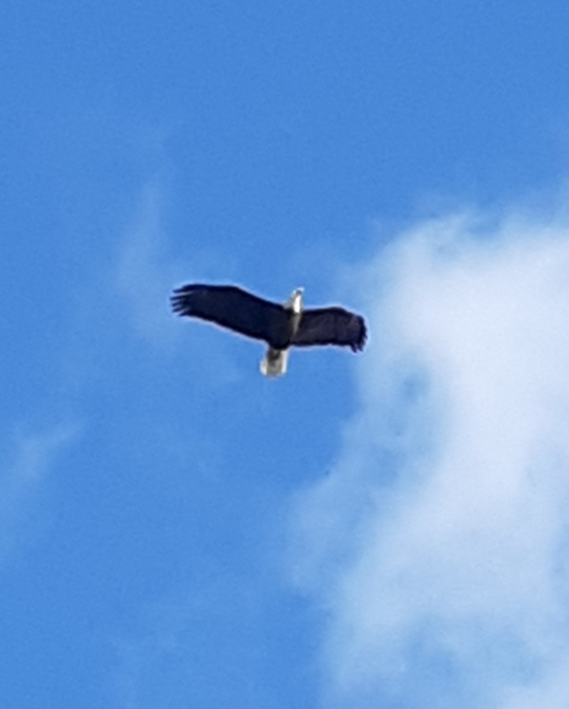
Day 5: We left the house at 9:30am. We went to Amicalola Falls State Park. Visited the Lodge, Falls and hiked steps and trails. Well, Ginny hiked steps and trails. Phil, Jeannette and I stayed at the Lodge and waited for Ginny to finish her hike. We went to Dahlonega; a great little town. The Town square had lots of shops and restaurants. We had lunch at 19 Degrees North. Great food nice people. Ginny and Jeanette went shopping and Phil and I people watched. We came back to the house and off we went to a Friendship Force farewell dinner at West Milford Farm. Very tasty. All the Des Moines People said a little about Des Moines. Some said a lot. After dinner we got to watch or join in on Square Dancing. We were watchers. The dancers were great. It was a lot of fun to watch. This was our last event at Big Canoe. Carmie Renda

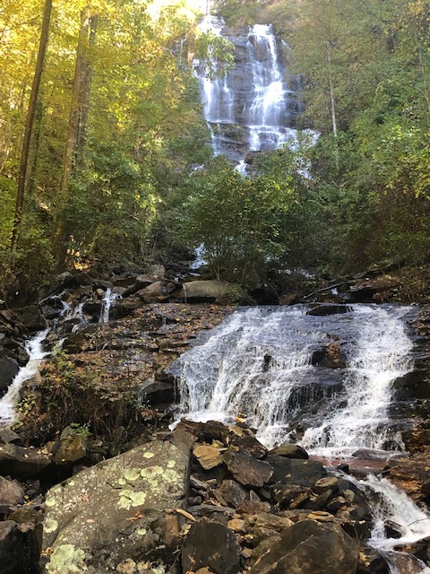 | 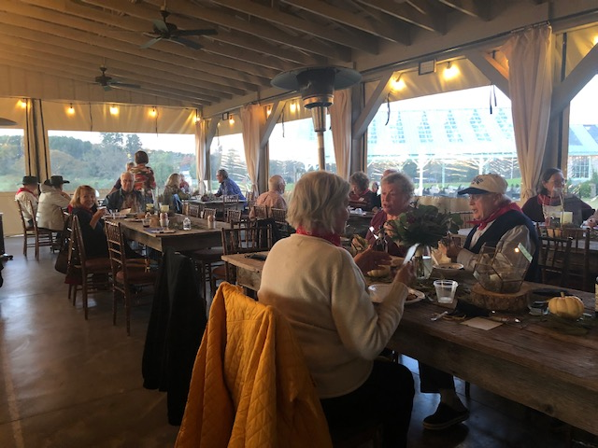  Farewell Dinner | 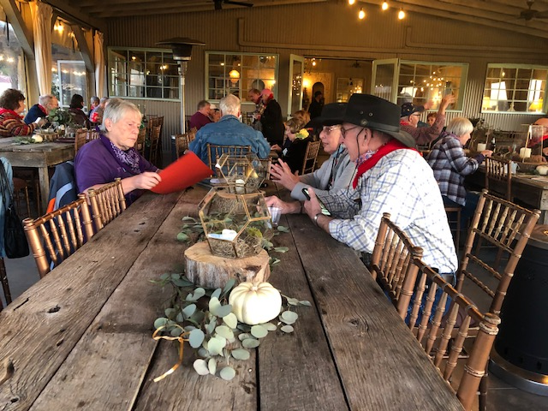  Farewell Dinner
Amicalola Falls
Day 5: We met the group at the Amicalola State Park Visitors Center to weed the sheep from the goats. The few stalwarts decided to climb and then descend what we were told were the 640 steps which paralleled the waterfall. Wimps like me drove up to a viewing area at the top of the falls, which were in fact impressive.
Pat Headley and I, driven by our intrepid host Diane Briscoe, grabbed a burger so we’d have time to visit the Etowah Indian Mounds State Park, which we agreed were reminiscent of the Mayan pyramids we had seen in Mexico. We visited the small museum there and climbed (once more) to the top of the main mound.
The farewell dinner that evening was held at West Milford Farm, an event center out in the boonies. The theme was country, and we were all sporting the bandannas that came in our gift bags. The scrumptious buffet included pulled pork and chicken with a variety of barbecue sauces and ended with a blueberry cobbler. Each Des Moines ambassador spoke about some attraction here, as we’re hoping the Big Canoe folks will visit us next May. Pat Westphal

Day 5: I was impressed by the incredible hospitality of our hosts. What I found amazing was the vast geographical territory their club covers. There was never a dull moment. Actually, there was hardly an empty moment. Despite all the driving of more than 250 miles, there was plenty to see and do. Several have mentioned the food, and it was splendid; including the fat, tasty homemade chicken salad sandwiches. We saw everything from wineries to massive gardens, museums, waterfalls, a lake, and an extensive hand tool display.
What really impressed me was the thought that went into making the welcome bags. Each item except the bandana was reminiscent of Georgia. Its contents were apples, homemade candied cinnamon pecans, a small jar of Georgia peach preserves, a Reese’s peanut butter pumpkin bar, salted peanuts, and a small bag of walnuts with dried cranberries. Non food items included a Big Canoe ink pen, a club pin, a homemade greeting card in the shape of Georgia, a Georgia map, various brochures, and of course the bandana for the farewell BBQ and square dance.
As I watched the film at the Trail of Tears exhibit housed in the Funk Center at Reinhardt University, I learned some new things about the Cherokee. Our government considered them one of four “civilized” tribes because they dressed and lived quite a bit like non-Indians. Still, the government marched them 200 miles away from their homeland, thus killing many of them on the way due to the harsh conditions. The “Tools of the Trade” exhibit, is also housed at the Funk Center. Most of the hand tools in the collection are made of wood and other natural materials. It’s easy to see the influence of university art students in the arrangement of each panel.
At Amicalola Falls, two of us, Jerry Dunkin and I, hiked the mountainside rather than the steps to get to the top of the waterfalls. It took a bit over an hour with one three-minute rest stop, and we clocked three miles, according to my phone’s health app. The journey was successful in so many ways, as is witnessed in this journal. I can only hope we can impress our Georgia friends as well, when they visit us next May. Pat Headley
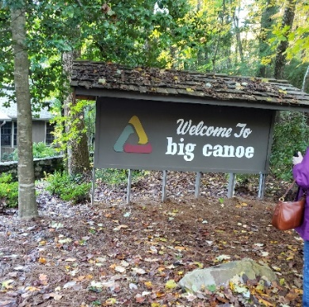 | 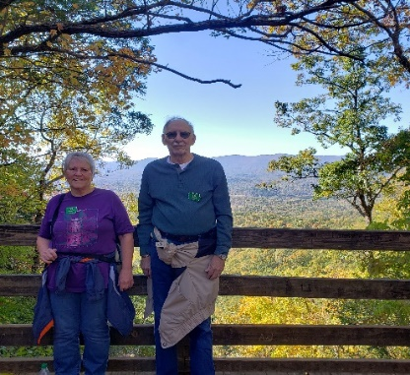 | 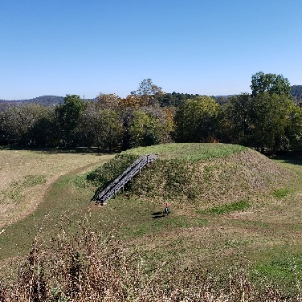
Club Name At the top Etowah Mounds
