2021 FFGDM Activities  (Dates and activities subject to change) |  |  | RSVP to join Friendship Force at…  The Path to Paradise  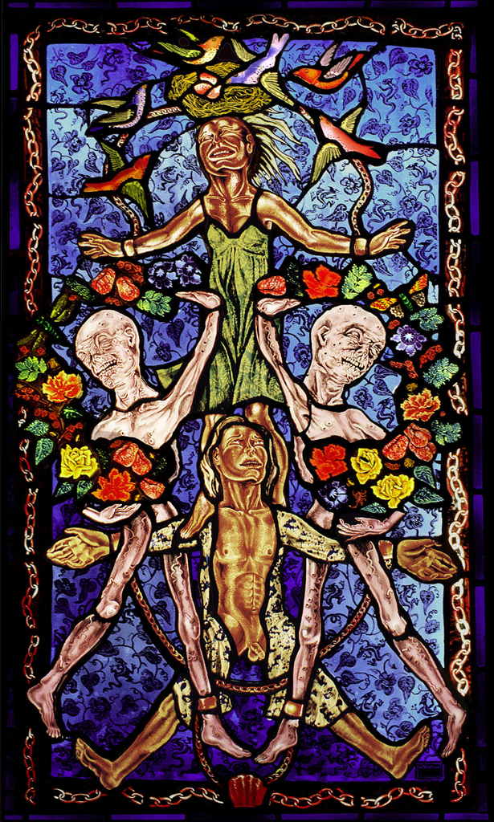  Tuesday, May 11  1:00 pm  Des Moines Art Center  The stained-glass panels, drawings, and process of the artist  Judith Schaechter, titled The Path to Paradise, will be on display  in the Meredith Gallery.  Ms. Schaechter’s artwork has been on exhibition in a number  of prominent museums in the United States and Canada. Dark subjects such as death, violence, and romance are included in  the 45 panels of stained glass.  If you would like to attend this activity with Friendship Force,  email Ginny Renda at grpbears@aol.com
May 11 |  | Visit to Judith Schaechter’s stained glass exhibit at the Art Center.
May |  | Small Group Socials
June |  | Small Group Socials
July |  | Small Group Socials
Aug |  | Small Group Socials
Sep 17-23 |  | FF Dayton inbound
Sep 19 |  | All Iowa FF picnic
Oct 28 – Nov 1 |  | FF Big Canoe outbound
2022
April TBD |  | FF Knoxville outbound
May TBD |  | FF Nova Lima & FF Paracicaba, Brazil, outbound
TBD |  | FF Ottawa inbound

Our club has continued to host at
least one activity a month within
covid guidelines. Please check your email regularly so you don’t miss out.
President’s Message
Hello Friendship Force Members and Friends,
Here we are a full year plus, into what has been challenging to say the least. I think we’ve done quite well, despite all the closings, restrictions, exciting new face wear, and a demand for more creativity than ever before. We’ve all had that dream where we suddenly find an extra room in our house we never knew was there. It might have a regular sized door you just open and walk through, or a scrunched-up-crawl-through-on-your-knees-door. But there it is, as big as life, and yet how did we not know it was there? I think this past year was like that room. Opportunities popped up we never knew were there, or we simply failed to notice, because we didn’t need to. How many of you developed a new hobby, or pastime, or skill, or developed new ways to be slovenly? My morning shower sometimes happened at 4:00 p.m., and only then because I had someplace to be. I once attended a retirements party where the guy was asked what his plans were. “Well, there’s always the garage,”
he said. In my case, there’s still the garage.

This year, we will walk, crawl, run, or leap into new possibilities. We will explore that extra room. We’re tired of waiting for the world to correct itself so we can move on. I think Ralph Waldo Emmerson said it best. “What lies behind us and what lies before us are tiny compared to what lies within us.” I think also that surprise spare room represents our resilient character, and we have demonstrated plenty of that. I don’t intend to burden you with too many quotes but must share this one as well. I found it in the Aug/Sept 2020 issue of AARP The Magazine (p28), where Kimberly Langford is also quoting the “World Happiness Report.” “The key to finding happiness during this time is not through social distancing but rather through distance socializing.” Well, holy buckets, we’ve done plenty of that too, wearing masks and doing what we needed/wanted to do to stay connected.

As this year moves forward, I hope you’re all ready to break out of any lingering isolationist paradigms and get on with being a club, participating in so many activities it makes our head spin. I’m proud to be part of a group who can roll up its sleeves and say, “well, now what,” and watch that group make things happen. And it wasn’t just one person doing all this planning. So many members stepped forward to provide what they could to come up with ideas for outings, tours, visits, picnics, and small groups. Thank you for being such a great group to work with. Perhaps we will see each other soon at a large event.

In Friendship,
Pat Headley
FFGDM Co-President

 | FFI News
Friendship Force & COVID

Earlier this year, FFI encouraged clubs to develop policies regarding COVID and a return to club activities and travel. At our Midwest Leaders meetings, we have discussed this and several clubs are working on guidelines, just as we have.

The FFGDM board selected a committee to study, discuss, and develop guidelines for when we can get back together in large groups. The board has already seen these. It's now time to share with you. You can read the Guidelines on the following page. – Pat Headley and Ginny Renda

“Man cannot discover new oceans unless he has the courage to lose sight of the shore.”
– Andre Gide
FFGDM COVID–19 Guidelines
April 2021

Our first responsibility as a nonprofit organization is the safety of our members, guests and ambassadors who travel to our city and stay in our homes. As such, we are taking all necessary precautions as we look forward to welcoming Friendship Force members back to club activities. To allow this to happen safely, all members will be required to offer proof of an FDA approved COVID 19 vaccination. If members or guests have medical /religious reasons preventing them from getting vaccinated, a doctor’s note or related documentation substantiating that should be provided to the Friendship Force Club. This should not list the diagnosis. These individuals will be required to wear a mask.

Much is unknown and, in the future, we will follow official CDC guidelines in determining additional steps we should take and whether we need to revise our COVID 19 Policy.

Ambassadors: Outbound and Inbound
- All ambassadors are required to be fully inoculated with the Covid-19 vaccine at least 14 days prior to a journey. This would include a booster if CDC/Scientists determine it is needed.
- All ambassadors will be required to provide proof of vaccination before the start of a journey and must have received both doses of the vaccine if recommended by the manufacturer. This would include a booster if CDC/Scientists determine it is needed.

Hosts:
- All hosts are required to be fully inoculated with the Covid-19 vaccine at least 14 days prior to Ambassadors arrival. This would include a booster if CDC/Scientists determine it is needed.
- Hosts will be required to provide proof of vaccination before Ambassadors arrive.
- Provide liquid hand soap for frequent hand washing and hand sanitizer in a couple of different areas of the home
- Provide paper towels for hand drying in a multi-person bathroom.

Club Activities:
- All members and guests are required to be fully inoculated with the Covid-19 vaccine at least 14 days prior to a large group activity, including a booster if CDC/Scientists determine it is needed.
- All members and guests will be required to provide proof of an FDA approved COVID 19 vaccination.
- If members or guests have medical /religious reasons preventing them from getting vaccinated, related documentation substantiating this should be provided to the Friendship Force Club. This should not list diagnosis. These individuals will be required to wear a mask.
- All members and guests will wear a mask and adhere to social distancing as required by any Organization/place of business that the Club is visiting.

If you have any questions, concern or are unable to receive the vaccine, please contact Ginny Renda at grpbears@aol.com or Pat Headley at headleypatricia651@gmail.com who will strive to keep personal information as confidential as possible.

Journey News

Journey Director’s Report  We have some great news about journeys in 2021 and 2022. Assuming  the pandemic continues to recede and we feel comfortable traveling, FFI has confirmed journey matches.  We have confirmed that on September 17-23 of this year, we will host a visit from the Dayton club. Marla Carr is our Host Coordinator—thanks, Marla. Marla has started working on a plan and she needs members to volunteer for committees. Contact her at marlakcarr@yahoo.com.  We are excited that we will journey to Big Canoe, Georgia, October 28-November 1. The Big Canoe community is north of metro Atlanta. They have told us this is a great time to come, as the trees will be changing color. We are looking for one or two volunteers to be ambassador coordinator or co-coordinators.  You might recall that we hosted the Knoxville club a few years ago and  had organized a return visit to them last spring before it was cancelled  due to the pandemic. Now we get to complete the exchange by taking a journey to Knoxville in April 2022. Shelley Bain will resume the position of Ambassador Coordinator.  Our club journeyed to Ottawa, Canada, in 2019. They were scheduled  to come here in 2020. We were excited to learn that they are matched  to come here in 2022. Once we set a date, we will ask for a volunteer to serve as journey coordinator. This was a great group of people, so it will be wonderful to host them.  Our final 2022 match is to go to Nova Lima and Paracicaba, Brazil. We were scheduled to go to Brazil in 2020. We’ll be in touch with those  clubs to discuss possible dates, but it might be a while until everything is confirmed.  If you have not been a journey coordinator, or it’s been a long time and you feel a bit rusty, we have a coordinator training program and manual available to journey coordinators. In addition, we have experienced coordinators who can assist or mentor you if you wish.  A portion of the cost of the journey for coordinators is covered under our coordinator earned seat reimbursement policy.  If you have any questions, please contact me at 515-491-1954 or mjdavisconsulting@gmail.com. – Mike Davis, Journey Director |  | Wanted  Journey Coordinator for  Big Canoe Outbound  October 28 – November 1, 2021  Big Canoe is an 8,000-acre gated mountain community just one hour north of Atlanta, Georgia. It’s located between Jasper and Dawsonville and has about 3,000 residents. Nearly one-third of the total property has been set aside as wildlife areas and parks.  Journey Coordinator for  Ottawa Inbound  2022 – TBD  Ottawa is Canada’s capital, in the east of southern Ontario, near the city of Montréal and the U.S. border. Sitting on the Ottawa River, it has at its centre Parliament Hill, with grand Victorian architecture and museums such as the National Gallery of Canada, with noted collections of indigenous and other Canadian art.  If you have any questions or want to volunteer to be journey coordinator, please contact  Mike Davis at 515-491-1954 or mjdavisconsulting@gmail.com.
 | Club Activities

Small Group Socials  Small Group Socials were so popular last year, we’ve decided to do it again this year, or at least until we can begin meeting in large groups again. The first one will be in late May and continue through summer. Groups of 6 or so people will meet in each other’s back yard, patio, deck, garage, park or wherever we can still do distance socializing.  We do need HOSTS. This person will call/email the people on their assigned list and announce the place and time to meet. These meetings can be with or without food/drink. All participants will bring their  own lawn chair.  If you are interested in joining, please email Mary Marshall at dpmmgm@msn.com by May 10 and tell  her the following information: 1) I want to be in a small group and 2) I will host and which month (May thru August). |  |  | Tour of the Civic Center  Members and guests toured the backstage of the Civic Center on April 27. This was a great opportunity to learn the nuts and bolts about a venue most of us know by attending the Des Moines Symphony or a touring musical or concert. Did you know our own Cathy Jensen and Lee Ann Bakros are Supervisors? Members Nikki Hubbard and Anita Lindfield also work there and Pat Hipple is a volunteer.  Thanks to Marla Carr for coordinating this activity.  FF Walking Club  On March 13, the FF Walking Club walked around the Sherman Hill Neighborhood after the tour of Hoyt Sherman Place. I was able to point out the location of Friendship Force’s former office.  We'd like to invite you to join us on future walls and hikes. To be added to the club contact list, please send your email to me at skyhicathy@q.com.  -- Cathy Jensen
Tour of Historic Hoyt Sherman Place

Twenty-one members and guests took a tour of Hoyt Sherman Place on Saturday, March 13. The tour concentrated on the new 3-story brick box that was built to facilitate performers with spacious dressing rooms, bathrooms, and equipment loading areas. There are also new offices for staff and two multi-purpose or reception rooms.

The office suite included posters from many of the concerts held at Hoyt Sherman Place Auditorium and members could reminisce about attending a concert, lecture, or dance troup. The next concert is Jazz in July: Amina Figarova Group on July 13.

While there, members could view the 113th Annual Women’s Club Art Exhibition which was held the same week. Thank you to Dee Willemsen for organizing this interesting activity.

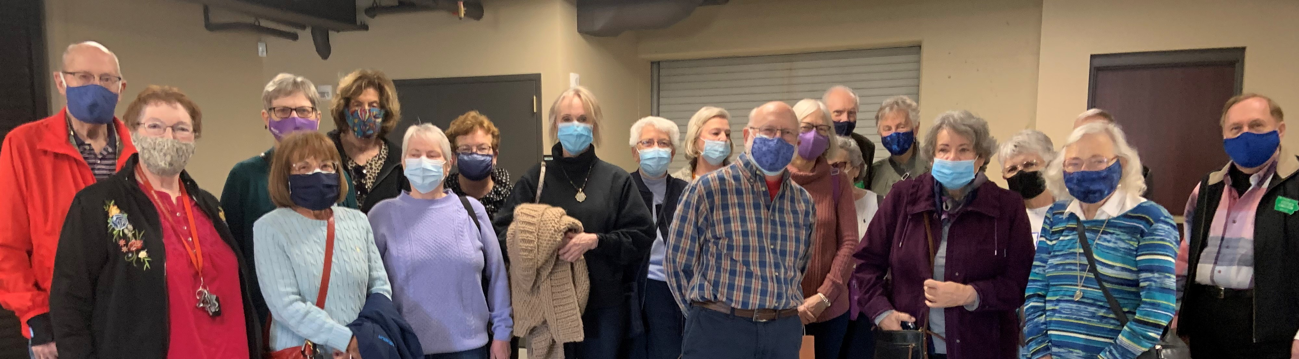 |  |  |  |  | History lesson: The Hoyt Sherman Neighborhood dates to 1850 when Hoyt Sherman purchased five acres of land for $105.  Sherman was Des Moines’ first postmaster and the brother of Civil War general William Tecumseh Sherman.
Book Friends

Book Friends continues to meet via Zoom. Murder in an Irish Pub by Charlene O’Connor was discussed in March and Daughter of the Reich by Louise Fein was discussed in April. We meet the fourth Monday of each month. Any member who would like to join may contact me at nihubbard@aol.com. – Nikki Hubbard
2021 Selections
Month | TITLE | AUTHOR |  | HOST |  | NOTES
May | The Unlikely Adventures of the Sherrill Sisters | Balli Kaur Jaswall |  | Connie Walters |  | India
June | The Magical Strings of Frankie Presto | Mitch Albom |  | Nikki Hubbard |  | World travels
July | Next Year in Havana | Chanel Cleeton |  | Ronda Davis |  | Cuba
August | Temple of a Thousand Faces | John Shors |  | Mary Marshall |  | Angkor Wat
September | My Dear Hamilton | Stephanie Dray &  Laura Kamoie |  | Ginny Renda |  | U.S.A.
October | Each member brings a book to recommend and summarize
November | Beantown Girls | Jane Healey |  | Alice Rasmussen |  | WWII Red Cross
December | Curious Charms of Arthur Pepper | Phaedra Patrick |  | Nikki Hubbard |  | World travels

Membership News

Our sympathy to the family of former members  Ella May Quiner  2/8/27 – 3/29/21 |  |  |  | Marla Carr – May 12  Elese Johnson – May 14  Cathy Jensen - May 15  Chuck Kilpatrick – May 16  Pam Sadler – May 16  Sharon Fisher - May 18  Anita Lindfield – May 20  Beverly Lytle – May 21  Jane Escobar – May 23  Karen Selby – June 1  Ron Grohe – June 8  Isabella Hurless-Banks – June 17  Lee Ann Bakros – June 16  Elaine Bredesky – June 21  Ronda Davis – June 24
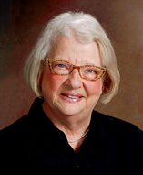 | Betty Wise  1/17/27 – 3/5/21  and  Jim Wise  9/26/1927 – 3/10/21 |  | 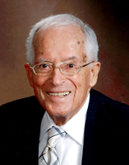
Betty was very active in Friendship Force for many years and served in various capacities, including club President.

Jim was a co-founder of our club and served as club President among other roles. He was also on the Friendship Force International Board of Directors for the three years and was honored as FFI’s Volunteer of the Year.

Betty and Jim were involved in many community organizations but their contribution of time, skills, and passion for the Friendship Force Mission helped establish our club over 40 years ago. We are grateful for their long lives well lived.

Their obituaries can be found at Betty Wise and Jim Wise.

New Member
Cindy Reitz
sarapique@centurylink.net
Show & Tell

If you wish to share a your personal milestone or accomplishment or want to brag on a child or grandchild, or share something that makes you happy, please send your news (photo optional) to shelleybain@centurylink.net. Thank you to Christine and Pat for their contributions this issue.
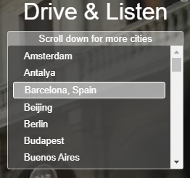  FF Cedar Rapids-Iowa City member Christine Allen shared this fun website for travelers who are not able to currently travel.  Drive & Listen takes you on a virtual car ride through cities of the world. For each city, viewers can opt to listen to their choice local radio stations, with or without street noise, and can control the speed of the car. There are 53 cities starting with Amsterdam and Antalya and ending with Yekaterinburg and Zurich. Be patient, it takes the video a few seconds to load.  https://driveandlisten.herokuapp.com/ |  | 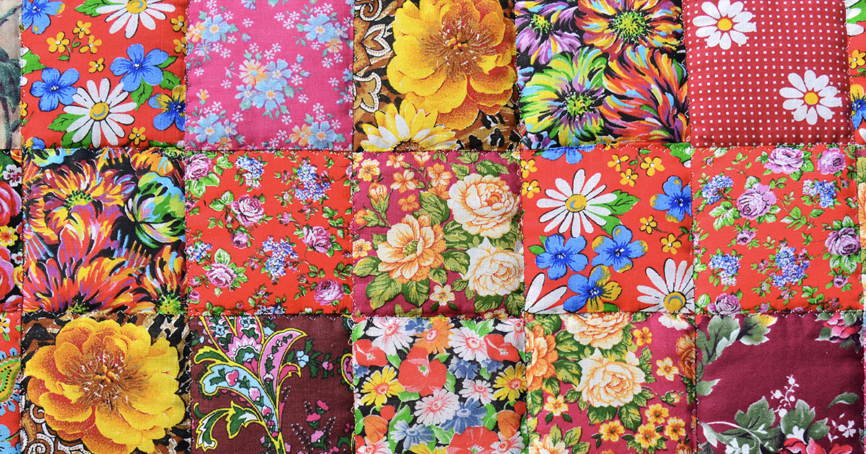 |  | My Story  by Pat Headley
One of my stories has been accepted by an online publication called Months To Years. My story, called “Saying Goodbye”, will appear in their Spring 2021 issue.

The mission of Months to Years is to cultivate a beautifully designed online space to showcase compelling, original creative nonfiction and poetry (as well as art and photography) that explore mortality and terminal illness. Founded in 2017, we publish a digital magazine quarterly. We periodically update our site to post new writing that is eventually compiled into the quarterly digital magazine.

Facebook: https://www.facebook.com/monthtoyearslit/
Instagram: https://www.instagram.com/monthstoyearslitmag/
Webpage: https://www.monthstoyears.org/ or https://www.monthstoyears.org/saying-goodbye-2/

Former Member Committee Report

The board requested that a committee be formed to contact former members to find out if they might be interested in rejoining Friendship Force. The committee formed consisted of these members: Elaine Bredesky, Cathy Jensen, Nancy Lundstrom, Alice Rasmussen and Francis Youngblut.

The committee met 4 times. We made a list of all previous members back to 2009 that were not members now, and then added names from contacts that Nancy had from her 40th anniversary list. Some of these names were called, some names were eliminated because of known health problems and other situations, and letters were sent to the remaining names on our list.

We have had 4 members so far that have sent in their membership form and dues. We are thrilled to have them back. If any of our current members know someone from previous years that might be interested in rejoining, please contact one of these names above or just bring them to an event! --- Alice Rasmussen

Member Roster

The updated 2021 Member Roster was emailed last week. Please keep it on your device or print a copy for your use. Let me know at off4ever@aool.com if there are any corrections. --- Alice Rasmussen

2021 FFDGM Board and Committee Chairs

Board Members | Term ends | Email
Pat Headley – Co-President | 2023 | headleypatricia651@gmail.com
Ginny Renda – Co-President | 2023 | grpbears@aol.com
Mary Marshall - Vice-President | 2021 | dpmmgm@msn.com
Janette House - Secretary | 2021 | j.house@mediacombb.net
Barbara Bailey – Treasurer | 2023 | dcblbailey@gmail.com
Marla Carr – Activities Committee Co-Chair, Dayton Journey Coordinator | 2022 | marlakcarr@yahoo.com
Mike Davis – Journey Director | 2021 | mjdavisconsulting@gmail.com
Gail Sheridan Lucht | 2022 | gail.lucht@gmail.com
Connie Walters - Book Friends Co-Coordinator | 2022 | yourfriendconnie@gmail.com
Other Committees and Tasks
Shelley Bain – Newsletter Editor |  | shelleybain@centurylink.net
Nikki Hubbard – Book Friends Co-Coordinator |  | nihubbard@aol.com
Cathy Jensen – FF Walking Club Coordinator |  | skyhicathy@q.com.
Nancy Lundstrom – Activities Committee Co-Chair |  | nancylundstrom@mchsi.com
Cookie Major – Community Service Coordinator |  | cookster50@gmail.com
Alice Rasmussen – Membership Chair |  | off4ever@aol.com

International Friends

June is wedding season in the United States, but we can celebrate wedding traditions around the world. This time it’s…

Some French Wedding Traditions

Instead of bridesmaids and groomsmen, French couples have témoins or "witnesses" that stand next to them during the ceremonies and sign the wedding registry. After the civil ceremony at city hall and, in some cases, a religious ceremony, the wedding party and dinner begin, which can easily last up to 5 hours.

The livret de famille booklet is a civil registry that a mayor issues to a couple upon their betrothal. Used for legal purposes, it contains the couple's marriage certificate, birth
certificates, passports, and other documents. The livret de famille legalizes the marriage and is both mandatory and a strong symbol that shows you're now creating your own family. It's used your whole life.

Le cortège refers to the act of the groom and groom's mother escorting each other down the aisle. Similar to American custom, the father of the bride accompanies his daughter down the aisle once the groom has arrived at the altar.

Everyone looks forward to the wedding cake ― a croquembouche (croque-en-bouche) consisting of choux pastry puffs filled with creme patissiere, piled into a cone shape, and bound with threads of caramel.

After the long wedding celebration, guests might wake up the sleeping newlyweds and feed them onion soup.

Membership Application

FFGDM membership dues cover a calendar year, January 1 through December 31.
Mail membership application and check to: FFGDM, PO Box 13136, Des Moines, IA 50310

Name _________________________________________________________________________

Street__________________________________________________________________________

City_______________________________________ State___________ Zip__________________

Home Phone ____________________________ Cell Phone _____________________________

Email ____________________________________________ Birthday MM and DD for newsletter _____ /______

Individual Membership at $35 per person ($30 if you join at your first event) | $
Newsletter mailed to you (rather than through email) at $12 per year | $
FFGDM name badge at $16 | $
Select fastener type: pin ______ magnet ______
Select one: green Iowa shape ______ rectangular with FFI logo ______
If ordering a name badge...Print your name as you want it to appear on the badge – max of 22 letters. |__|__|__|__|__|__|__|__|__|__|__|__|__|__|__|__|__|__|__|__|__|__|
Contribution | $
Total | $

Check as many as you like, but please check at least one activity you will help with -
□ Activities Committee | □ Journey Coordinator |  Inbound Journeys activities
□ Board Member (future) | □  Newsletter Editor | □ Day Hosting
□ Community Service | □  Photographer | □  Farewell Party Team
□  Entertainment/Speakers | □  Speaker’s Bureau | □  Host Coordinator
□  Financial Audit | □ Social Media | □  Home Hosting
□  Fundraising | □ Treasurer (future) | □ Planning Team
□  Greeter at events | □ Website | □  Small Dinner Hosting
□  Historical/Archiving | □ Other | □  Welcome Party Team
Please list a skill or interest you have, not listed above, that you are willing to share.
___________________________________________________________________________________
Friendship Force of Greater Des Moines is a 501(c) 3 nonprofit organization.
Your contribution may be tax deductible to the extent allowed by law.

