Journey #14212 - Des Moines to Perth and Auckland
Daily Journal – Part 9

Day 5 Itinerary – A day around Dunedin and Otago Peninsula.
I can organize for you to visit Larnach Castle, Olveston House, Toitu Museum and the botanic gardens, if you want. We will go to the Albatross Colony and hopefully the Yellow eyed penguin colony. Penguin numbers have dropped significantly and are threatened with extinction despite much effort to save them. There are entry cost for most of these activities which I will establish before you come. We will see the historic railway station and the world’s steepest street. Dinner and accommodation is as the previous night.

November 2 - Kathie
Just two days left until we leave New Zealand for home: While we are hankering for our own beds and, for me, my little dog Ozzie, we still have time for more exploration of New Zealand’s South Island. This is a place of immeasurable beauty as Peter steers us down the road to new landscapes.

We depart the collection of steps with rooms attached called Motel on York in Dunedin (featuring both Boysenberry juice and Weetbix on the breakfast menu) on a cool, sunny day. Deb joins us after few days of solo travel. The Pacific Ocean harbor reflects shades of sylvan green vegetation, stone walls plus grazing sheep and cattle. The morning is quiet and and serene.

We are steadily climbing on Otago Peninsula to view the historic Larnach Castle and Gardens. Owned by the Barker Family since 1967, the owners have spent thousands of dollars refurbishing the picturesque Castle which was completed in 1874. Beginning with ruins, the Barkers completely refurbishing all the rooms including the library and drawing rooms. They continued rebuilding the main foyer including, a monumental staircase leading to the bedrooms and nursery. The spiral staircase then transports you up to the battlements with a view definitely worth the climb. The panoramic Dunedin scape reveals the curving harbor below. The formal gardens, including a rain forest, rock, a tapestry pattern, and South Seas garden encircle the Castle.

Next up came the Albatross Center breeding colony and educational center, plus peninsula encounters with a variety of wildlife. A short conversation about efforts to protect animals, land, and the environment interested us. Then we traveled back to Anzac Square, home of Anzac University and the Octagon university district in Dunedin. Peter pointed out the art center and museum as well as a line-up of restaurants attracting college students and tourists. We stopped at Ratbags to sample their famous pizza. I finished early to search out a money machine before we left.
After catching a glimpse of Baldwin Street, knowns as the steepest street in the world (no one in our group put its sharp incline to the test), we caught a quick glimpse of the Dunedin Railway Station, boasting furnishings and ticket windows from the past. A frieze of Royal Dalton porcelains runs around the inside top of the building and a mosaic of historic British Minton tiles covers the floor of the Booking Office. Outside you can board the Taieri Gorge Railroad for a four-hour train trip through the magnificent Gorge. Next, we spent about 45 minutes in the city’s Botanical Gardens before driving past the now unlocked HM Prison, open on Saturdays for tours. It is a rare example of a purpose built courtyard gaol.

To finish this marvelous day, we had plenty of time to browse the Toitu Otago Settlers Museum, tracing Dunedin city and Otago province history and population from the first explorers right up to modern times. It is an amazing house of treasures and stories, mysterious lights and haunting sounds. Wandering through you progress through time, transport and technology, experiencing the passage of migration, the gold boom period, Victorian Dunedin, and the Chinese influence.

We also had time for a good look at the Museum Shop, probably the finest collection of original souvenirs, gifts and take home items I’ve never seen anywhere in the world. About 5 p.m. we board our mini-bus and head for our last motel and dinner of the tour. This was a very special day.

The full group dined happily at the restaurant across from the motel once the deadening sound of the TV soccer game subsided. We slept well, anticipating the long plane rides home.

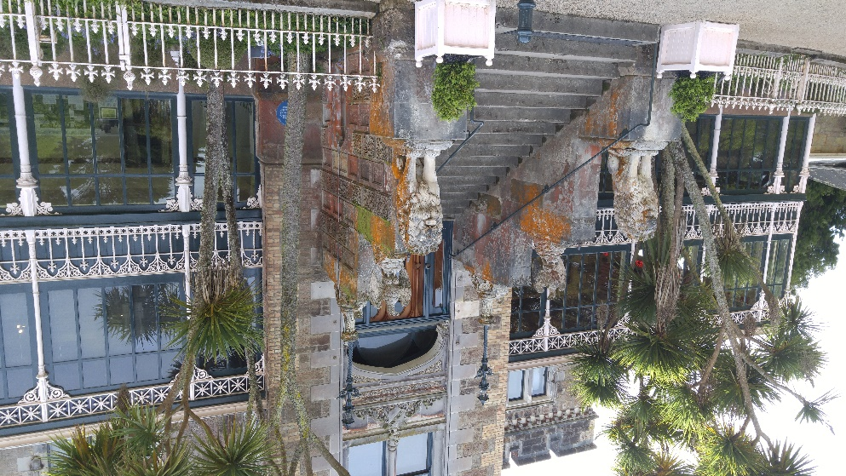 |  | 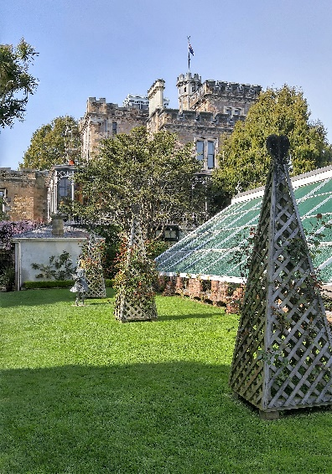
Larnach Castle and Gardens |  | Larnach Castle Glass House
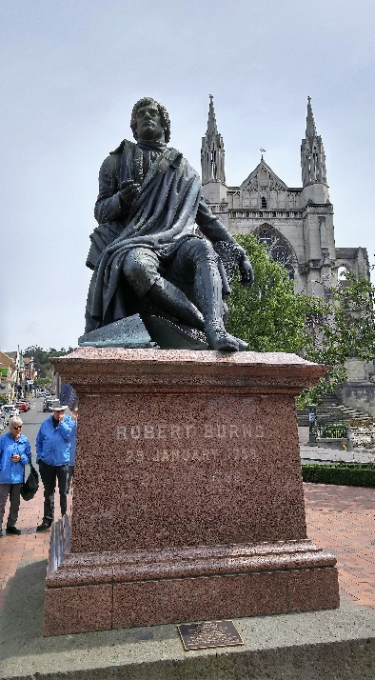 | 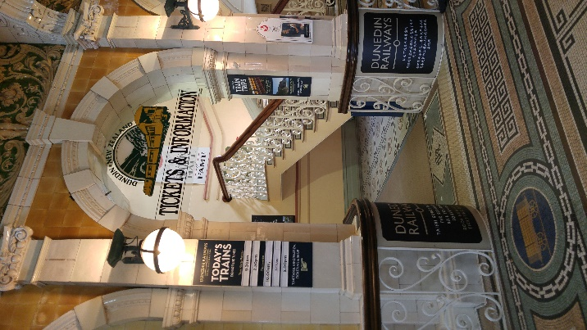 |  | 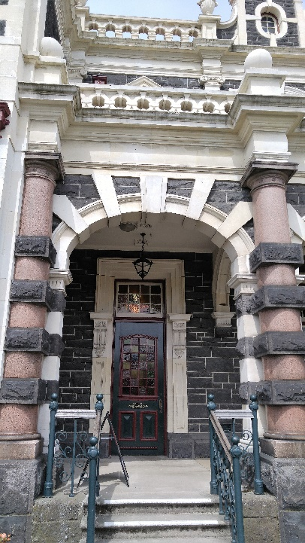
Robert Burns Statue in Dunedin | Dunedin Train Station |  | Dunedin Train Station

