Journey #14212 - Des Moines to Perth and Auckland
Daily Journal – Part 7

27th October – Auckland Program
We will visit Devonport and later take a ferry to Rangitoto Island for a trip up to the crater.

October 27 – Cherie
I was up in the middle of the night watching the full moon outside my bedroom window. Up around 8AM...my hosts, Pat and Don, are already up, getting ready for our trip today to Rangitoto Island: the newest volcano in New Zealand. We need snacks, water, wind breakers (or as Don says, "bring a jumper!).

Rangitoto means "blood red sunrise or sky", which the Maori called it 600 years or so ago, and getting there is quite the adventure: first, we met at the ferry dock where Margaret handed out sandwiches and cookies from Subway (this is a sacred FF ritual that was practiced by our hosts in Perth, too). Then it's a quick boat ride to the windswept island, where we were greeted by our resident Tour Guide, followed by a couple of hours bumping up the volcano in an open-air truck of sorts, pulled by his tractor. He told us the history of white people there: he explained how the "Bach" got its name (a term we had heard before, but without any explanation), and told of the endless killing of unwanted animals there who swam and continue to swim across from the other shore. There were thousands of laborers who worked with bare hands to build the road that we bumped along...imagine all the suffering there...

We stopped for our lunch break at the top of the volcano where we could see for miles around, before bumping back down to the ferry dock for the ride across the water and back home. The rain started, as we dropped off Margaret and Deb. Pat and Don and I went grocery shopping at a huge mall, then slogged home.

Today's trip to Rangitoto has been my favorite outing in Auckland so far...we have one more day to go...and it's been too cloudy to see the Southern Cross in the night sky, so far.

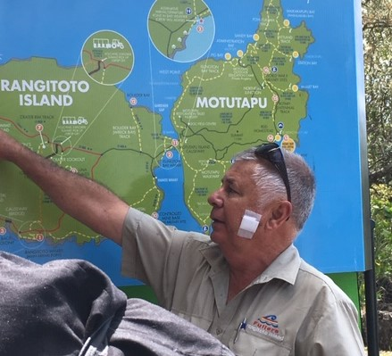 |  | 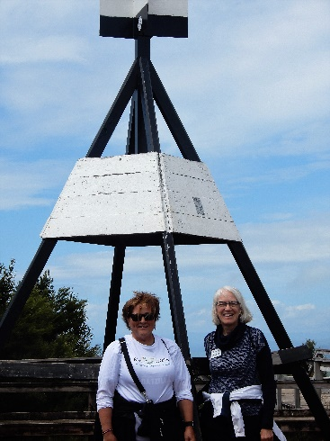 | 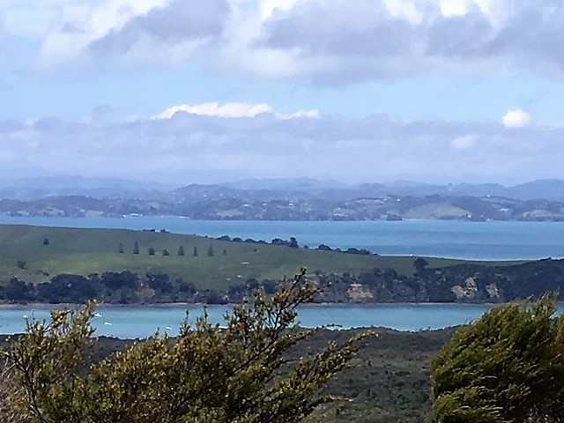
Ranger at Rangitoto |  | Jane and Mary at the top | View of Motutapu from Rangitoto
28th October – Auckland Program
Visit to local markets, time for some shopping at a Mall and our final and farewell meal at a restaurant on Cheltenham Beach (ambassadors treat hosts). Meal costs $35 NZ per person and a glass of wine $8 - lovely buffet Roast Meal in a beautiful setting.

October 28 - Claudia
This was a ‘free day’. Janet picked me up and took me and Mary Marshall to her Anglican, Holy Trinity Cathedral. The building recently went through a thorough remodel and was consecrated one year ago. It is a wonderful mix of old and new architecture that fits together perfectly. Old stone pillars and altar form a background for a modern wooden ceiling sanctuary with beautiful stained-glass windows and lots of chairs that can be arranged to suit the occasion. A huge brand-new organ was made in England and then installed in this Auckland facility. I was thrilled to hear it and the organist allowed me to play it after the service! A beautiful chapel with 3 glass walls and a VIEW was added to the other side of the ‘old’ altar.

Next to it is the old St. Mary’s which has been moved from across the street. It Is part of yet separate from the Holy Trinity building. I also enjoyed a piece of artwork showing a flat world map with Australia and New Zealand at the center top and the Northern Hemisphere on the bottom. What a different perspective of the world! We were invited to eat lunch with a group of believers after the service. What an enjoyable morning!

Then we went to the Auckland war memorial museum. One room was dedicated to women and their struggles to earn the vote and equality. Another part was about the first people here, the Maori. Historical originals and reproductions helped to explain parts of their history. We saw dinosaur bones and experienced a simulated earthquake and volcanic eruption. In front of this building is a display of 6,266 crosses representing each New Zealander who died during the Great War. This year marks the 100-year anniversary of Armistice Day.

We took time for a climb to the top of the hill to see the ‘disappearing cannons’ and the view and then on to the farewell dinner where a delicious buffet supper was served. Thanks for a lovely day and stay in Auckland, New Zealand!

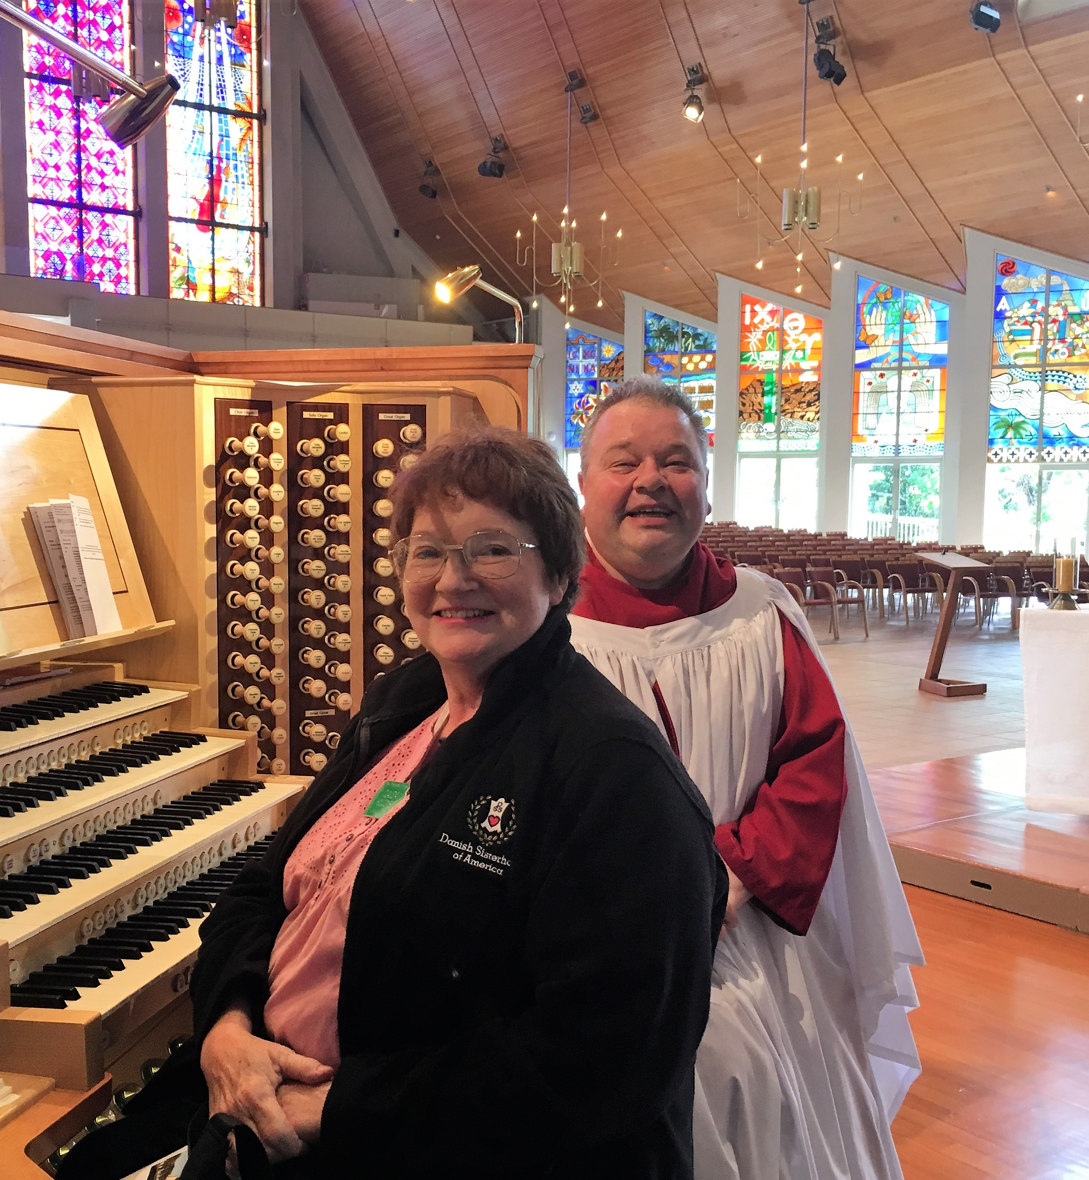 | 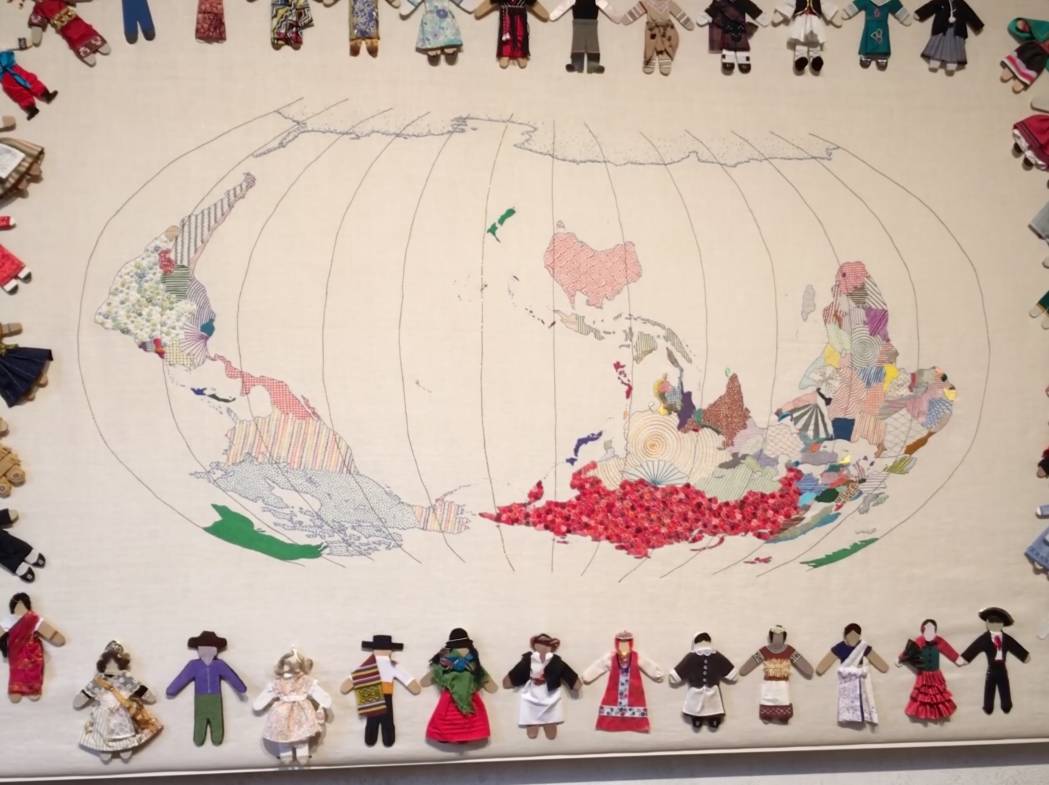 |  |  | 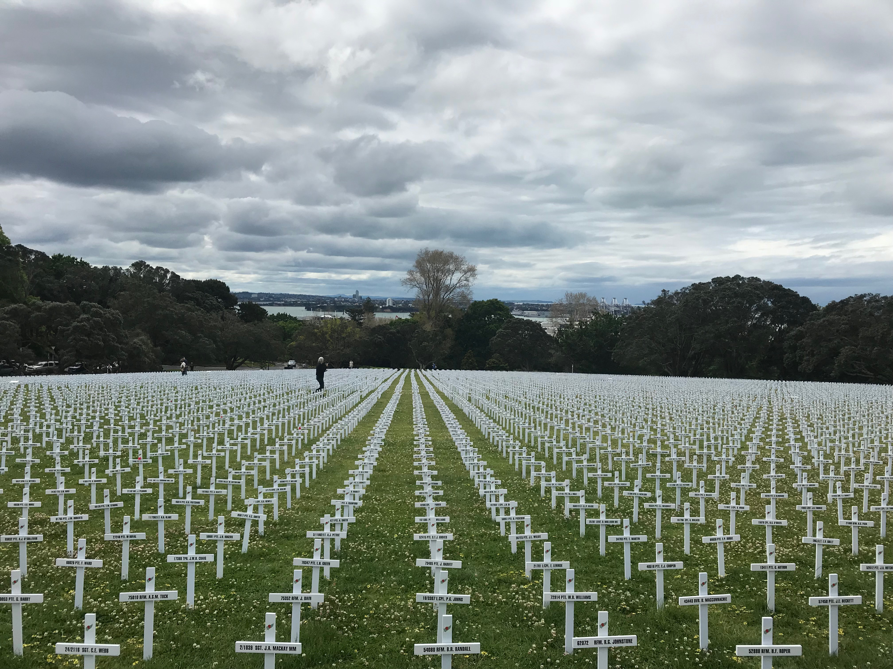
Claudia at Holy Trinity Cathedral | Upside down map |  |  | Auckland War Memorial museum
29th October – Auckland Program
Shuttle returns our Ambassadors to the Airport.

