Journey #14212 - Des Moines to Perth and Auckland
Daily Journal – Part 6

26th October – Auckland Program
Today we will head North to the Honey Centre, Sheep World demonstration, a Kauri forest and Museum, a Pottery tour and we will finish the day with a special stop on the way home.

October 26 - Charlotte
SWEET—DRY—WET—WOOLEY

Sweet: The day started with honey tasting and shopping at the Bee Center.

Dry: A pottery demonstration and shopping followed by lunch at the Morris and James Café.

Wet: Visited Pu Hoi Pub. Pu Hoi is a charming village settled by immigrants from Bohemia in 1805 who immediately built a Catholic church and a pub.

Wooley: Visited Sheep World where we shopped and saw a demonstration of sheepherding and sheep shearing.

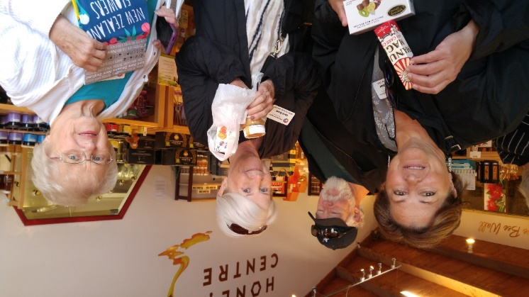 |  |  |  | 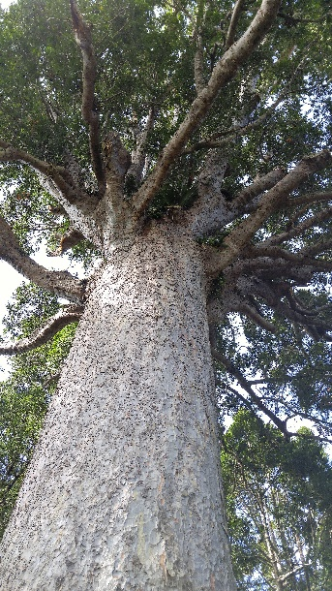
Jane, Jerry, Carol, and Janette at the Honey Center |  |  |  | Ancient Kauri Tree
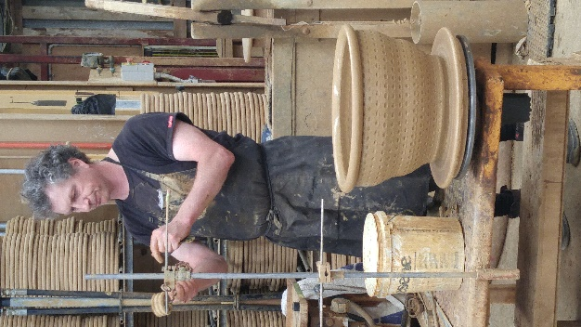 |  | 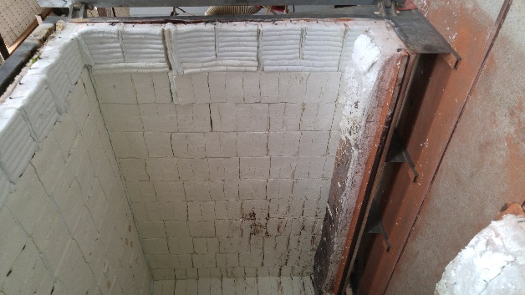 |  | 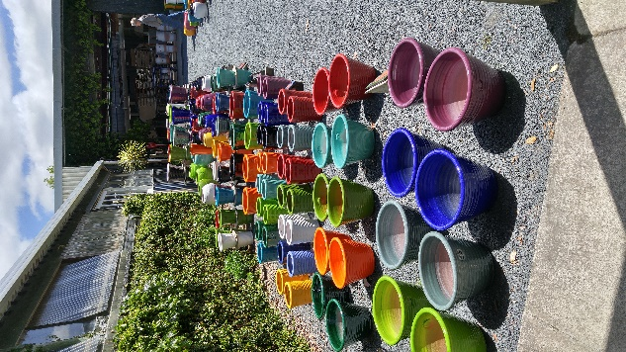
Potter at Morris & Jame Pottery |  | Drive in Kiln |  | The results
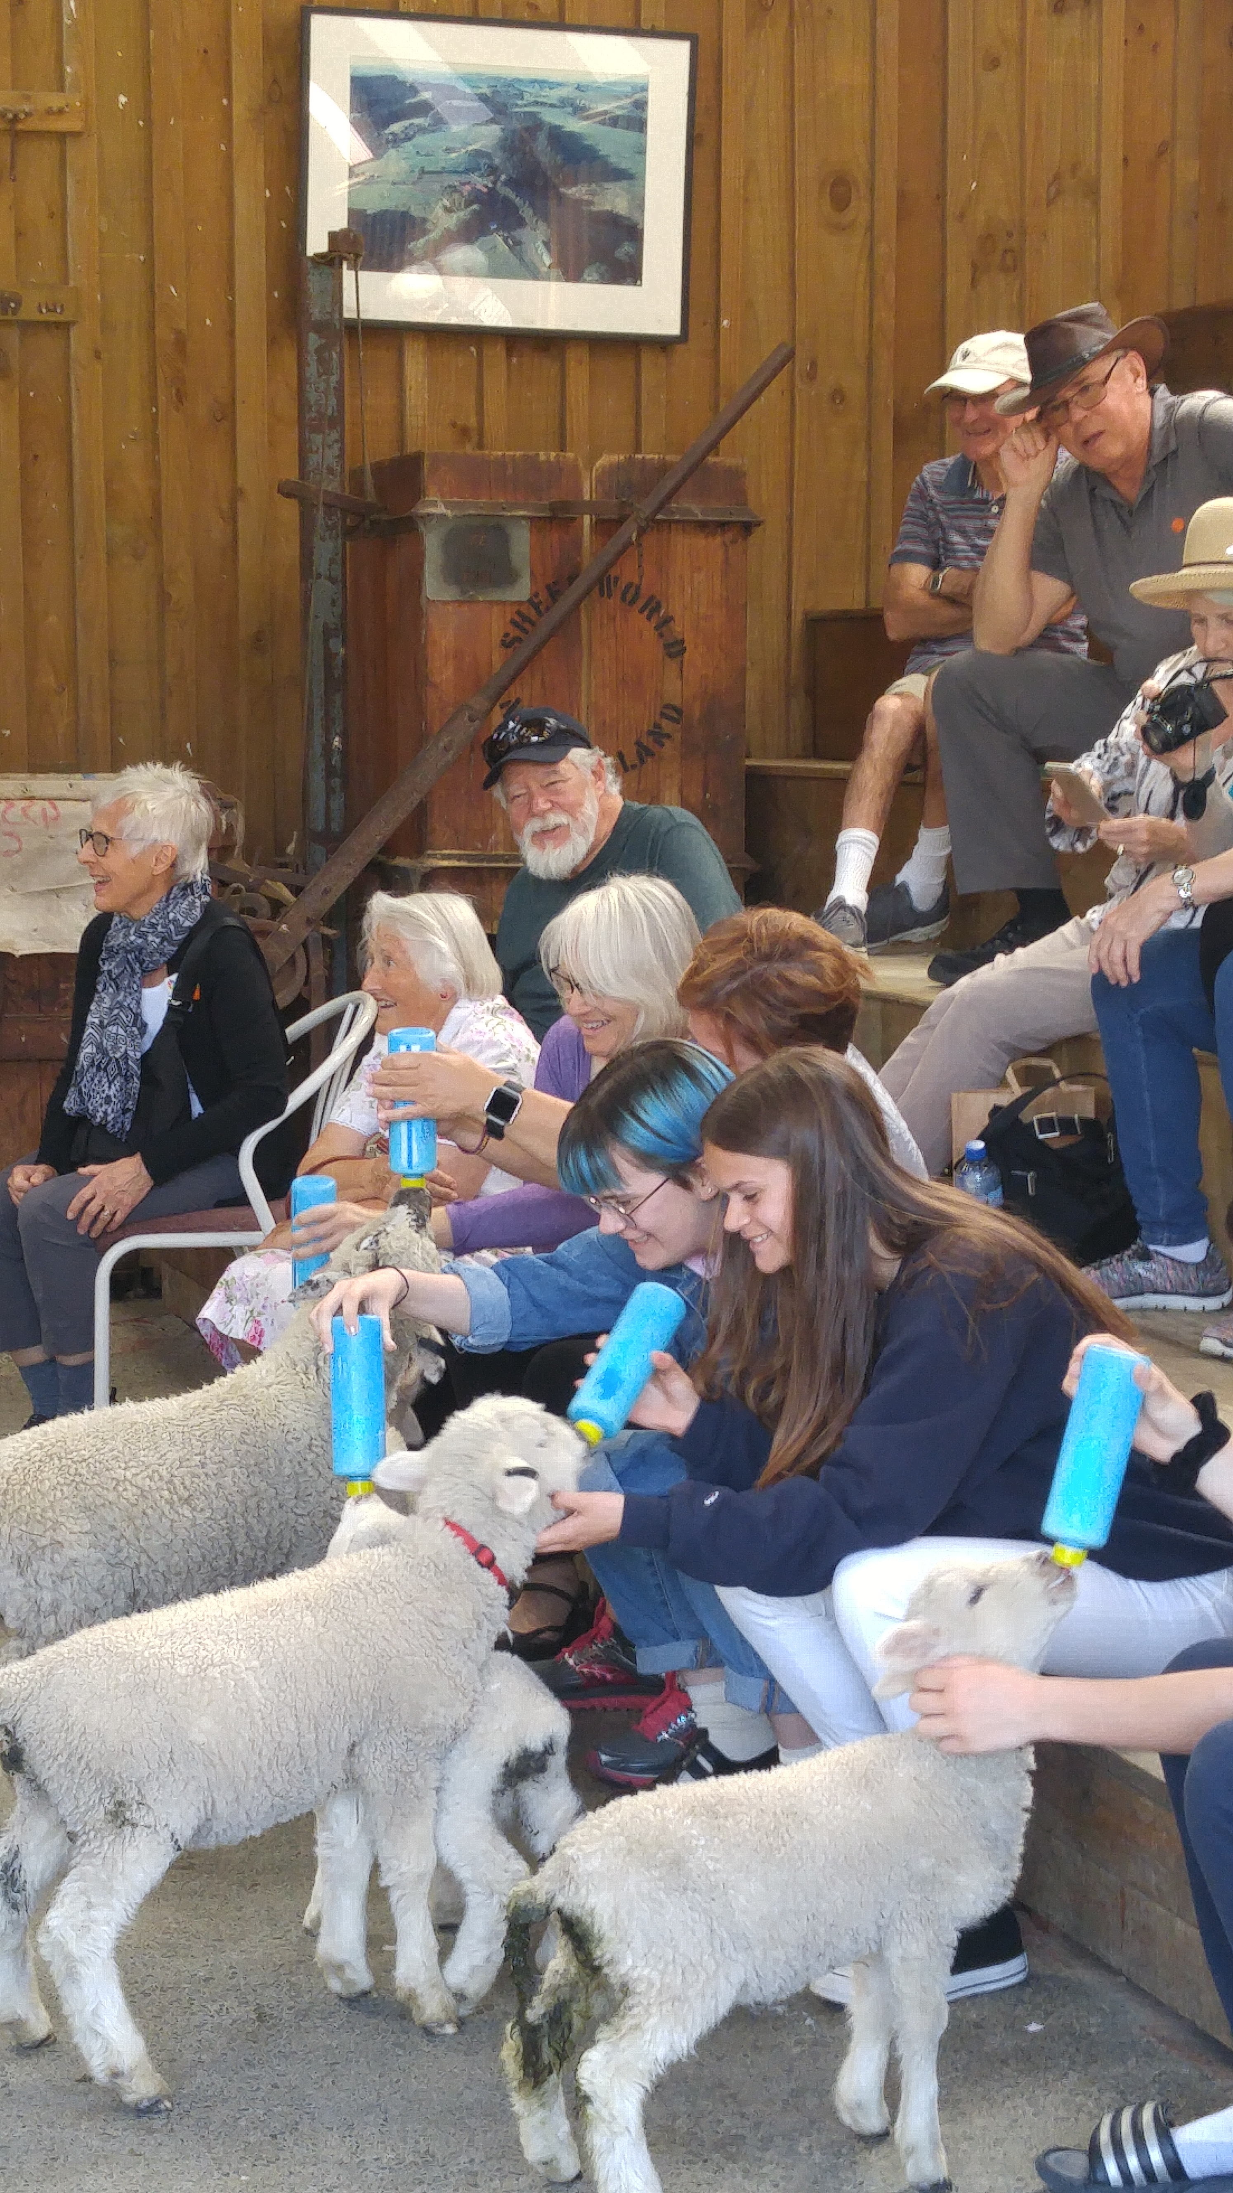 |  |  | 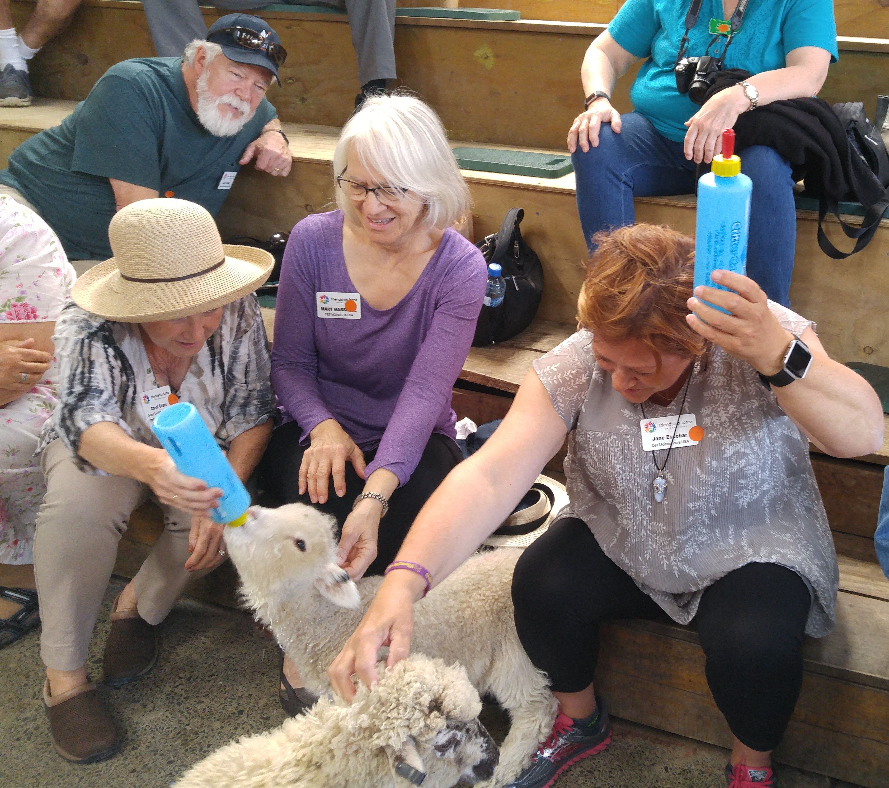
Sheep World |  |  | Carol, Mary and Jane feeding lambs

