Journey #14212 - Des Moines to Perth and Auckland
Daily Journal – Part 5

October 25 – Carol
Friendship Force members met at the Birkenhead ferry wharf about 10am for a ferry ride across Auckland Harbor to Princes Wharf, on Queen Street, the main street in downtown Auckland. From there we took a shuttle to Kelly Tarlton’s Sea Life Aquarium for a tour. Kelly Tarlton is renowned for diving, archaeology, conservation and building Kelly Tarlton's SEA LIFE Aquarium out of unused sewage tanks.

Selected highlights from the aquarium tour:
Scott Base: We entered the aquarium through this replica of an Antarctica field research base, named in honor of Captain Robert Falcon Scott, who led two British expeditions to the Ross sea area of Antarctica.

King (second largest of the species – with distinctive yellow markings) and Gentoo penguin exhibit: We enjoyed watching the penguins swoop through the icy sea water display. Aquarium staff blow in 5 tons of snow and ice each day before opening to maintain a quality habitat. This facility is one of the most successful breeding programs in the world.

Plexiglass tunnel: A ‘people mover’ slowly took viewers through this 180° marine exhibit. Seeing sharks and rays from underneath was a favorite view.

Due to uncertain weather, the group ate sack lunches in the Aquarium cafeteria instead of across the street at Okahu Bay. We then took the Shark Bus back to the wharf area and walked to the Sky Tower for a tour, where we enjoyed beautiful views from the 51st floor observation level. Sites included a view of Rangitoto and bungee jumpers leaping from the floor above us.

We walked back to the wharf for a return ferry ride to Birkenhead, then back to our host homes. That evening we enjoyed small group dinners hosted in the homes of Auckland Friendship Force members.
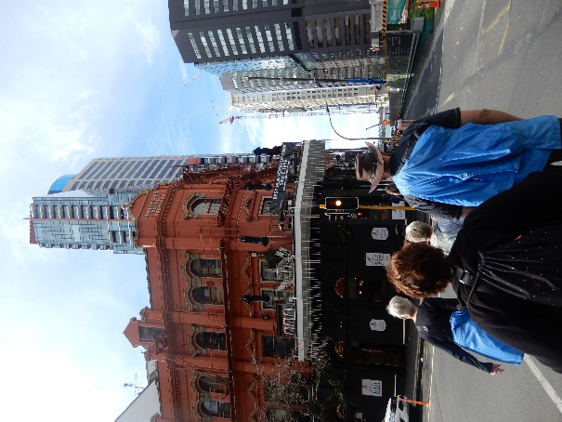 | 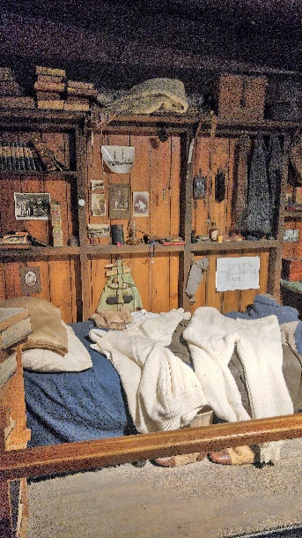 | 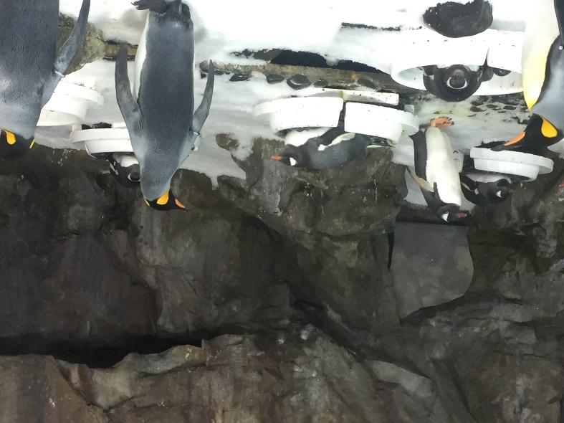
Auckland WalkingTour | Scott Exhibition | Penquins

