Journey #14212 - Des Moines to Perth and Auckland
Daily Journal – Part 3

October 20 – Deb
Today was Fremantle Day. We began our day on a short cruise down the Swan River from Perth to Fremantle - passing parks, yacht clubs and expensive homes.
Onto a tour of the Fremantle Maritime Museum which showcased life on the water and lots of boats - from the smallest to the sailboat that won the America Cup.
Since it has been more than 3 hours, on to eating lunch. Our group did fish and chips which was quite tasty.
After lunch onto the Roundhouse Gun. The building had a jail and also functioned as the keeper of time for the boats in the harbor. At 1 o’clock a cannon was fired and a large black ball on a mast dropped to signal the time. Our own Jane Escobar had the honor of firing the cannon.

Next, we went to the museum of boats who didn't stay on top of the water - Shipwrecks Museum. There were stories and artifacts of multiple shipwrecks. The largest collection was from the Batavia. They had most of one side of the rear of the boat due to the fact they were carrying large amounts of brick and stone which pinned it down under the water and protected the section of the hull.
We had our quota of history and now on to the Fremantle Market. The market had fresh fruits and vegetables, prepared food and any trinket or item you could think of.

After a short rest, on to the Cook's home for a barbeque and an evening of great food, good conversation and lots of laughs.

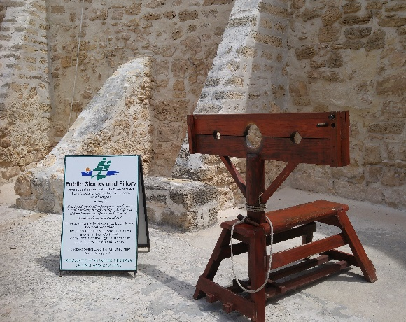 |  | 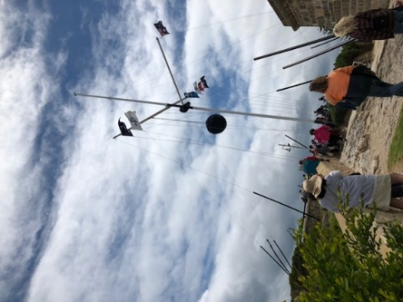 |  |  |  | 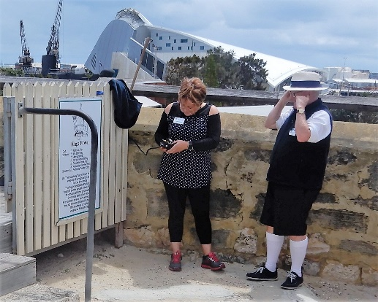
Stocks at Freemantle Roundhouse |  | Walking toward cannon |  |  |  | Jane firing the cannon
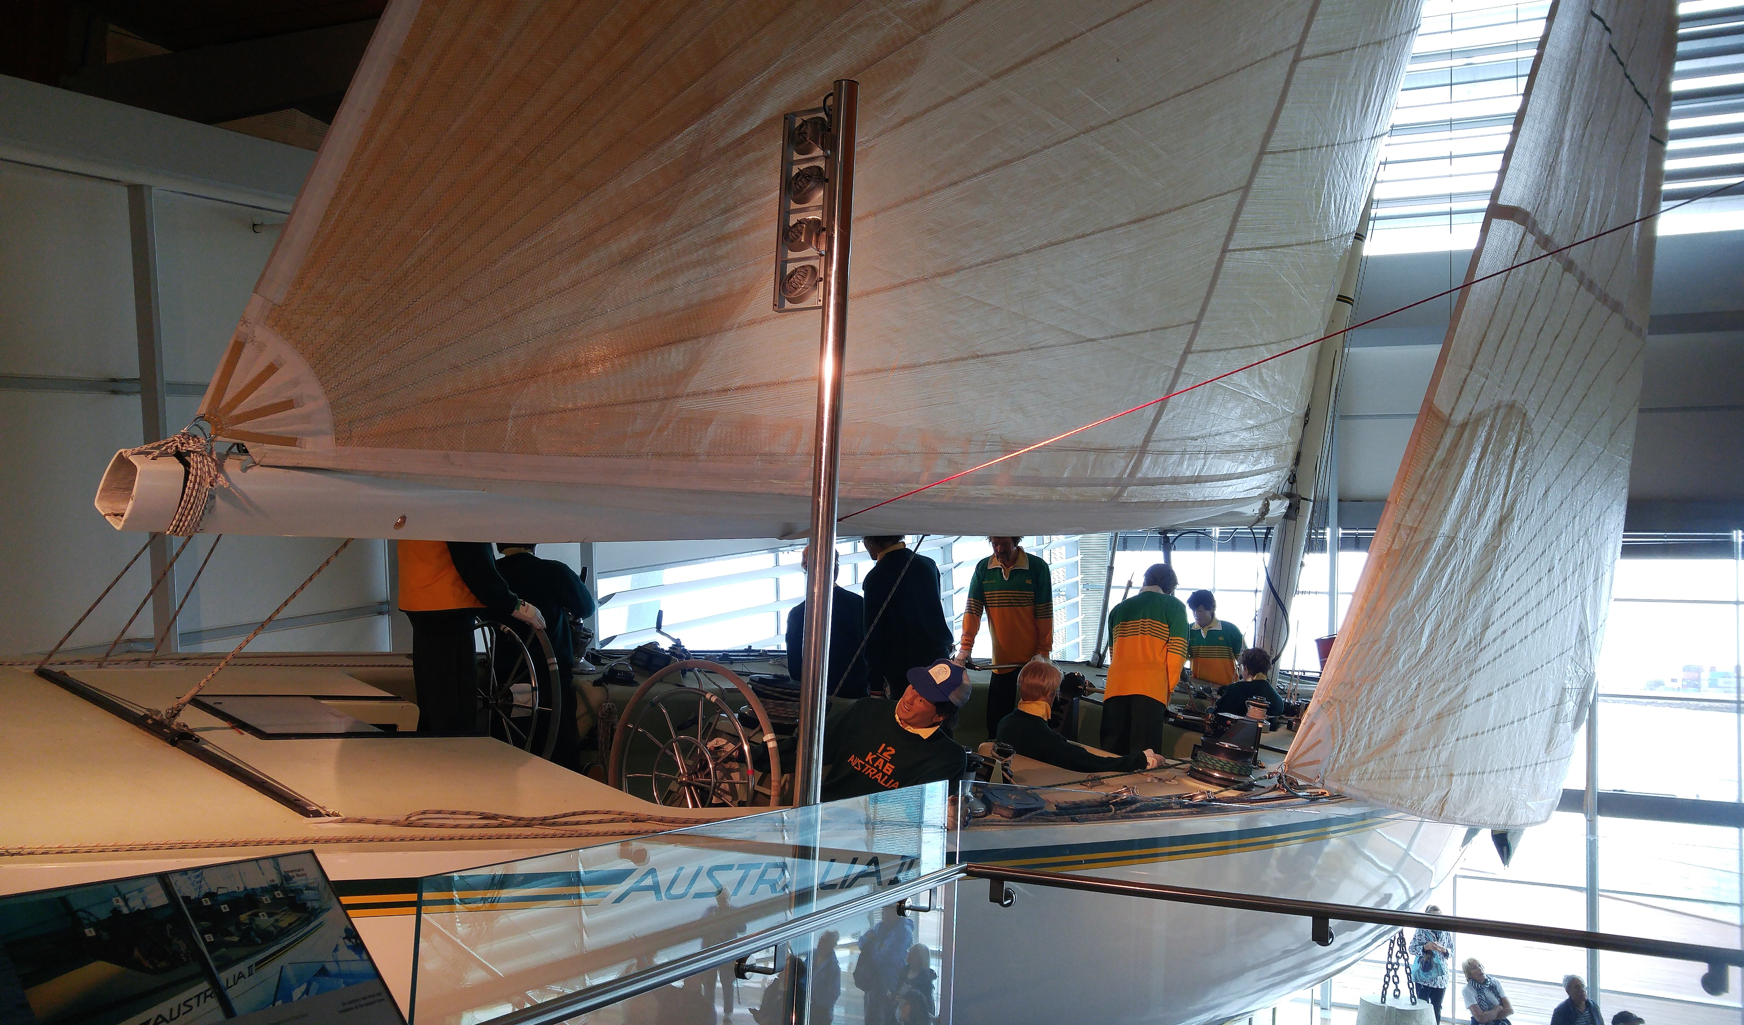 |  |  |  |  | 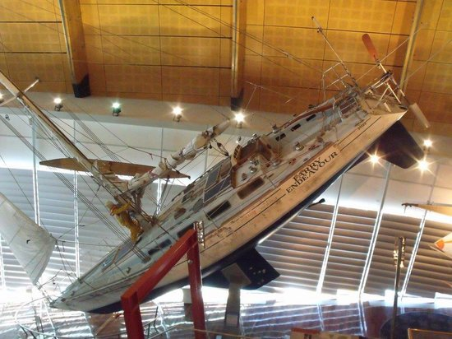
America’s Cup yacht Australia II |  |  |  |  | Parry Endeavour
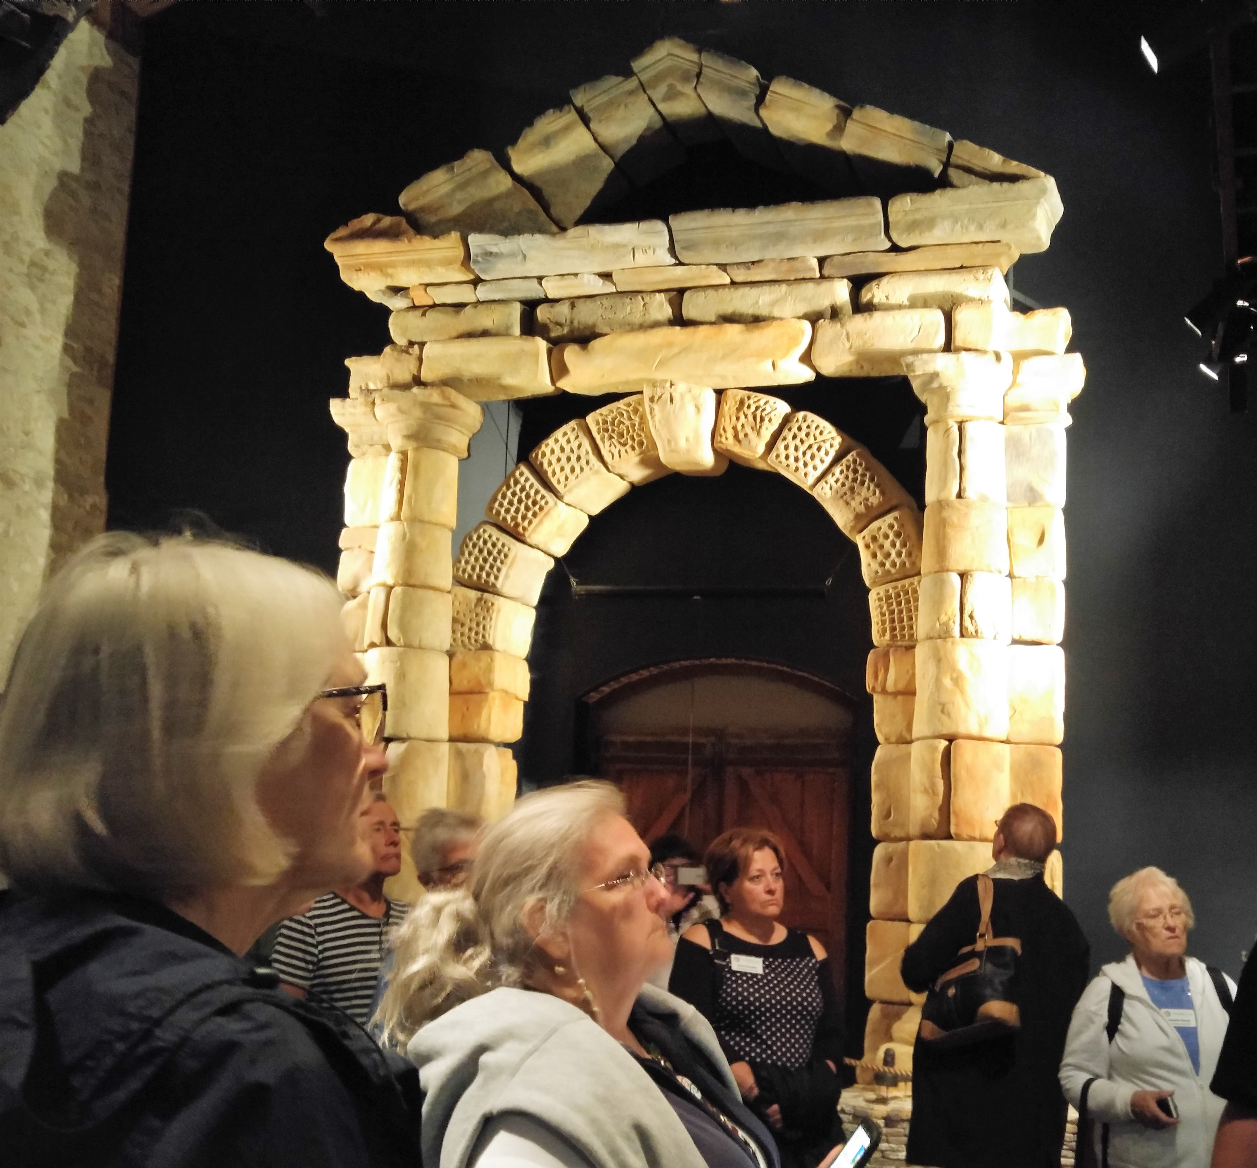 |  |  | 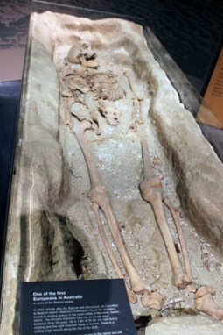 |  |  |  | 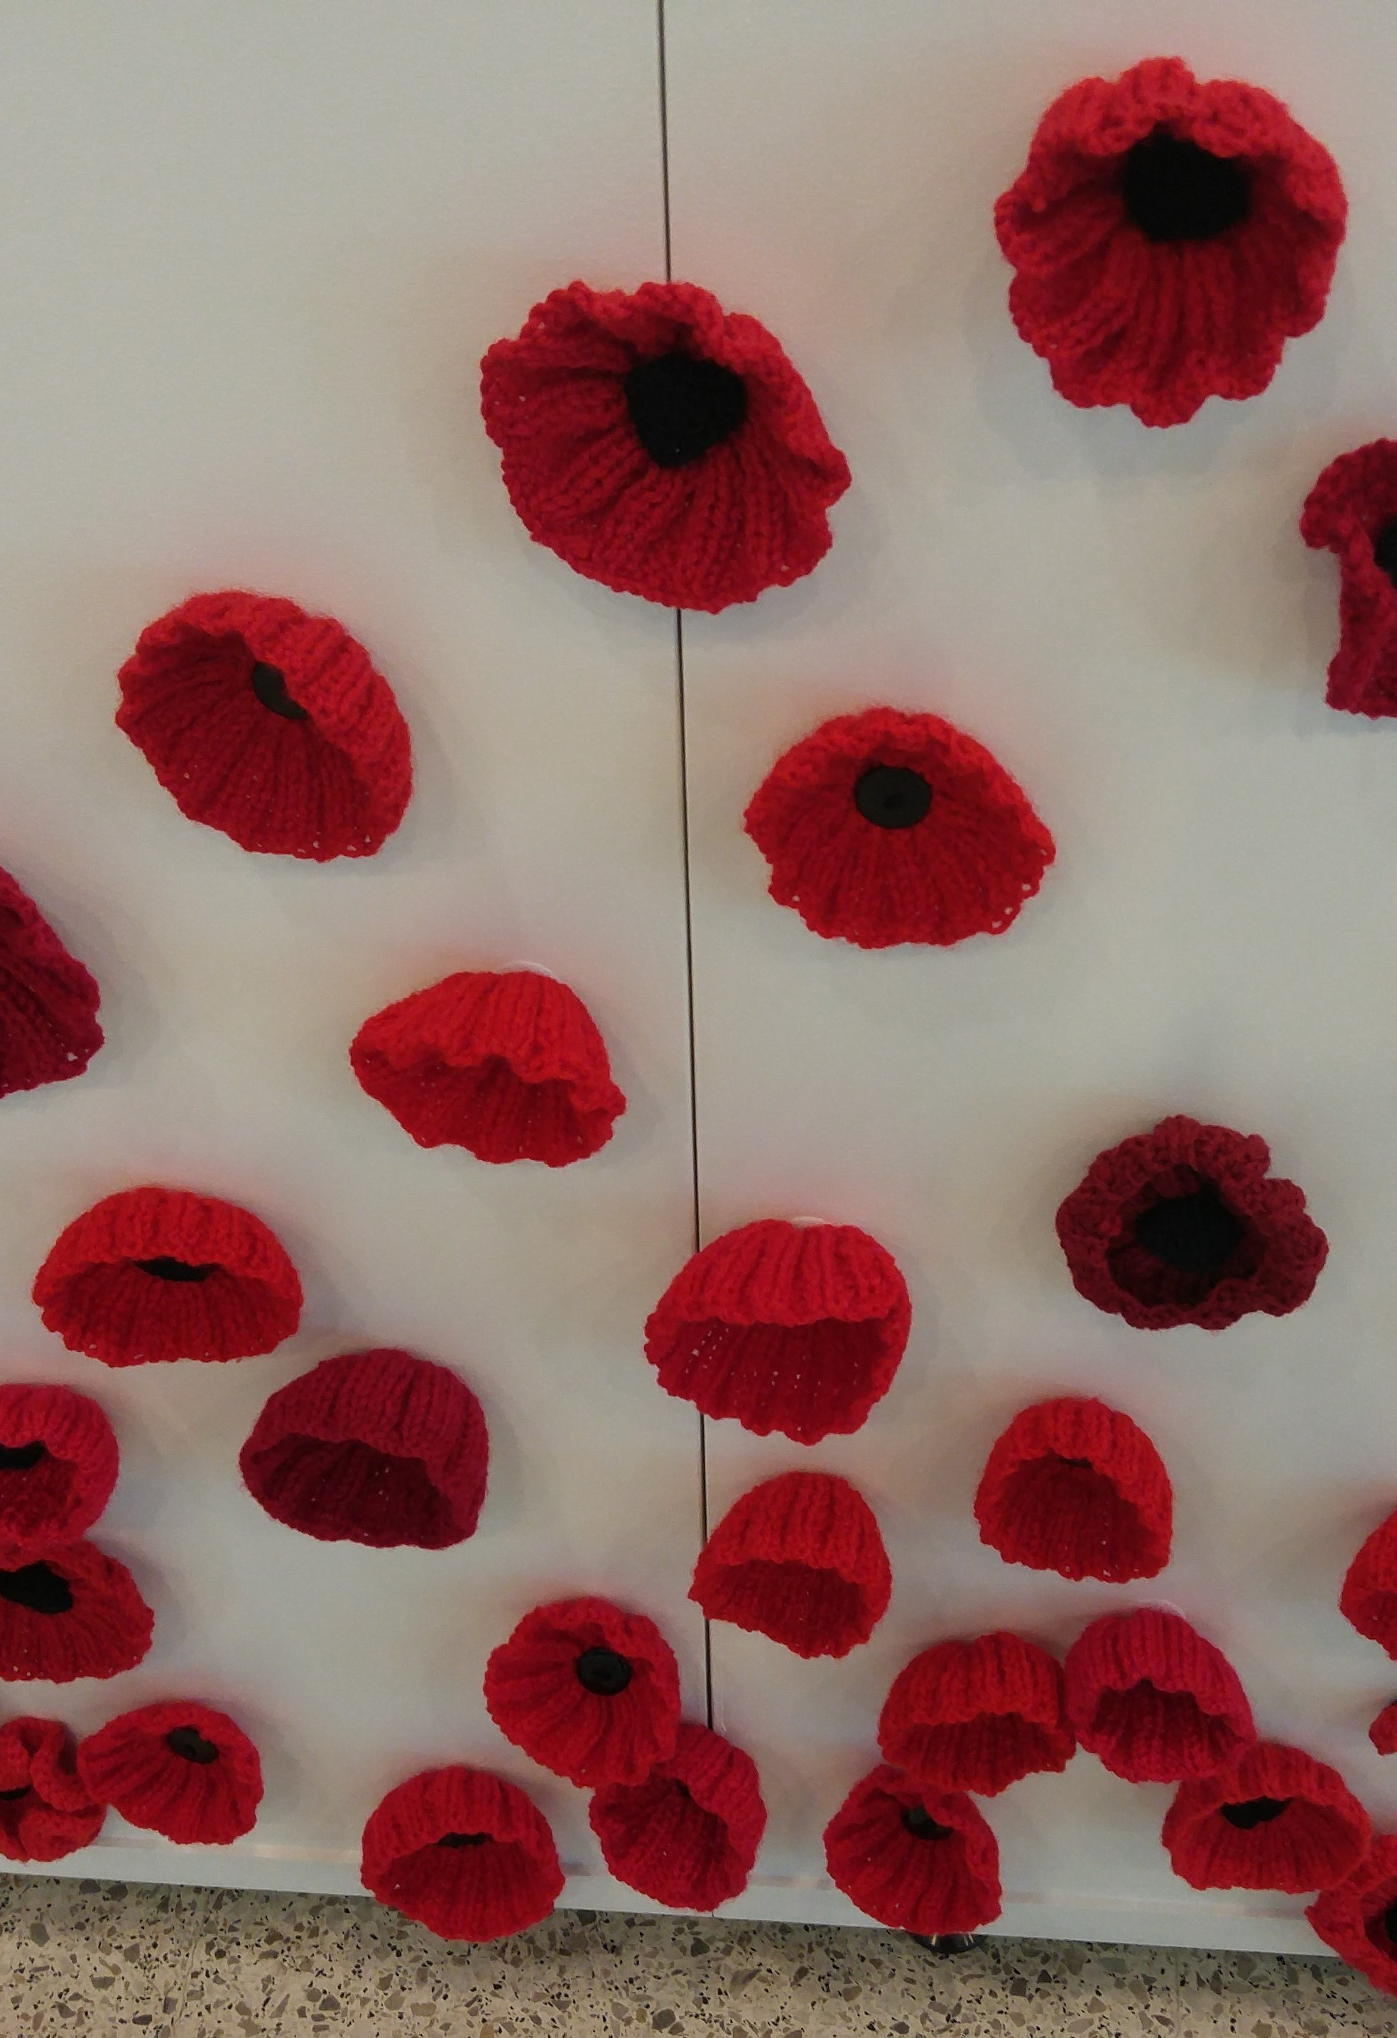
Ambassadors at Shipwrecks Museum |  |  | In 1963 an excavation of Beacon Island, the Batavia’s graveyard, found 2 skeletons in a coral reef. |  |  |  | Crochet poppies on memorial wall
Perth Program for Sunday 21st October
10.45 am Dolphin Cruise Mandurah then lunch on own
2.00 pm Rockingham Environmental Park - Walk through wetlands and conservation area
6.00 pm Farewell dinner at Lionel Samson’s Building in Freemantle

October 21 - Pat
We saw dolphins on the cruise from Mandurah out into the bay. They swam alongside our boat in the wake of a similar boat as we moved in tandem. In Little Venice, a ritzy new housing development on the water, lots were selling at $150,000. (Only $108,500 US.) No house.

At Rockingham Environmental Park we met, Bubbles, a lizard that loved strawberries, and a non-venomous snake. We toured the extensive garden plots, maintained by volunteers, and tasted a wide variety of seasonings.

The Farewell Dinner was held at Lionel Samson’s Building in an atmospheric wine cellar. There was a buffet of chicken, beef, pork, veggies and salads. Evidently Ian Cook, one of our hosts, has a winery in his family and the bottle I tasted was excellent.
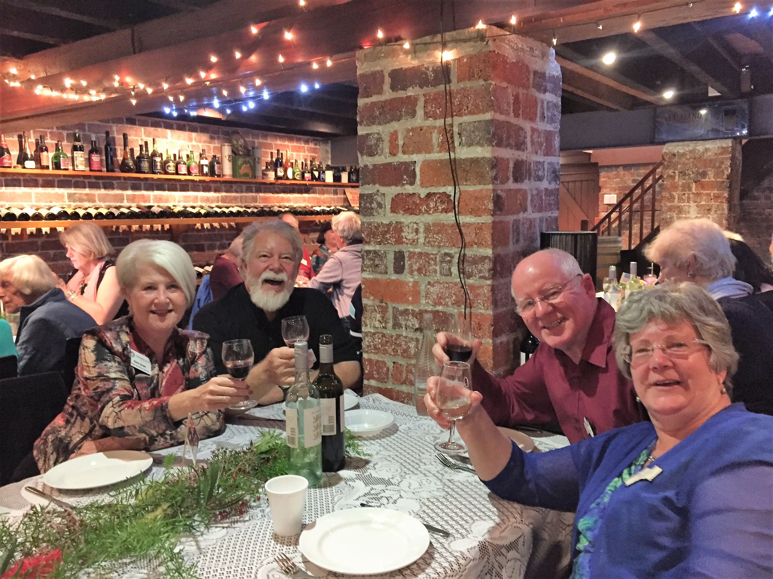 |  |  |  | 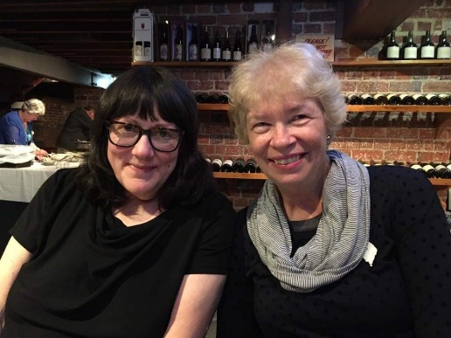
Carol and Jerry Grant with their hosts Linda and Colin Allen |  |  |  | Cherie Erwin and her host Sue Eyers
Perth Program for Monday 22nd October
Free day with hosts
4.00 pm Be at Perth International Airport - Ambassadors depart at 6.35pm for Auckland - flight NZ176

October 22 – Kathie (free day)
Our last day in Perth, Western Australia’s sunny, friendly capital city, began for me with breakfast at Anna and Ken Heedes’s home. The bright sun flooded the kitchen and escalated the flavor of Ken’s superb flat white coffee made from a fancy, huge machine on the back counter. While Anna and Ken skipped eating brekky as usual, I enjoyed fruit and yogurt, topped with granola sprinkles.

Because it was our last day in Perth and a free day for hosts and guests, we lingered at the table, chatting about the happenings of the past week. Because the kitchen faces the canal running through their housing park, we bemoaned the fact that time and weather had never allowed us to take their boat out. It sat there proudly in the water, suggesting the good times we missed. The Heedes live about an hour from Perth central, so we always dove into the traffic scramble to be on time for the day’s fun.

I spent the morning packing, making sure I wasn’t forgetting anything. About noon we packed up my belongings and drove through their town, seeing things we had missed. This also included a second view of the Mandurah Estuary, where we had chased bottlenose dolphins the day before.

For lunch we drove to Silk Thai, a very favorite restaurant of Anna and Ken’s. Warm sun allowed us to eat outdoors. I had curry with prawn stir fry, accented with garlic and peppers, besides lots of fresh vegetables. We shared a grand bottle of Crackerjack Cabernet Sauvignon. Super delicious all the way around.

At the airport a few of the hosts helped us with our luggage and we sadly bid everyone from the Auckland Friendship Force farewell and thanks. Our flight to Auckland took off at 6:35 p.m.
October 22 – Shelley
My hosts, Ian and Geraldine Cook, and I made up for lost time on the free day. We spent several hours at King’s Park and had a lovely and leisurely lunch at one of their favorite lunch spots, on the water, of course. Ian and Geraldine were perfect hosts and I had a wonderful time in their home. A couple of things I appreciated were the motion sensor lights that showed me the way to the lavatory at night and reading up on the Royal visit every morning. I enjoyed meeting their son and daughter who live in Perth and hearing the adventures of their other daughter who lives with her family in Scotland.

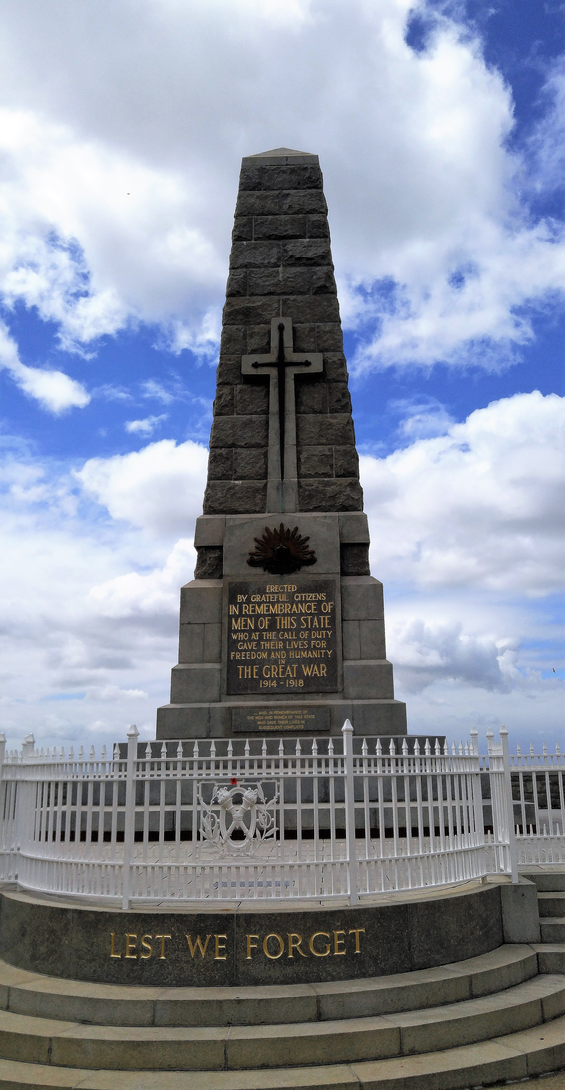 | 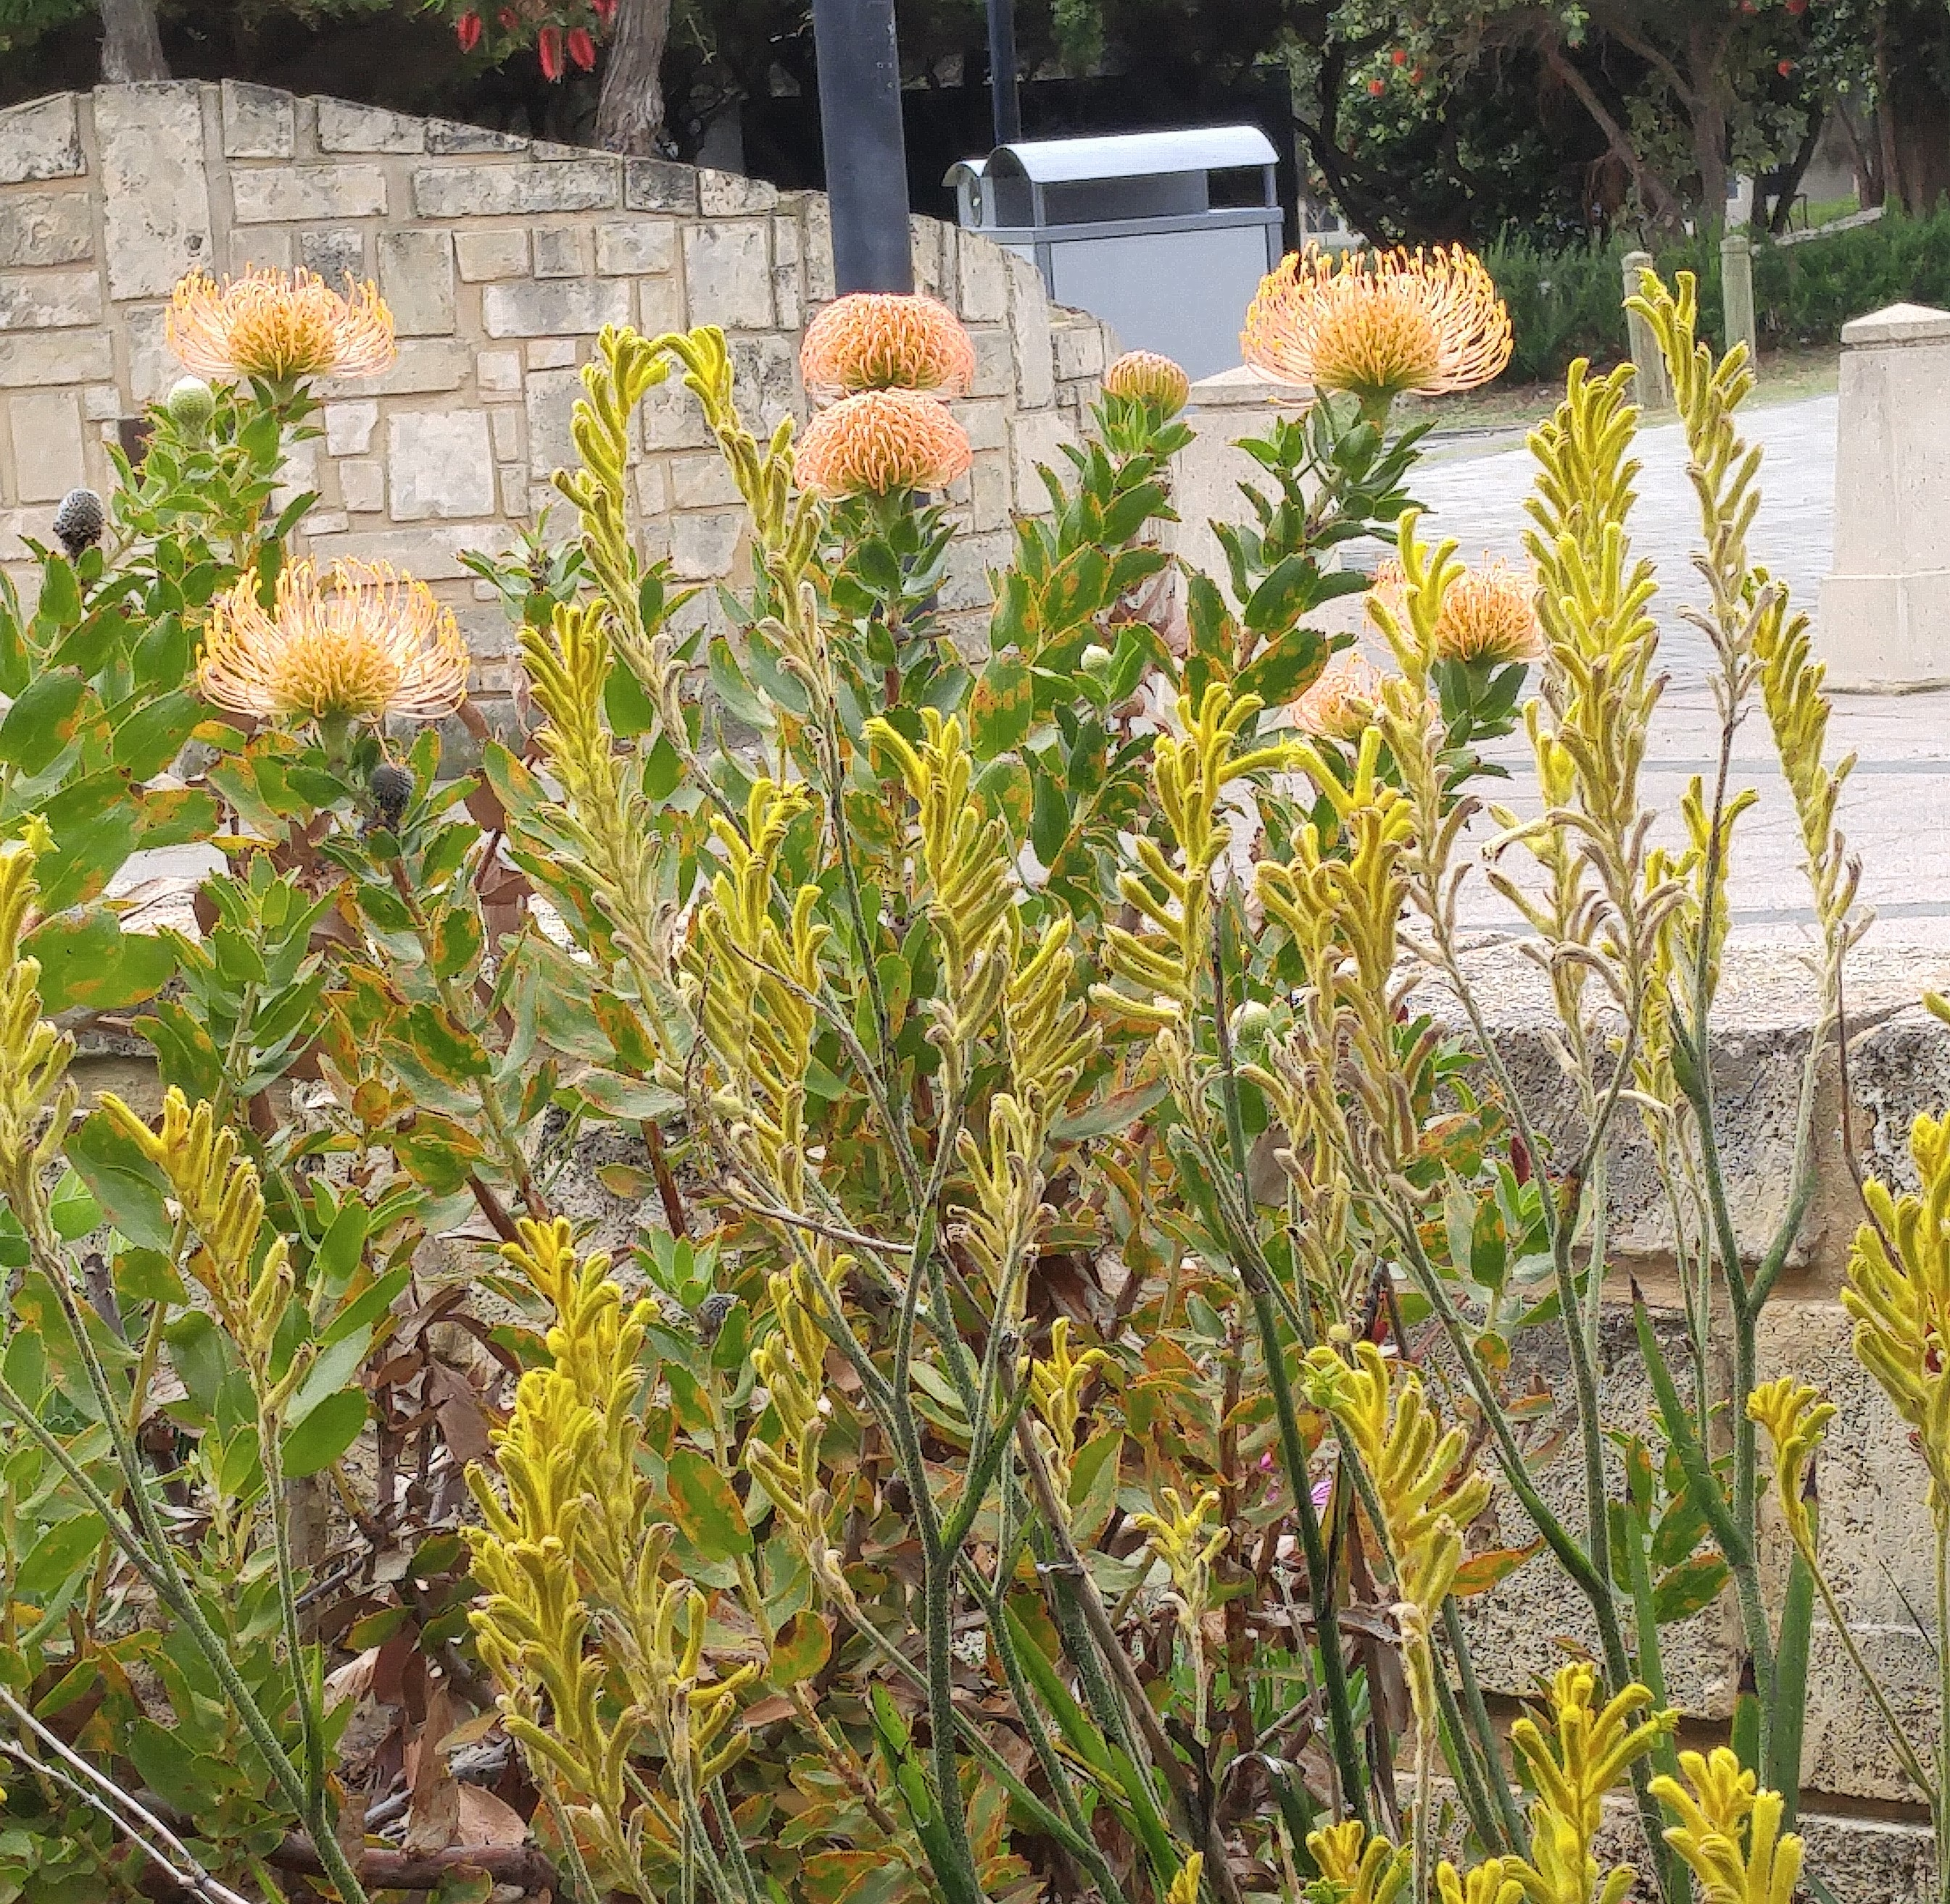 |  |  |  |  | 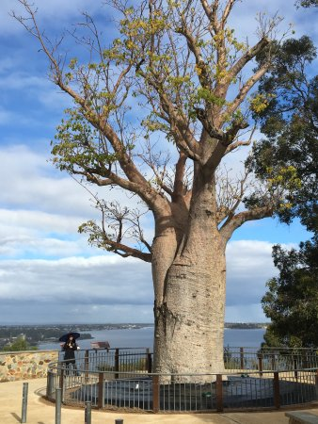  Boab Tree
 | Proteus
 | 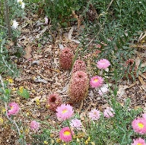
Kings Park – State War Memorial
 | Banksia

