Journey #14212 - Des Moines to Perth and Auckland
Daily Journal – Part 2

Perth Program for Wednesday 17th October
9.45 am Tour of Western Australia Ballet
Morning tea included.
12.00 Lunch at Burswood Park Rotunda (provided)
1.00 pm Park at new stadium and walk over Swan River on Matagarup Bridge
1.20 pm Visit to Friendship Wall
Catch YELLOW CAT bus to Perth Mint.
2.20 pm Tour of Perth Mint
After - return on CAT bus and cross Matagarup Bridge
6.00pm Dinner Hosting

October 17 - Jerry
First stop of the day was at the West Australia Ballet. This ballet is the older one in Australia and was founded in 1952 by Madame Kira Bousloff. We were given a tour of the ballet and were told about all of the programs available to their students that made the ballet company successful. They have a very strong youth program, available training, a specialized therapy and body conditioning program and a strong choreography program. The most interesting aspect of the ballet though, was the extremely professional costume design and creation program. We were shown the process from start to finish. Design, create, performer fitting, cleaning, and storage allowing for the costumes to have a shelf life for more than one performance. Overall, it was one of the best events we were privileged to visit.

The second stop of the day was a picnic lunch at the Burswood Park located on the south bank of the Swan River; a very well-known and beautiful location in Perth. After lunch, we drove to the pedestrian Matagarup Bridge. The bridge spans the Swan River and its structural shape resembles two flying swans, with the bridge arches representing the wishbones, but it can also be seen as a swimming dolphin, a serpent or a ribbon. There are 900 meters of multicolored LED lighting covering the bridge. We walked across the bridge on our way to the Friendship Wall.

The Friendship Force Wall, made of yellows bricks, is complete with plaques of all the clubs that visited Perth throughout the years. It is located along a pedestrian/bicycle trail giving it great visibility in the area.

After visiting the Friendship Force wall, we travelled to the Perth Mint for our group tour. In 1885, the first Western Australia gold discoveries were found at Halls Creek. This triggered the gold rush in Western Australia. The Perth Mint was established in 1899 to profit from Australia's richest goldfield at Kalgoorlie, the last and most important early goldfield in Western Australia.

During our tour, we saw replicas of several large gold nuggets, some of the largest found in the world. We watched a short film on the history of the Australian gold rush and viewed the Australian Kangaroo One Tonne Gold Coin issued as legal tender in 2012 with a value of 1 million dollars.

We then visited the smelting room and watched as an actual gold bar was made. We also found out that they periodically had to burn up the vessels that held the liquefied gold and clean off the walls and ceiling to reclaim gold lost in the smelting process.

At the end of our tour, we were able to stop at a programed scale that gave us a certificate showing how much we were worth, if we were made of gold. After the tour ended, we all went back to our hosts’ home in preparation for the evening meal with our Dinner Hosts.
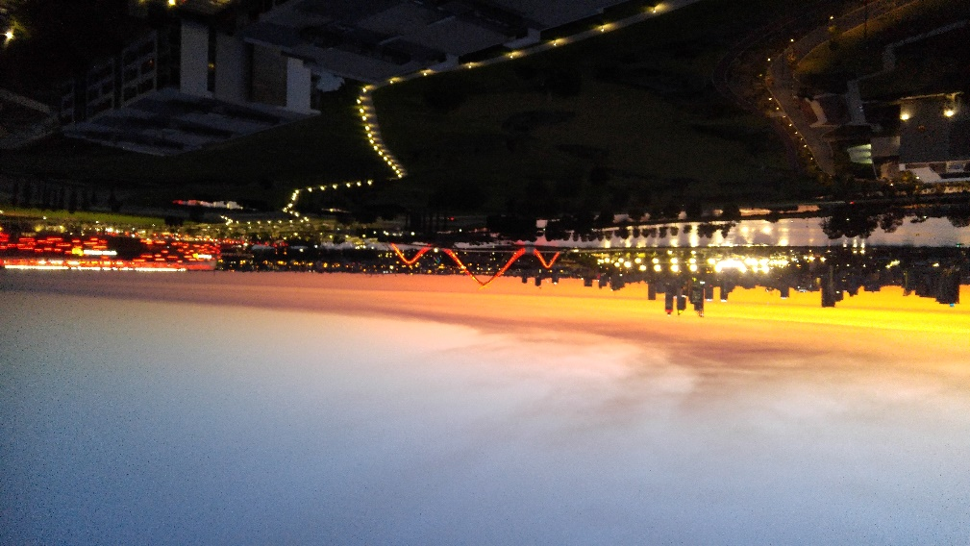 | 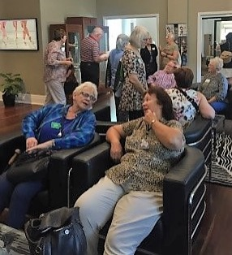 |  |  |  |  | 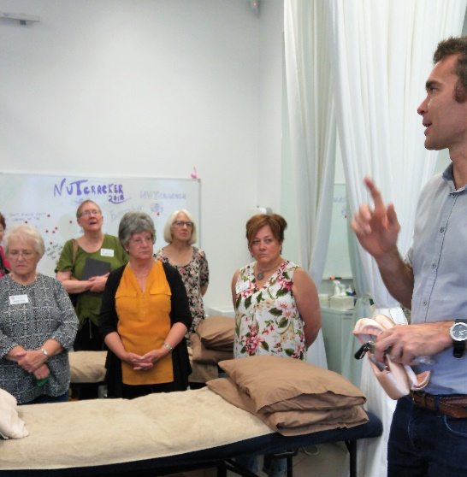
View of the stadium from group dinner | Kathie Swift and Gat Meehan at WA Ballet |  |  |  |  | Learning about shoes at the WA Ballet
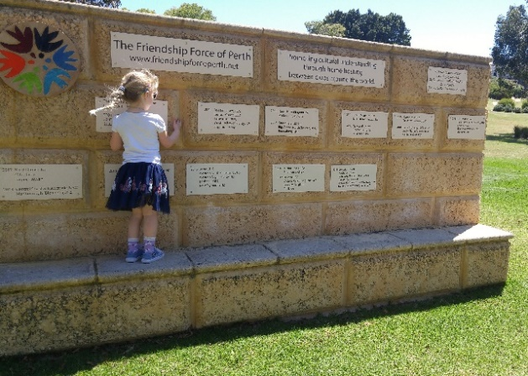 |  |  | 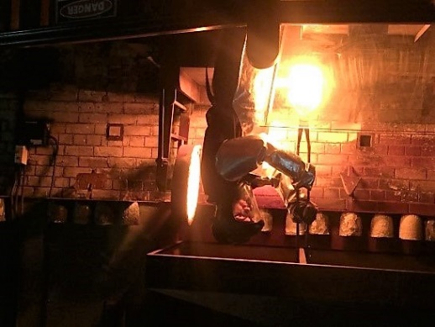 |  |  |  |  |  | 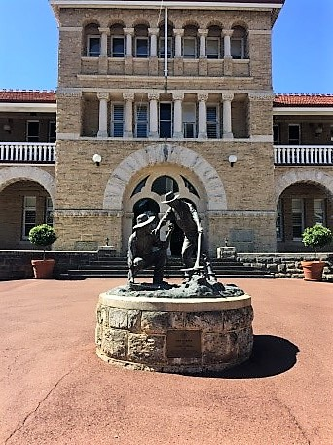
Friendship Force Wall |  |  | Casting gold at the Perth Mint |  |  |  |  |  | Entrance to Perth Mint
Perth Program for Thursday 18th October
9.30 am Visit to Police Academy in Joondalup
11.00 am Drive via Pinnaroo Cemetery to Hillarys Marina
12.00 Lunch at Hillarys Marina
1.00 pm Drive via West Coast Hwy to Raebold Hill and to Cottesloe Beach
2.30 pm Walking tour of Kings Park
Free evening

October 18 – Pat
We made a list of words that struck us: a flat white=a latte; peak hour=rush hour; lots of British usages like Mind the gap, the boot of the car, jumpers=sweaters, car park. I always imagined a shapely stool when I saw the sign for the “female toilet.” “Yeah, yeah” with a uniquely local vowel was a constant.

An overcast sky and some rain again. A morning visit to the police academy conducted by a retired Taser expert. We kept him busy with questions for nearly two hours. The grounds include a sort of movie set-village that’s used for training. We saw a simulated arrest. If an officer stops a car, s/he parks behind it, so the driver would find it hard to turn around to shoot. In Western Australia the police force is state-wide police rather than limited to a city. There are 8,600 officers for WA. aim teaser for muscles, chest and thigh. Sympathetic firing. 30-35% women in the service. No size restrictions. A big problem is ice (meth) in Western Australia and violence. Permits for guns are very difficult. To get one you must prove you have permission to hunt on someone's land. Officers must document each use of a taser, but they are used every day.
Drove through Pinnaroo Cemetery, but no kangaroo sightings. Others in our group saw many. Australians seem to see roos in much the same way we see deer, as pests.

Lunch at Harbour Terrace in Hillary's Marina and browsing in the shops. Our walk-through King's Park was canceled due to uncertain weather.

That evening Claudia and I were on our way to Bunbury to attend the high school graduation of our host's granddaughter, a two-hour drive on the four-lane.

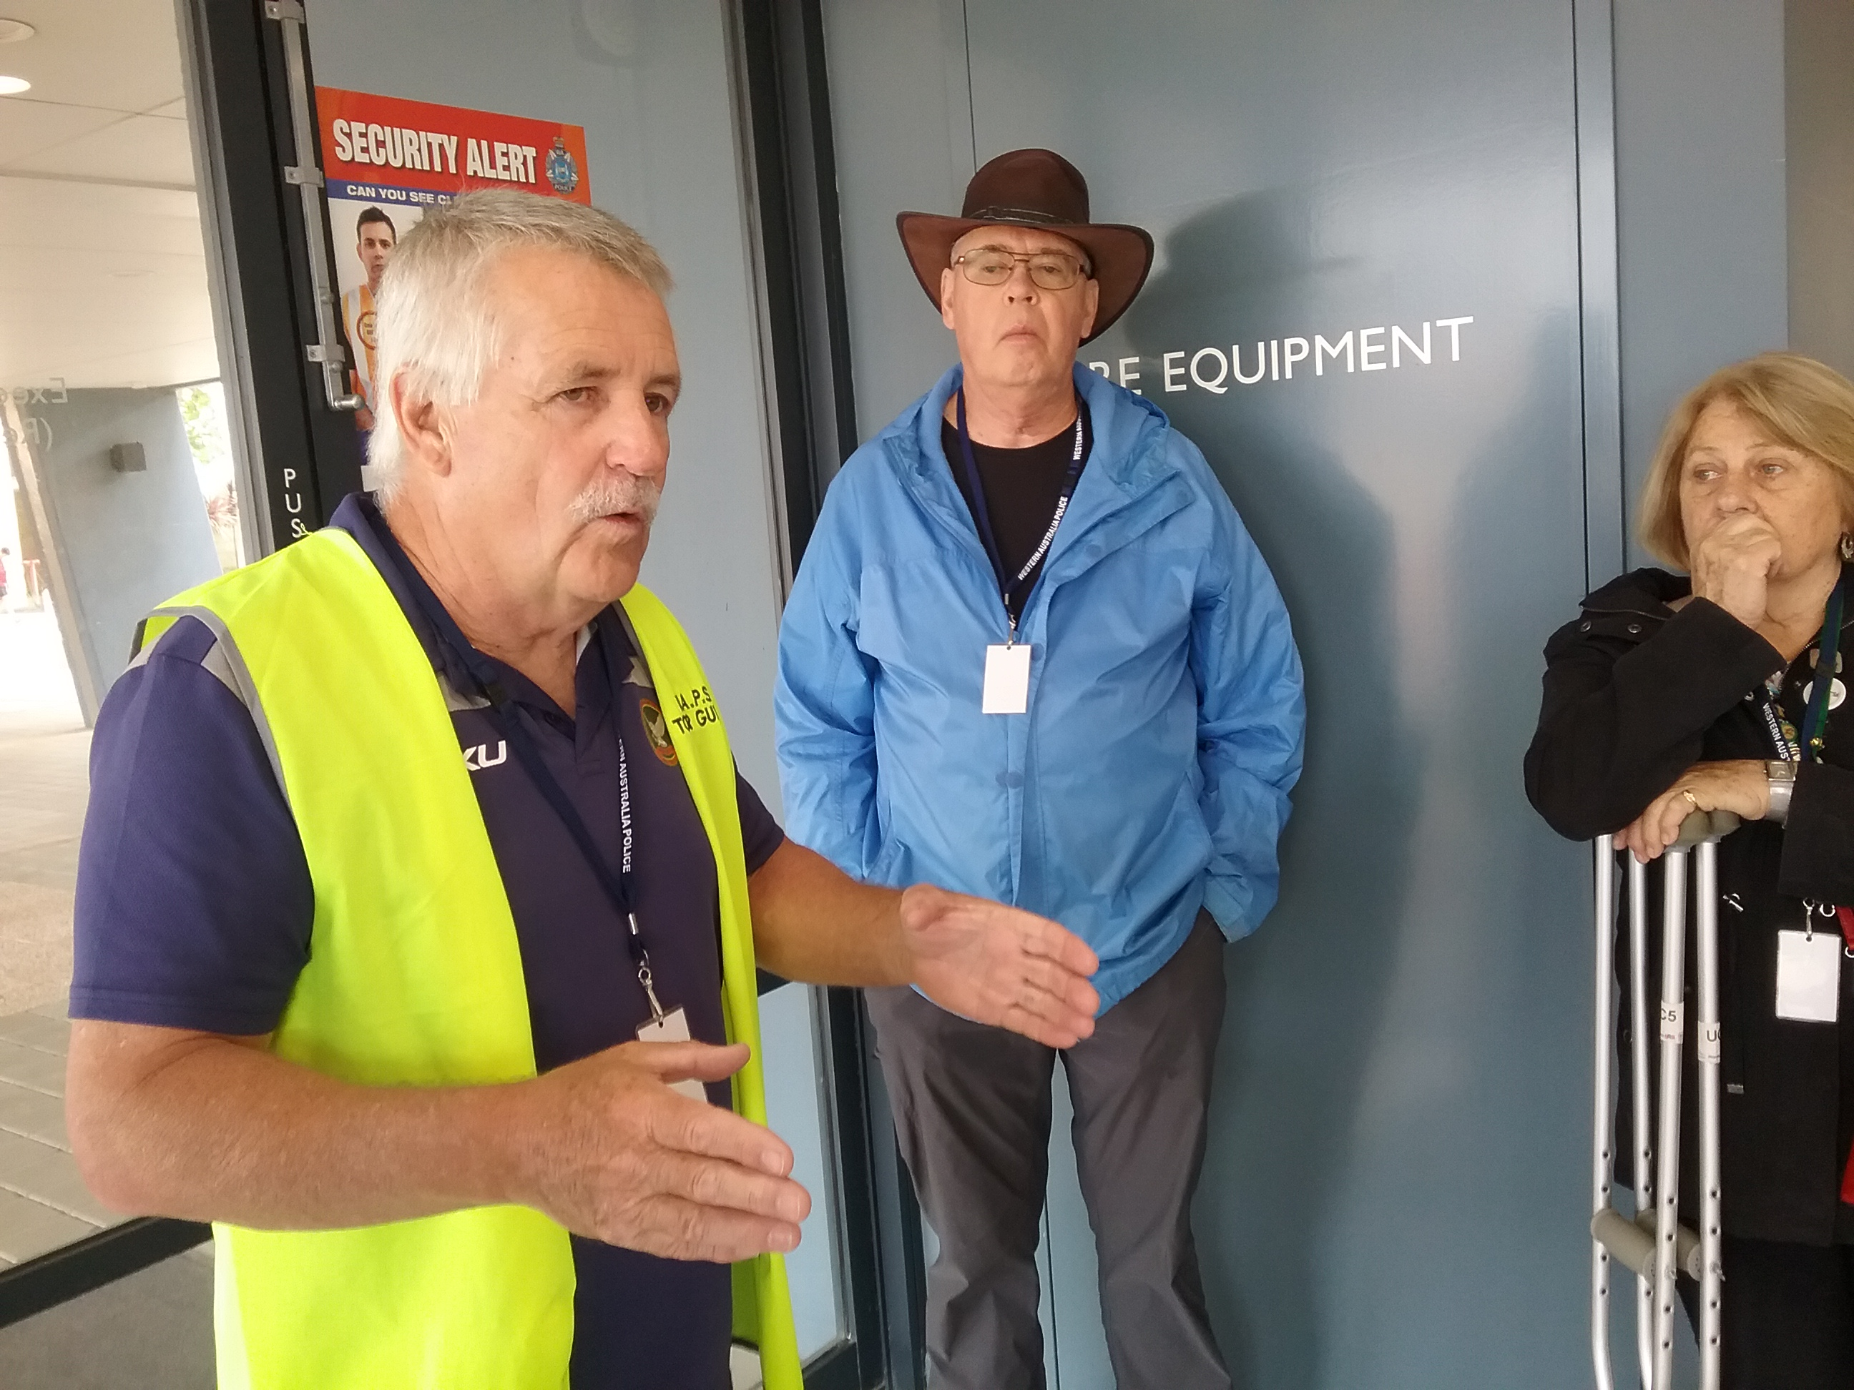 |  |  |  | 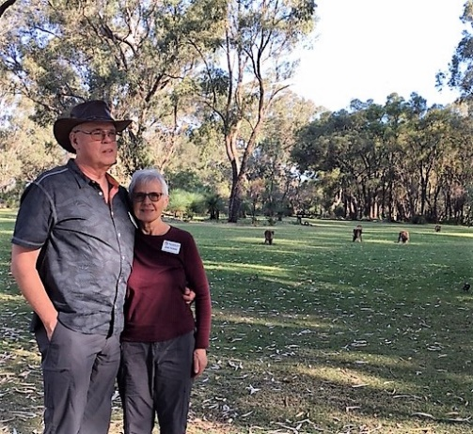 |  |  |  | 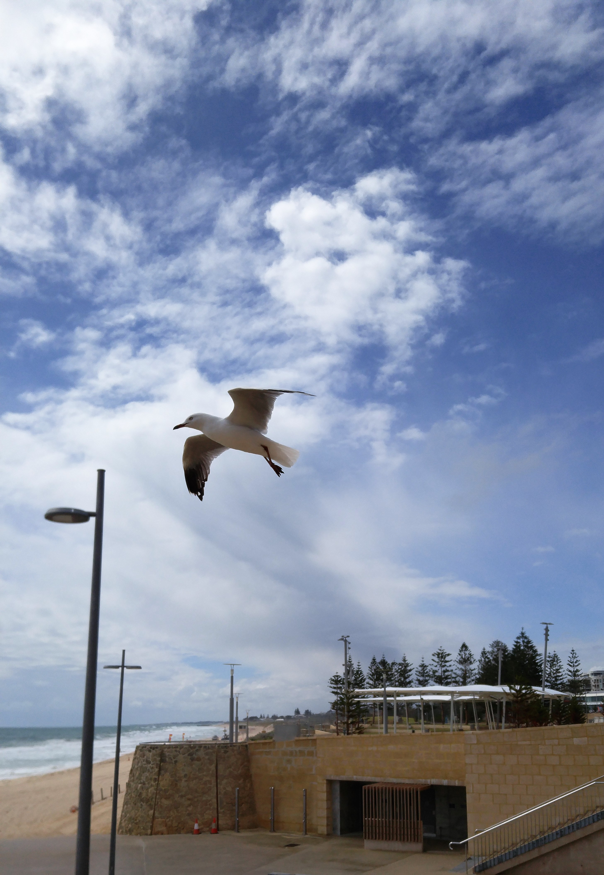
Police Academy |  |  |  | Jean and Dean at Pinnaroo Cemetery |  |  |  | Cottesloe Beach
Perth Program for Friday 19th October
9.40 am Caversham Wildlife Park Show
12.00 Whiteman Park
1.30 pm Swan Valley tour
Includes visits to Margaret River Chocolate Factory, Maalinup Aboriginal Gallery,
All Saints Church, The House of Honey, Wizard of Fire, and Gomboc Gallery
5.45 pm Ambassadors take hosts to dinner
Old Fig Tree Restaurant, 55 Benara Rd, Caversham

October 19 – Deb
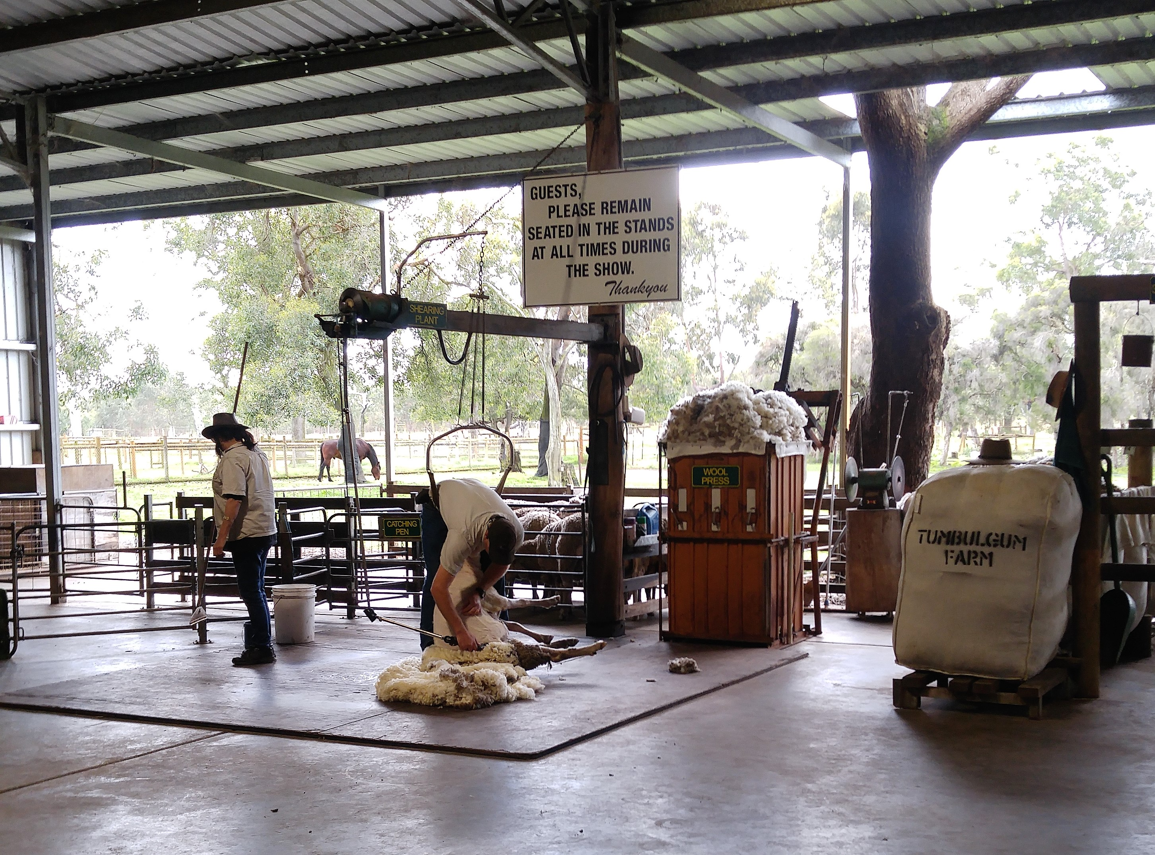 |  |  |  | 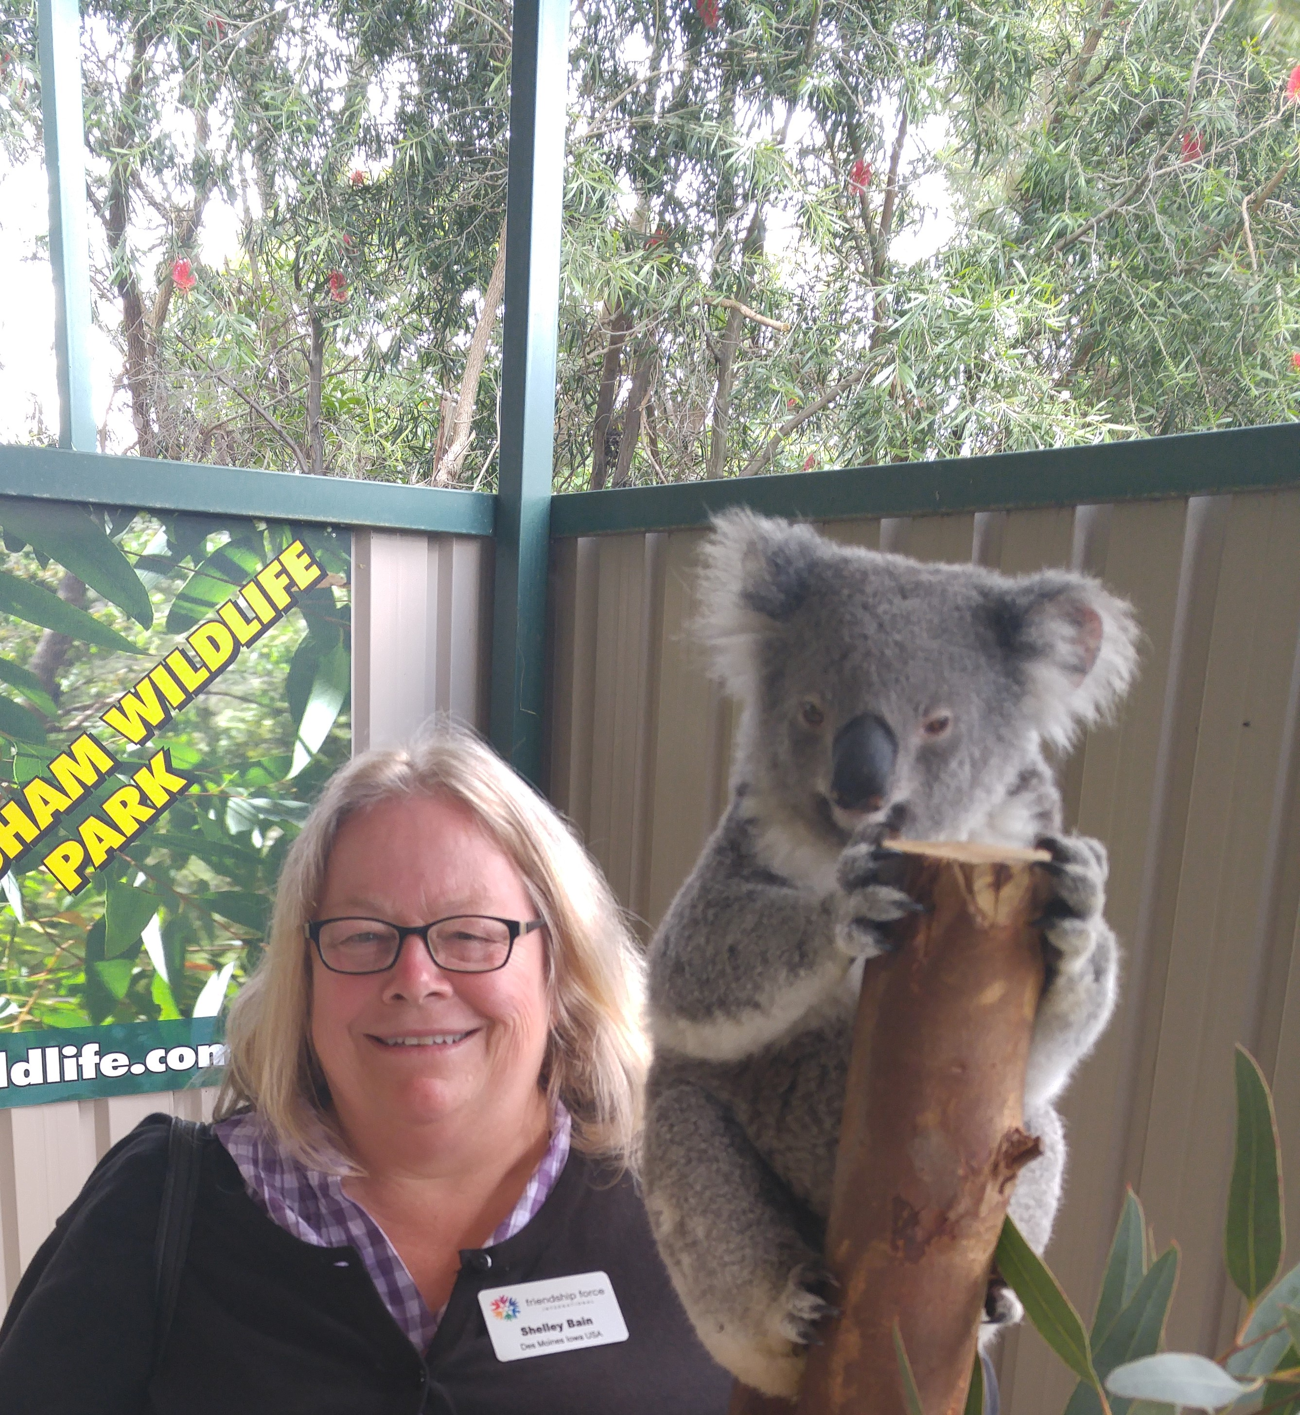 |  |  | 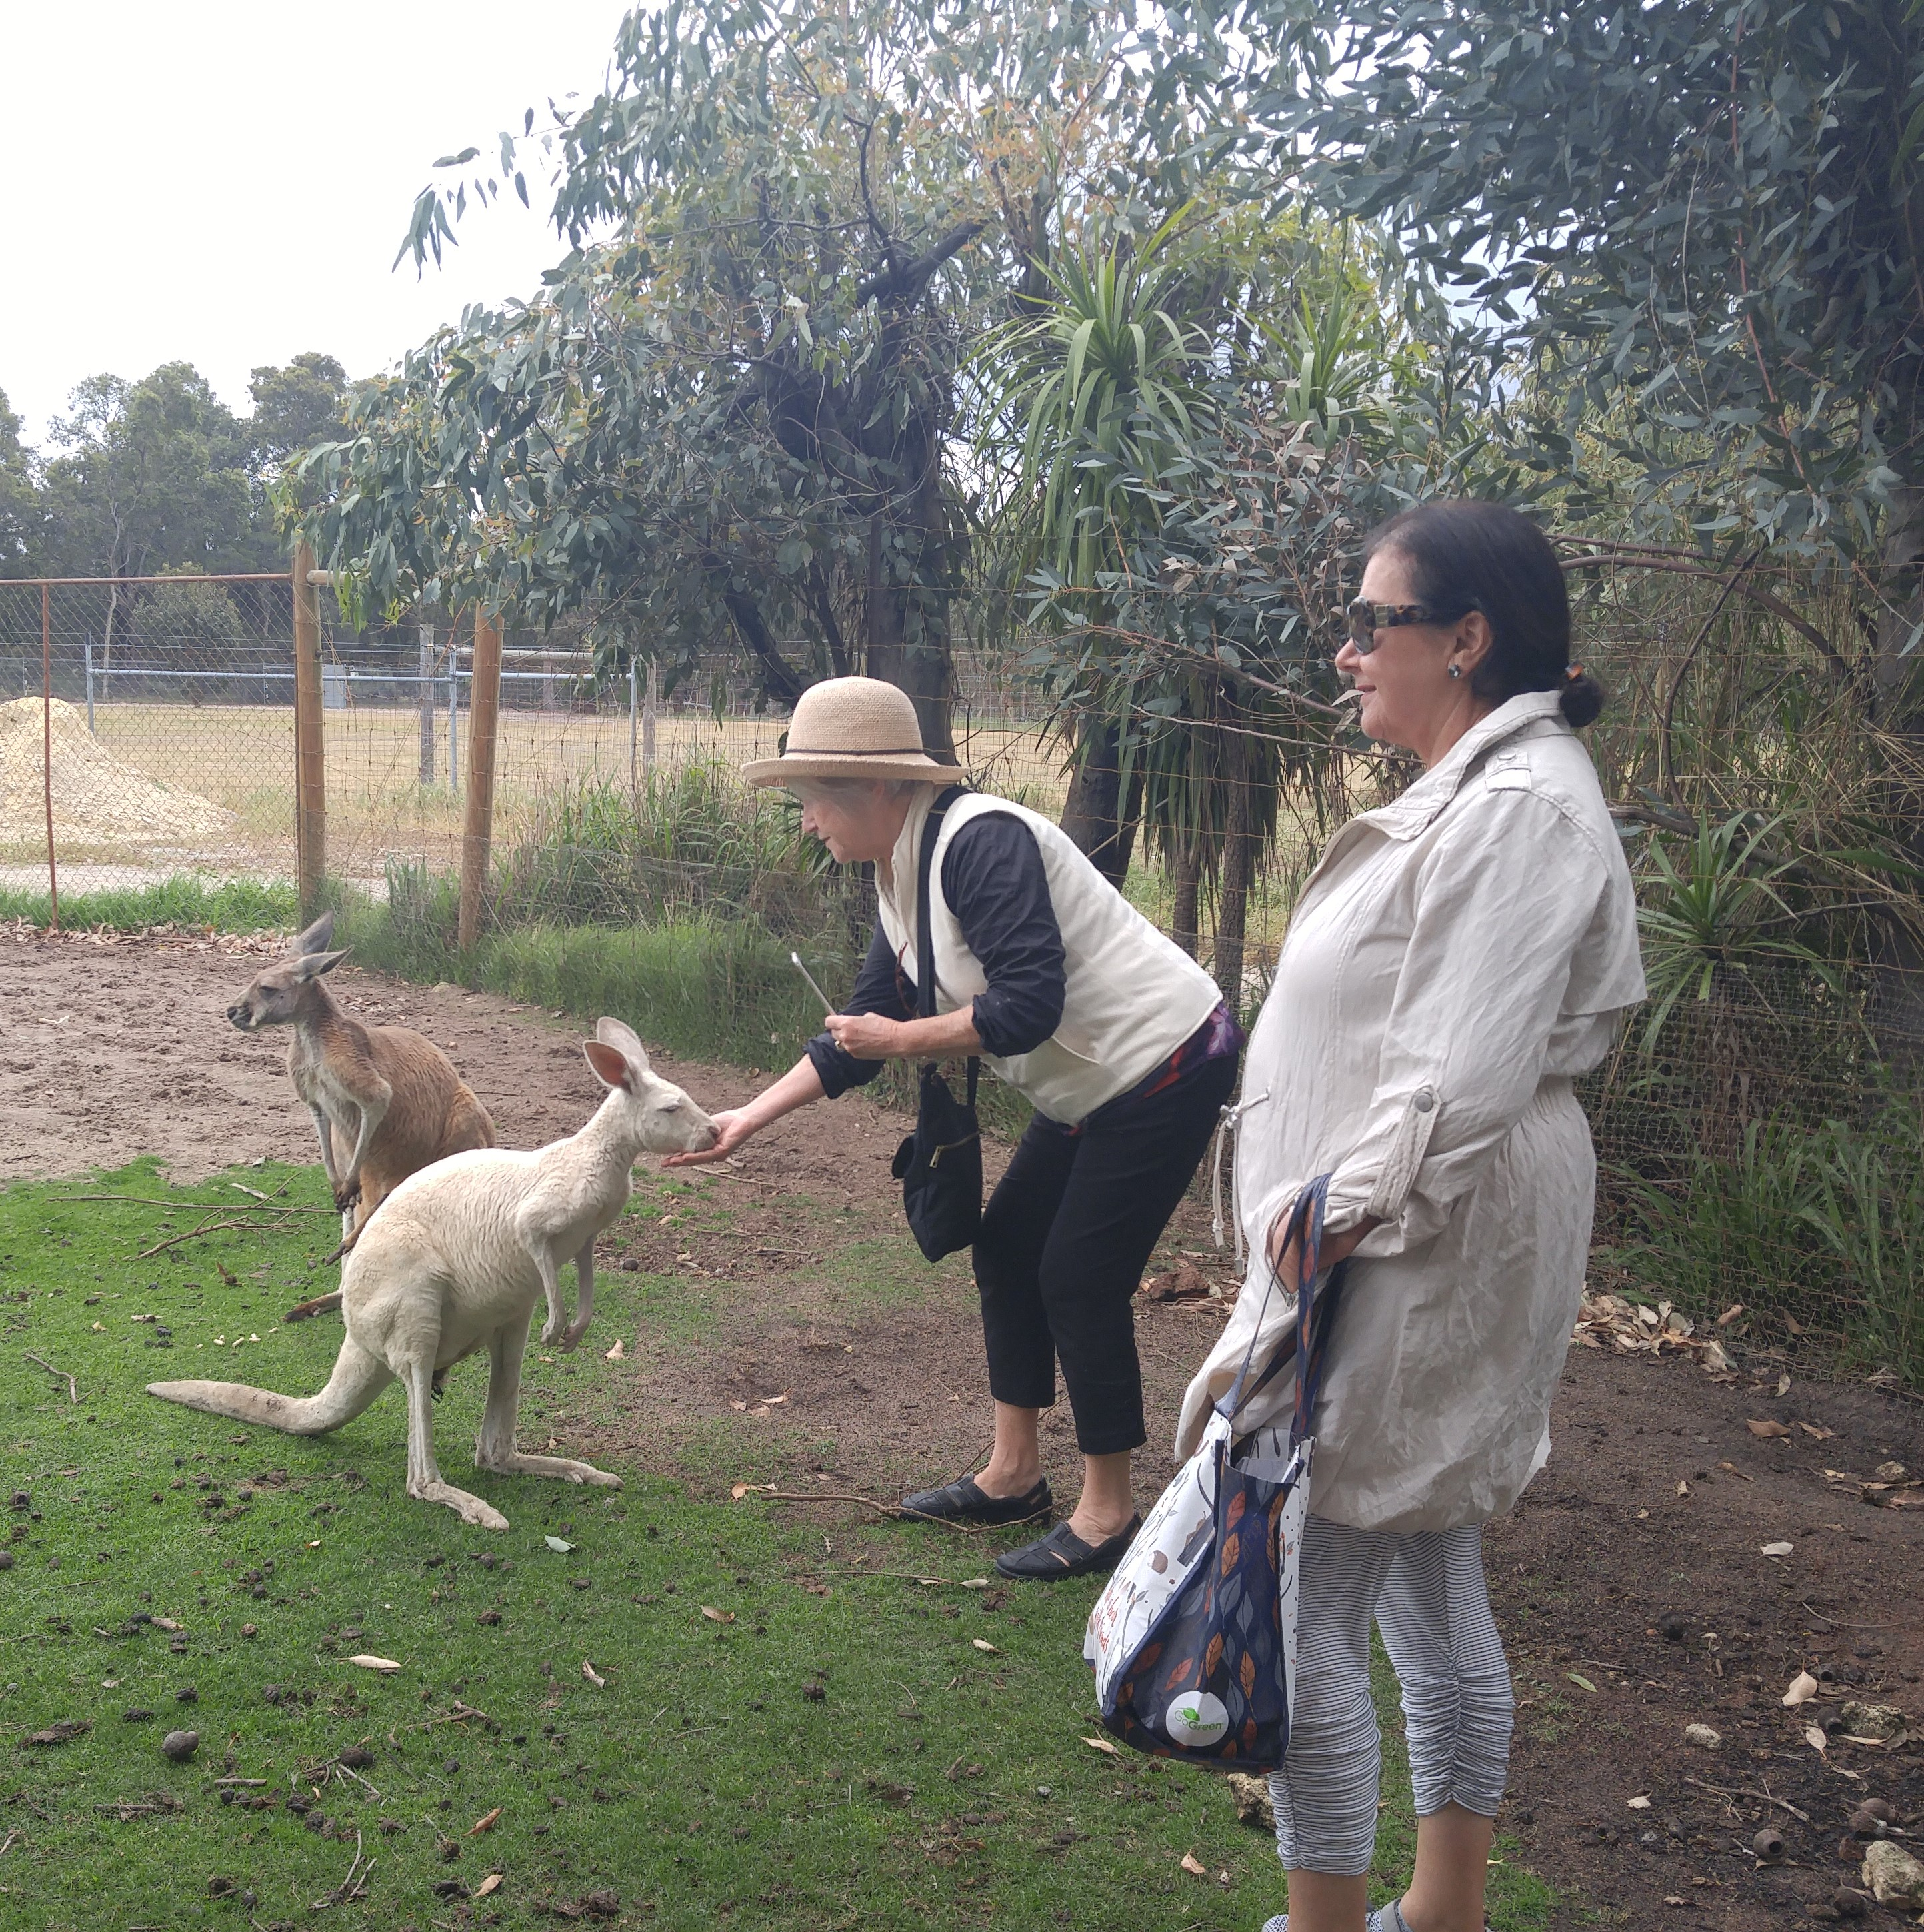
Sheep Shearing at Caversham Wildlife Park |  |  |  | Shelley with a koala |  |  | Carol feeding a roo
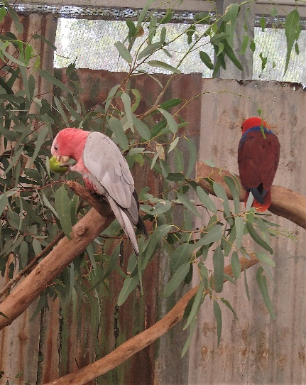 |  | 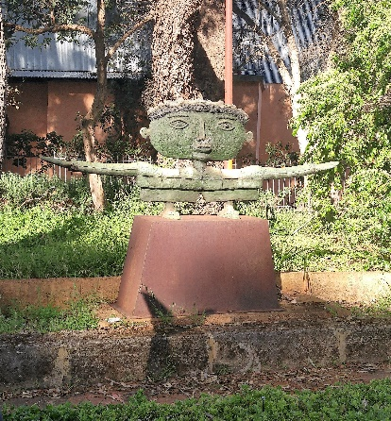 |  |  |  | 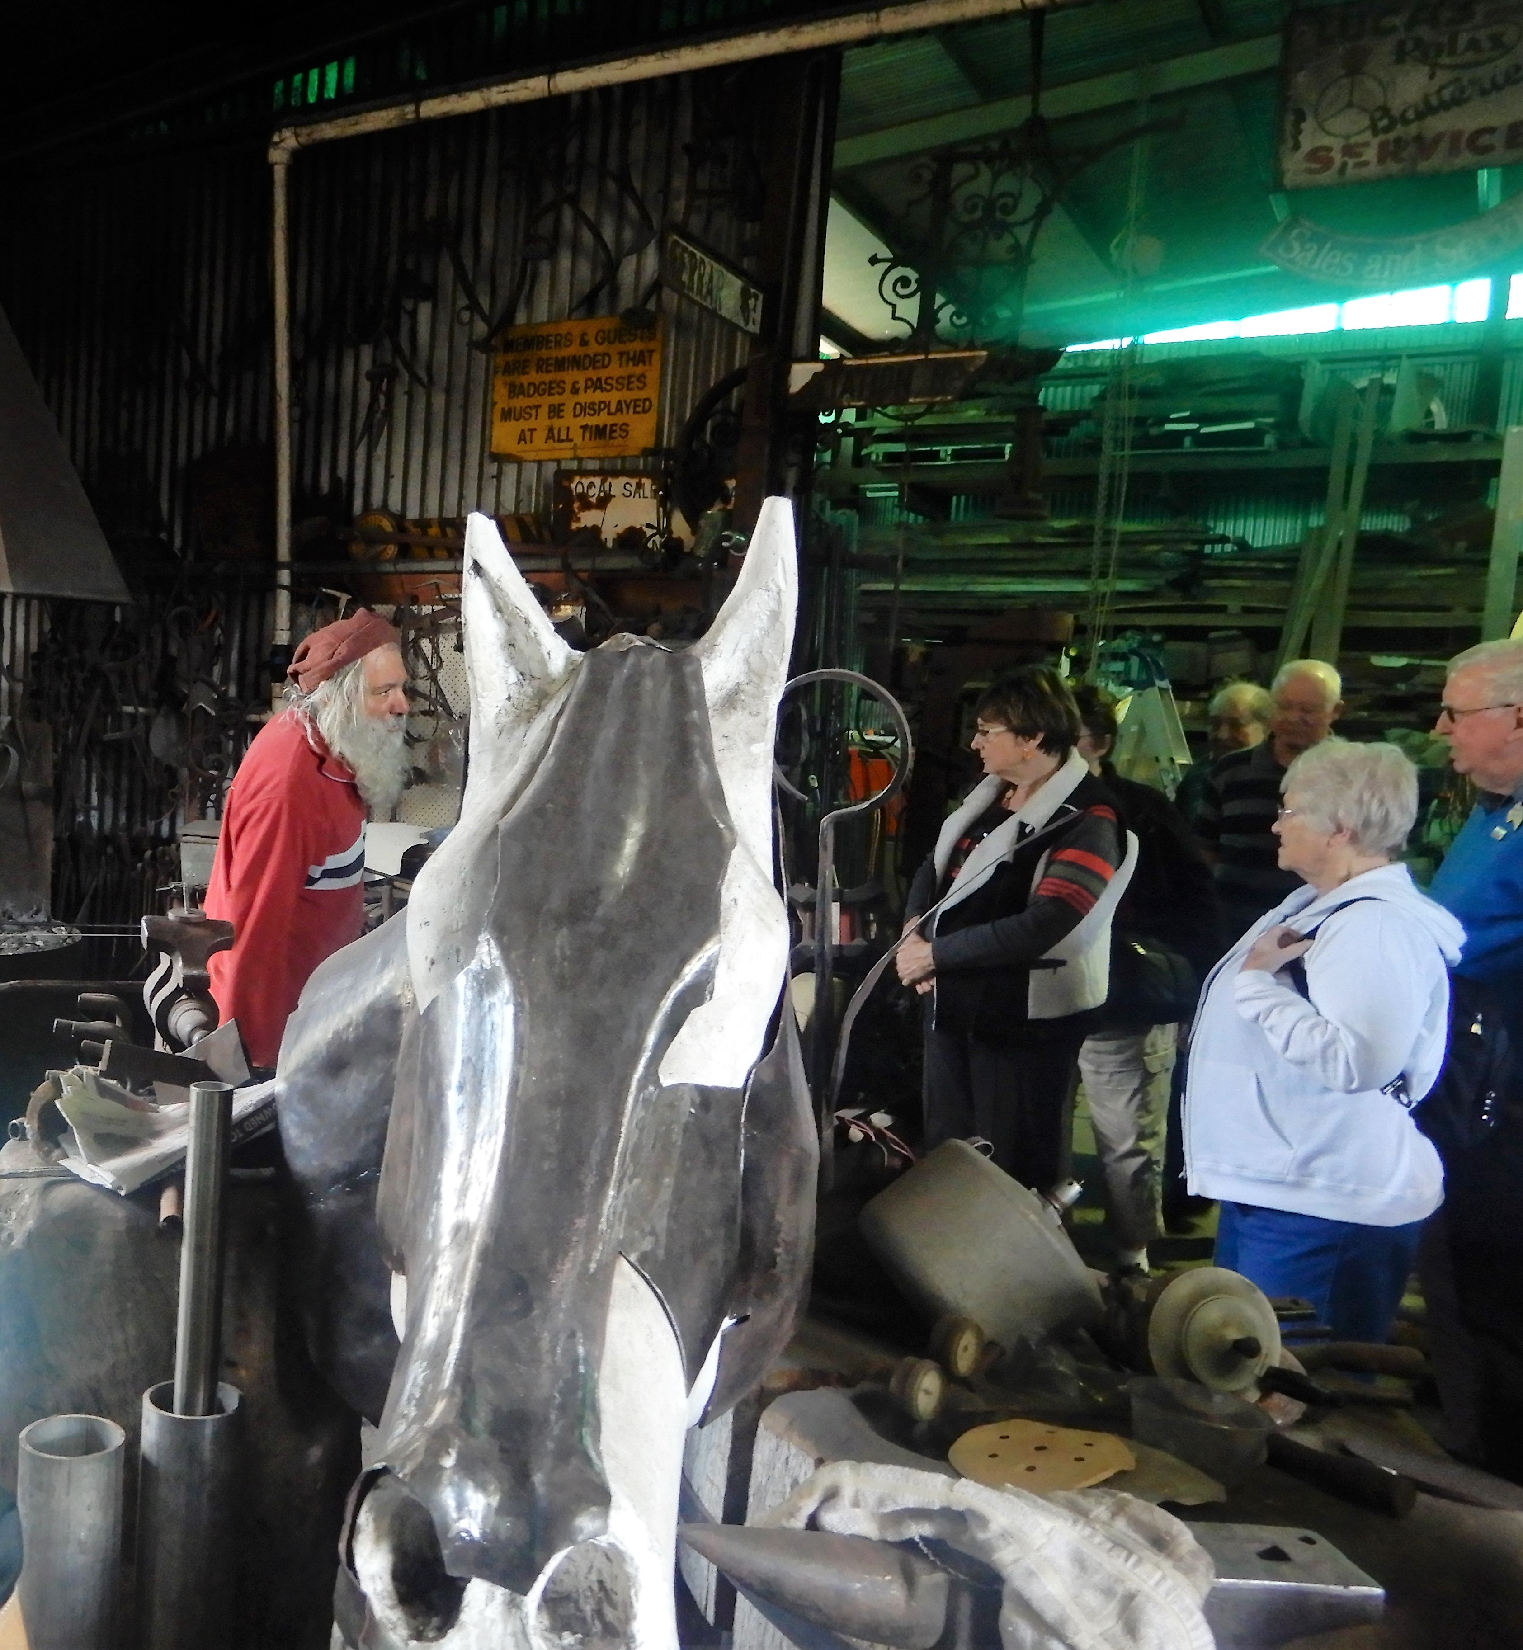
King Parrot |  | Gomboc Gallery in the Swan Valley |  |  |  | Wizard of Fire in the Swan Valley

